WEB-BASED HOTEL RESERVATION SYSTEM

YONG WEN KAI

SESSION 2020/2021

FACULTY OF COMPUTING AND INFORMATICS

MULTIMEDIA UNIVERSITY

MARCH 2021

WEB-BASED HOTEL RESERVATION SYSTEM

BY

YONG WEN KAI

SESSION 2020/2021

THE PROJECT REPORT IS PREPARED FOR

FACULTY OF COMPUTING AND INFORMATICS

MULTIMEDIA UNIVERSITY

IN PARTIAL FULFILLMENT

FOR

BACHELOR OF COMPUTER SCIENCE

B.CS (HONS) SOFTWARE ENGINEERING

FACULTY OF COMPUTING AND INFORMATICS

MULTIMEDIA UNIVERSITY

MARCH 2021

Copyright of this report belongs to Universiti Telekom Sdn. Bhd. as qualified by Regulation 7.2 (c) of the Multimedia University Intellectual Property and Commercialisation Policy. No part of this publication may be reproduced, stored in or introduced into a retrieval system, or transmitted in any form or by any means (electronic, mechanical, photocopying, recording, or otherwise), or for any purpose, without the express written permission of Universiti Telekom Sdn. Bhd. Due acknowledgement shall always be made of the use of any material contained in, or derived from, this report.

© 2017 Universiti Telekom Sdn. Bhd. ALL RIGHTS RESERVED.

# 

# DECLARATION

I hereby declare that the work have been done by myself and no portion of the work contained in this thesis has been submitted in support of any application for any other degree or qualification of this or any other university or institute of learning.

__________________________

Name: Yong Wen Kai

Faculty of Computing and Informatics

Multimedia University

Date: 8 March 2021

# ACKNOWLEDGEMENT

First of all, I would like to thank my supervisor Dr. Ng Hu for guiding me and preventing me from losing my direction throughout this Final Year Project.

I would also like to thank all that material that people had provided on the internet. Moreover, I would like to thank my friends for their countless helps in this Final Year Project by offering their help in data collection, offering ideas and system testing.

Last but not least, I would like to thank my families with their priceless and endless of support and encouragement throughout my study.

# ABSTRACT

In this era of globalization, technology had become a thing that we all cannot live without. With the advancement of technology these days, people are able to communicate with each other with the help of internet. Communication comes in several ways, such as text messages, video calling, voice messages and voice calling. When it comes to business, especially hotelier, they are hugely benefitted from this invention of internet. With the internet, they are able to communicate with their customers. In the other hand, customers will be able to communicate to the hotelier to check for information so that they will not have to travel physically to the hotel.

In the older era, peoples will have to check for room availability, prices, room condition physically when they reach the particular hotel. These inconveniences will cause a lot of drawbacks towards people, especially traveler.

Hence, the purpose of this project is to build a hotel reservation website that allows people from all walks of life to access and make reservation using the website. As the demand of hotel industry increasing from time to time, online reservation services will become very convenient and handy when it comes to hotel industry. People will be able to have advance knowledge of that particular hotel.

**Table of Contents**

DECLARATION ii

ACKNOWLEDGEMENT iii

ABSTRACT iv

Table of Contents v

List of Tables ix

List of Figures ix

Chapter 1: INTRODUCTION 1

1.1 Project Overview 1

1.2 Problem Statement 2

1.3 Project Objectives 3

1.4 Project Scope 4

1.5 Project Plan 5

1.5.1 Milestones 5

1.5.2 Gantt Chart 6

Chapter 2: BACKGROUND STUDY 7

2.1 Existing Systems 7

2.1.1 Trivago 7

2.1.2 Agoda 14

2.1.3 Airbnb 23

2.1.4 Comparisons between existing system and proposed system 28

2.2 Programming Language for Building Hotel Reservation Website 29

2.3 Web Server and Database Server for Hotel Reservation Website 30

Chapter 3: REQUIREMENTS 31

3.1 Software Development Methodology 31

3.2 Market Survey 33

3.2.1 Survey Analysis 39

3.3 System Minimum Requirements 46

3.4 Use Case Diagram 47

3.4.1 User Module 47

3.4.2 Hotelier Module 48

3.4.3 Admin Module 49

3.5 Data Flow Diagram 49

3.5.1 Context Diagram 50

3.5.2 Data Flow Diagram Level 0 for User 52

3.5.3 Data Flow Diagram Level 0 for Hotelier 54

3.5.4 Data Flow Diagram Level 0 for Admin 56

3.5.5 Data Flow Diagram Level 1 for User 58

3.5.6 Data Flow Diagram Level 1 for Hotelier 62

3.5.7 Data Flow Diagram Level 1 for Admin 65

3.6 Entity Relationship Diagram 68

Chapter 4: DESIGN 73

4.1 Sequence Diagrams 73

4.1.1 Sequence Diagram for Login 73

4.1.2 Sequence Diagram for Logout 74

4.1.3 Sequence Diagram for Reserve 74

4.1.4 Sequence Diagram for Register 75

4.1.5 Sequence Diagram for Rate 76

4.1.6 Sequence Diagram for Pay 76

4.1.7 Sequence Diagram for Comment 77

4.1.8 Sequence Diagram for Book 78

4.1.9 Sequence Diagram for Cancel Book 79

4.1.10 Sequence Diagram for Change Password 80

4.1.11 Sequence Diagram for Register Hotel 80

4.1.12 Sequence Diagram for Deregister Hotel 81

4.1.13 Sequence Diagram for Manage Hotel 82

4.1.14 Sequence diagram for Edit User Information 82

4.1.15 Sequence Diagram for Edit Hotelier Information 83

4.1.16 Sequence Diagram for View User Information 84

4.1.17 Sequence Diagram for View Hotelier Information 84

4.1.18 Sequence Diagram for View Hotel Information 85

4.1.19 Sequence Diagram for View Booking History 85

4.3 Screen Design 86

4.3.1 Hotel Reservation Website homepage 86

4.3.2 Hotel Reservation Website login/register page 87

4.3.3 Hotel Reservation Website forgot password page 88

4.3.4 Hotel Reservation about us page 89

4.3.5 Hotel Reservation Website contact us page 89

4.3.6 Hotel Reservation Website search result page 90

4.3.7 Hotel Reservation Website hotel detail page 91

4.3.8 Hotel Reservation Website book/reserve page 94

4.3.9 Hotel Reservation Website payment page 95

4.3.10 Hotel Reservation Website user profile page 96

4.3.11 Hotel Reservation Website hotelier profile page 97

4.3.12 Hotel Reservation Website add hotel page 98

4.3.13 Hotel Reservation Website edit hotel page 99

4.3.14 Hotel Reservation Website manage room page 100

4.3.15 Hotel Reservation Website admin page 101

4.3.16 Hotel Reservation website rate and comment page 103

Chapter 5: TESTING 104

5.1 Functional Testing 104

5.2 User Acceptance Testing 104

5.2.1 Feedback Analysis 107

Chapter 6: CONCLUSION 113

6.1 Evaluation 113

6.2 Limitation 113

6.3 Lesson Learnt and Skill 114

6.4 Future Plan 114

REFERENCES 115

APPENDIX A: COMMERCIALIZATION PROPOSAL 117

1. Executive Summary 117

2. Market Analysis 117

3. Problem Statement 118

4. Unique Value Proposition 118

5. Objective 118

6. Methods and Scope of Work 119

7. Business Model 119

8. Milestones and Key metrics 119

9. Project Outcome 120

10. Strength, Weakness, Opportunity, and Treat (SWOT) analysis 120

10.1 Strength 120

10.2 Weaknesses 120

10.3 Opportunities 120

10.4 Threats 121

APPENDIX B: SUPPORTING DOCUMENTS 122

A. Functional Testing Test Cases Table 122

B. Meeting Logs 135

APPENDIX C: SIMILARITY INDEX FROM TURNITIN 177

# List of Tables

Table 1‑1. Star rating by (Pascarella, 2009) 2

Table 1‑2. Milestones for Trimester 2 5

Table 2‑1. Advantages and disadvantages of trivago.com 14

Table 2‑2. Advantages and disadvantages of agoda.com 22

Table 2‑3. Advantages and disadvantages of Airbnb.com 28

Table 2‑4. Comparisons between proposed system and existing system 28

Table 3-1. Data Dictionary for Hotel Reservation System part one 69

Table 3-2. Data Dictionary for Hotel Reservation System part two 70

Table 3-3. Data Dictionary for Hotel Reservation System part three 70

Table 3-4. Data Dictionary for Hotel Reservation System part four 71

Table 4-1. Objective accomplishment table 113

Table 0-1. Homepage test cases 122

Table 0-2. Sign in test cases 123

Table 0-3. Register test case 124

Table 0-4. Logout test case 125

Table 0-5. Change password test case 125

Table 0-6. Booking test case 126

Table 0-7. Rate and comment test case 127

Table 0-8. Cancel booking test case 127

Table 0-9. View booking test case 128

Table 0-10. View hotel test case 128

Table 0-11. Payment test case 129

Table 0-12. Promo test case 130

Table 0-13 Blacklist test case 131

Table 0-14. Add hotel test case 132

Table 0-15. Add room test case 133

Table 0-16. Check in & check out test case 134

# List of Figures

Figure 1-1. Gantt chart for Trimester 2 6

Figure 2‑1. Trivago home page (Trivago, 2020) 8

Figure 2‑2. Login page of trivago.com (Trivago, 2020) 9

Figure 2‑3. Searching result page (Trivago, 2020) 9

Figure 2‑4. Selected hotel (Trivago, 2020) 10

Figure 2‑5. Info tab on the selected hotel (Trivago, 2020) 11

Figure 2‑6. Photos tab is selected (Trivago, 2020) 11

Figure 2‑7. Review tab is selected (Trivago, 2020) 12

Figure 2‑8. Details tab is selected (Trivago, 2020) 13

Figure 2‑9. Idle for 30 minutes (Trivago, 2020) 13

Figure 2‑10. Homepage of agoda.com (Agoda, 2020) 15

Figure 2‑11. Sign in and register page of agoda.com (Agoda, 2020) 15

Figure 2‑12. Search result page (Agoda, 2020) 16

Figure 2‑13. Selected hotel page (Agoda, 2020) 17

Figure 2‑14. Room tab selected (Agoda, 2020) 17

Figure 2‑15. Facilities tab is selected (Agoda, 2020) 18

Figure 2‑16. Review tab is selected (Agoda, 2020) 19

Figure 2‑17. Map tab is selected (Agoda, 2020) 20

Figure 2‑18. Children and extra beds tab is selected (Agoda, 2020) 20

Figure 2‑19. Booking page of selected room (Agoda, 2020) 21

Figure 2‑20. Payment page (Agoda, 2020) 22

Figure 2‑21. Homepage of airbnb.com (Airbnb, 2020) 23

Figure 2‑22. Search result page (Airbnb, 2020) 24

Figure 2‑23. Selected stays (Airbnb, 2020) 24

Figure 2‑24. Amenities tab is selected (Airbnb, 2020) 25

Figure 2‑25. Review tab is selected (Airbnb, 2020) 25

Figure 2‑26. Reserve button is clicked (Airbnb, 2020) 26

Figure 2‑27. Verification of mobile number is required for reservation (Airbnb, 2020) 27

Figure 2‑28. Payment page (Airbnb, 2020) 27

Figure 3‑1. Iterative waterfall model (Pal, 2018) 31

Figure 3‑2. Questions one, two and three of the survey 34

Figure 3‑3. Questions four, five and six of the survey 35

Figure 3‑4. Question seven of the of the survey 36

Figure 3‑5. Question eight of the survey 37

Figure 3‑6. Questions nine and ten of the survey 38

Figure 3‑7. Gender and age of respondents 39

Figure 3‑8. Occupation of the participants 40

Figure 3‑9. “Have you used Hotel Reservation Website before?” 40

Figure 3‑10. “How often does the participants use Hotel Reservation Website” 41

Figure 3‑11. “Do you think Hotel Reservation Website will be useful and beneficial?” 41

Figure 3‑12. Factor that cause the participants to use a particular website 42

Figure 3‑13. Existing system rating part one 43

Figure 3‑14. Existing system rating part two 43

Figure 3‑15. Partial result of the question “Do you have trouble using the existing Hotel Reservation Websites? If so, which website and why?” 44

Figure 3‑16. Partial result of participant’s opinion on feature lacking in existing Hotel Reservation Websites 45

Figure 3-17. Use case diagram for User module 47

Figure 3-18. Use case Diagram for Hotelier module 48

Figure 3-19. Use case diagram for Admin module 49

Figure 3-20. Context diagram for Hotel Reservation Website 50

Figure 3-21. Data flow diagram level 0 for User 52

Figure 3-22. Data flow diagram level 0 for Hotelier 54

Figure 3-23. Data flow diagram level 0 for Admin 56

Figure 3-24. Data flow diagram level 1 for User 58

Figure 3-25. Data flow diagram level 1 for Hotelier 62

Figure 3-26. Data flow diagram level 1 for Admin 65

Figure 3-27. Entity Relationship Diagram for Hotel Reservation Website 68

Figure 4-1. Sequence diagram for Login 73

Figure 4-2. Sequence Diagram for Logout 74

Figure 4-3. Sequence Diagram for Reserve 74

Figure 4-4. Sequence Diagram for Register 75

Figure 4-5. Sequence Diagram for Rate 76

Figure 4-6. Sequence Diagram for Pay 76

Figure 4-7. Sequence Diagram for Comment 77

Figure 4-8. Sequence Diagram for Book 78

Figure 4-9. Sequence Diagram for Cancel Book 79

Figure 4-10. Sequence Diagram for Change Password 80

Figure 4-11. Sequence Diagram for Register Hotel 80

Figure 4-12. Sequence Diagram for Deregister Hotel 81

Figure 4-13. Sequence Diagram for Manage Hotel 82

Figure 4-14. Sequence Diagram for Edit User Information 82

Figure 4-15. Sequence Diagram for Edit Hotelier Information 83

Figure 4-16. Sequence Diagram for View User Information 84

Figure 4-17. Sequence Diagram for View Hotelier Information 84

Figure 4-18. Sequence Diagram for View Hotel Information 85

Figure 4-19. Sequence Diagram for View Booking History 85

Figure 4-20. Hotel Reservation Website homepage 86

Figure 4-21. Hotel Reservation Website login/register page 87

Figure 4-22. Hotel Reservation Website register page 87

Figure 4-23. Hotel Reservation Website forgot password page 88

Figure 4-24. Hotel Reservation Website about us page 89

Figure 4-25. Hotel Reservation Website contact us page 89

Figure 4-26. Hotel Reservation Website search result page 90

Figure 4-27. Hotel Reservation Website hotel detail page (1) 91

Figure 4-28. Hotel Reservation Website hotel detail page (2) 91

Figure 4-29. Hotel Reservation Website hotel detail page (3) 92

Figure 4-30. Hotel Reservation Website hotel detail page (4) 92

Figure 4-31. Hotel Reservation Website hotel detail page (5) 93

Figure 4-32. Hotel Reservation Website book/reserve page 94

Figure 4-33. Hotel Reservation Website payment page 95

Figure 4-34. Hotel Reservation Website user profile page (1) 96

Figure 4-35. Hotel Reservation Website user profile page (2) 96

Figure 4-36. Hotel Reservation Website user profile page (3) 97

Figure 4-37. Hotel Reservation Website hotelier profile page 97

Figure 4-38. Hotel Reservation Website add hotel page (1) 98

Figure 4-39. Hotel Reservation Website add hotel page (2) 98

Figure 4-40. Hotel Reservation Website edit hotel page (1) 99

Figure 4-41. Hotel Reservation Website edit hotel page (2) 99

Figure 4-42. Hotel Reservation Website manage room page (1) 100

Figure 4-43. Hotel Reservation Website manage room page (2) 100

Figure 4-44. Hotel Reservation Website admin page (1) 101

Figure 4-45. Hotel Reservation Website admin page (2) 101

Figure 4-46. Hotel Reservation Website admin page (3) 102

Figure 4-47. Hotel Reservation Website rate and comment page 103

Figure 5-1. Feedback form (1) 105

Figure 5-2. Feedback form (2) 106

Figure 5-3. Feedback form (3) 107

Figure 5-4. Gender of the respondent 107

Figure 5-5. Do you think the Hotel Reservation is easy to use? 108

Figure 5-6. Do you think the user interface design of the website is clean and simple? 108

Figure 5-7. Rating of user interface and functionality of the website 109

Figure 5-8. Rating of pricing and respond time of the website 110

Figure 5-9. Recommendation and overall quality of the website 111

Figure 5-10. Suggestion for the website 112

# Chapter 1: INTRODUCTION

## 1.1 Project Overview

In this modern era, technology had played a big role in this modern society. From simple things like household chores to life saving experts in the medical field, technology had never been abandoned by this society. Hence technology had become a thing that our society cannot live without. Service industry, especially hotel service had greatly benefitted from the evolution of technology. As time passes, technology had become more and more modern. Ever since the invention of telephones in 1876 (Elon University School of Communications, 2020), internet in 1983 (Andrews, 2019), World Wide Web in 1989 (CERN, 2020), these technologies had extended the function of a hotel. By inventing these technologies, peoples no longer had to check the availability of rooms physically. By using these technologies, people can remotely check the availability, making advance bookings, reservation, price checking and facilities of a hotel.

In the older era of hotel services, peoples had to check for room availability of that hotel physically. This will cause a lot of inconvenience, especially for those people who are disabled. Peoples will have to travel across the city to find a suitable hotel that are available for accommodation. Even though they found a hotel that are suitable and comfortable, the pricing may not be suitable for them. In the end, they will have to travel more to find a more suitable hotel.

Hotel service and facilities varies from the price range and the star rating. Hotel star rating comes with five category, from one star to five star. The rating can be compared with the table below.

Table 1‑1. Star rating by (Pascarella, 2009)

|  |  |  |  |
| --- | --- | --- | --- |
| **Star rating** | **Travelocity** | **Expedia** | **Orbitz** |
| One-star | Meets budget basic needs | Economy, no-frills accommodations | Simple accommodations |
| Two-star | Meets basic needs | Value, clean, basic | Value, comfortable, affordable |
| Three-star | High service, additional amenities | Quality, style, comfort, personalized service | Mid-scale, convenience plus comfort |
| Four-star | Superior property, variety of amenities | Superior, upscale, high-quality | Deluxe/upscale, comfort plus quality |
| Five-star | Luxury setting, flawless guest services | Finest hotels, luxury, superlative service, highest comfort standards | Luxury, first-class services, well equipped and state of the art facilities |

## 1.2 Problem Statement

Based on the statistic provided by ( Miniwatts Marketing Group, 2020), internet users had increased from 0.4% of world population at year 1995 to 59.6% of world population at year 2020. Which is shockingly 16 million of users in year 1995 and 4648 million of users in year 2020. In the other hand, despite that enormous internet users, there are still a fraction of users who are dissatisfied when using the website. A few that caused dissatisfaction to the users are stated below:

1. Discomfort website content

When a website is filled with many advertisement and pop ups, the user will be interrupted and felt irritating when browsing the website.

1. Messy user interface design

A website with a messy layout will hinder the user from getting their job done as messy website tends to mislead and confuse users. For example, Agoda (Agoda, 2020) have a really packed user interface when showing the information about a particular hotel.

## 1.3 Project Objectives

The objectives of this project are:

* To develop a hotel reservation system with implementing a search engine for user without discomfort and messy searching experience and allowing view the hotel and the hotel rooms via pictures with price range and rating.
* Implementing a personality matching feature for users that allow users to comment, rate or gives feedback to the particular hotel.
* To develop various booking methods such as book now, book now pay later and cancellation of booking with or without cancellation fees based on the duration of booking.
* To create multiple payment methods such as pay using bank transfers, PayPal or pay when reach the hotel.

## 1.4 Project Scope

The scope of this project is focused on planning, designing and building a Hotel Reservation Website. In planning stage, background and existing system studies is carried out. In designing stage, database and UI design is carried out. Lastly in building stage, a fully functional website is implemented. Hotels in the websites only covers hotels in Malaysia only. There are three main modules in this project: user module, hotelier module and admin module. User in here will be the people who uses the website to book hotels. Hotelier in here will be the people who register and manages the hotel on the website. Admin module will manage the website.

1. User module

This module will allow users to register and login using their own unique account. Information such as location, price, premise type, photos, amenities, facilities, star rating, user ratings and user reviews can be view by users. Furthermore, users will also be able to book, reserve, pay, rate and review the hotel that they had chosen. In addition, users will also be able to edit their own account password.

1. Hotelier module

This module will allow hotelier to register and login using their own unique account. Operations such as register or deregister and manages their hotels that had registered on the website will be available for hoteliers. Furthermore, hotelier will be able to view their own hotel’s rating and reviews that is done by the users. Hotelier who are signed in using hotelier account will not be able to have booking operation.

1. Admin module

This module allows website administrator to login using the administrator account. The administrator will have the same functionality as users but without book, reserve, pay, rate and review the hotel. The administrator will be able to view all information about the users and hoteliers including username and account type.

## 1.5 Project Plan

### 1.5.1 Milestones

Table 1‑2. Milestones for Trimester 2

|  |  |  |
| --- | --- | --- |
| **Week** | **Milestones** | **Due date** |
| 1 | Project Review | 05/01/2021 |
| 1 | Introduction | 14/12/2020 |
| 3 | Background study | 21/12/2020 |
| 5 | Requirements | 28/12/2020 |
| 9 | Design | 05/01/2021 |
| 9 | Implementation | 05/03/2021 |
| 12 | Testing | 05/03/2021 |
| 15 | Conclusion | 05/03/2021 |
| 16 | Report submission | 08/03/2021 |
| 16 | Presentation | 10/03/2021 |

### 1.5.2 Gantt Chart

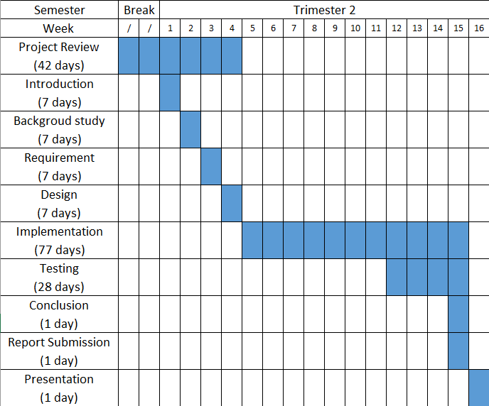

Figure 1-1. Gantt chart for Trimester 2

Figure 1-1 shows the timeline for the final year project trimester 1. The main activities are project review, introduction, background study, requirement, design, implementation, testing, conclusion, report submission and presentation.

# Chapter 2: BACKGROUND STUDY

## 2.1 Existing Systems

In this modern day, there are plenty of hotel reservation system being implemented by using varies of tools, technique and platform. Having a background study of these existing system will greatly benefit this project. Some of the existing hotel reservation website is studied. The characteristic, advantages and disadvantages of these website will be explained in the following section.

### 2.1.1 Trivago

Trivago is a hotel searching website that allows users to compare hotel prices form more than 400 booking websites for more than 1.8 million hotels in over 190 countries. Upon entering the website, the website will prompt the user to key in information such as location, check in date, check out date, the amount of person and the amount of room. Before keying in those details, the website will have a search history below the searching section. This shows your previous and recent search in that computer. The website also allow users to select the currency and language. In addition, the website also allow users to have login to their own account. Furthermore, trivago.com also offers registration via several method. The methods are email address, google account, Facebook account, amazon account and apple account.

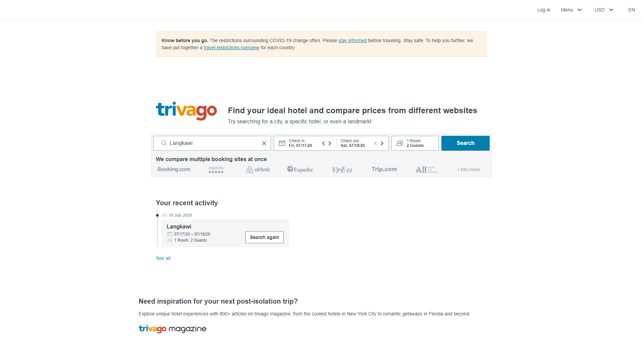

Figure 2‑1. Trivago home page (Trivago, 2020)

Figure 2-1 shows the homepage of trivago.com. User will have the option to change language and currency based on user preference. In this homepage, the website prompt the user to enter the location, check in date, check out date and number of person before searching. Below the searching bar, there is a recent activity section where you can view your recent searches.

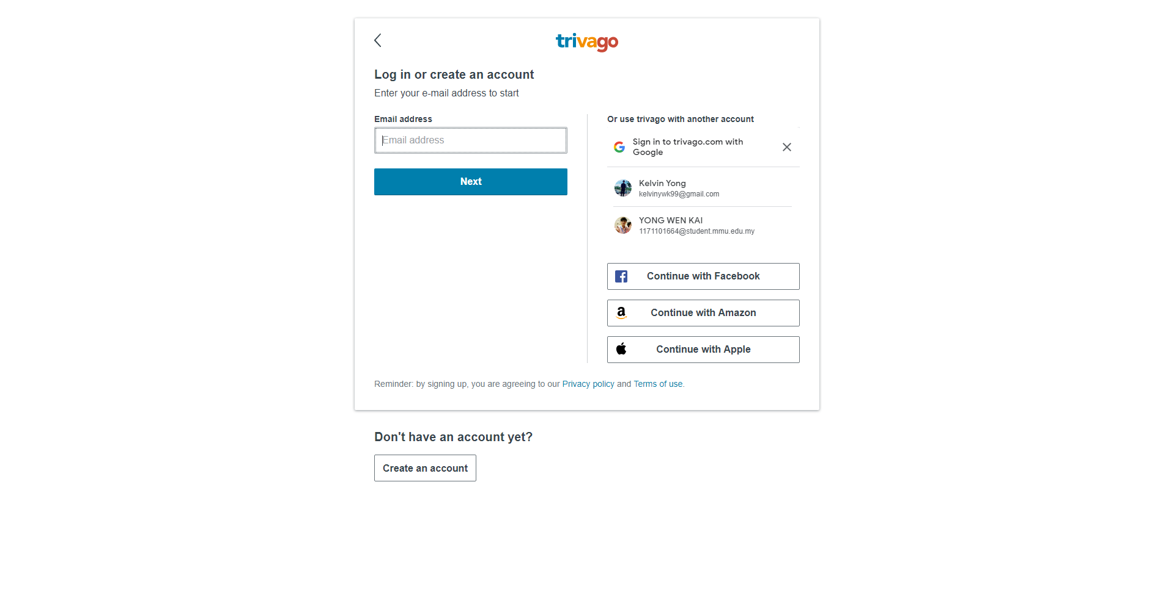

Figure 2‑2. Login page of trivago.com (Trivago, 2020)

Figure 2-2 shows the login page of trivago.com. As shown in the picture, users will be able to login using their own account. The website also allow users to have variety ways of logging in. Google account, Facebook account, amazon account and apple account is accepted.

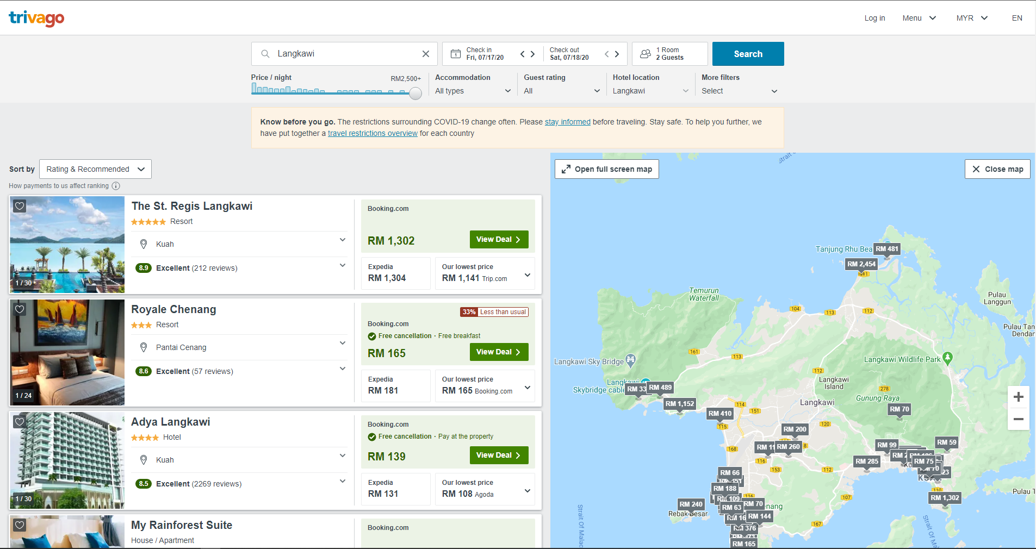

Figure 2‑3. Searching result page (Trivago, 2020)

Figure 2-3 shows the searching result page of trivago.com. In this page, user will be able to searches for hotels but not booking. Users will also able to view the location of the hotel on the map provided on the right side of the website either in map mode or satellite mode. In this page, the website also provided many sorting and filtering feature for better searching experience.

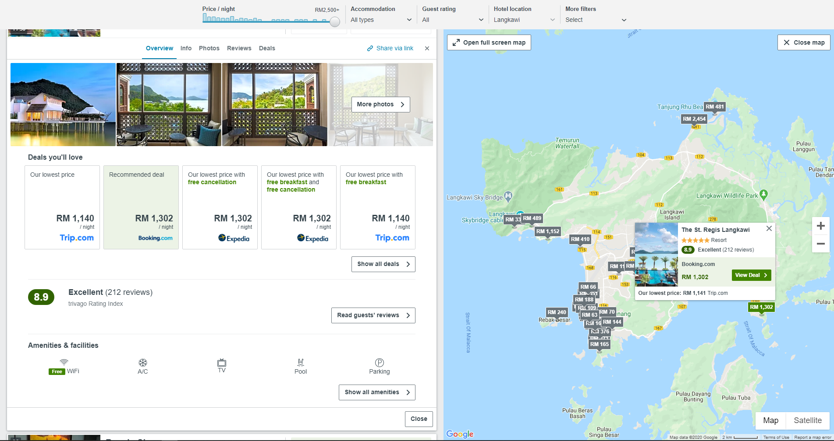

Figure 2‑4. Selected hotel (Trivago, 2020)

Figure 2-4 show the selected hotel on trigavo.com. When a particular hotel is selected, it will expand and shows all the overview of the hotel which included comparison of prices from different booking sites, user ratings, amenities and facilities. The selected hotel will also being highlighted on the map to help the user in locating the hotel.

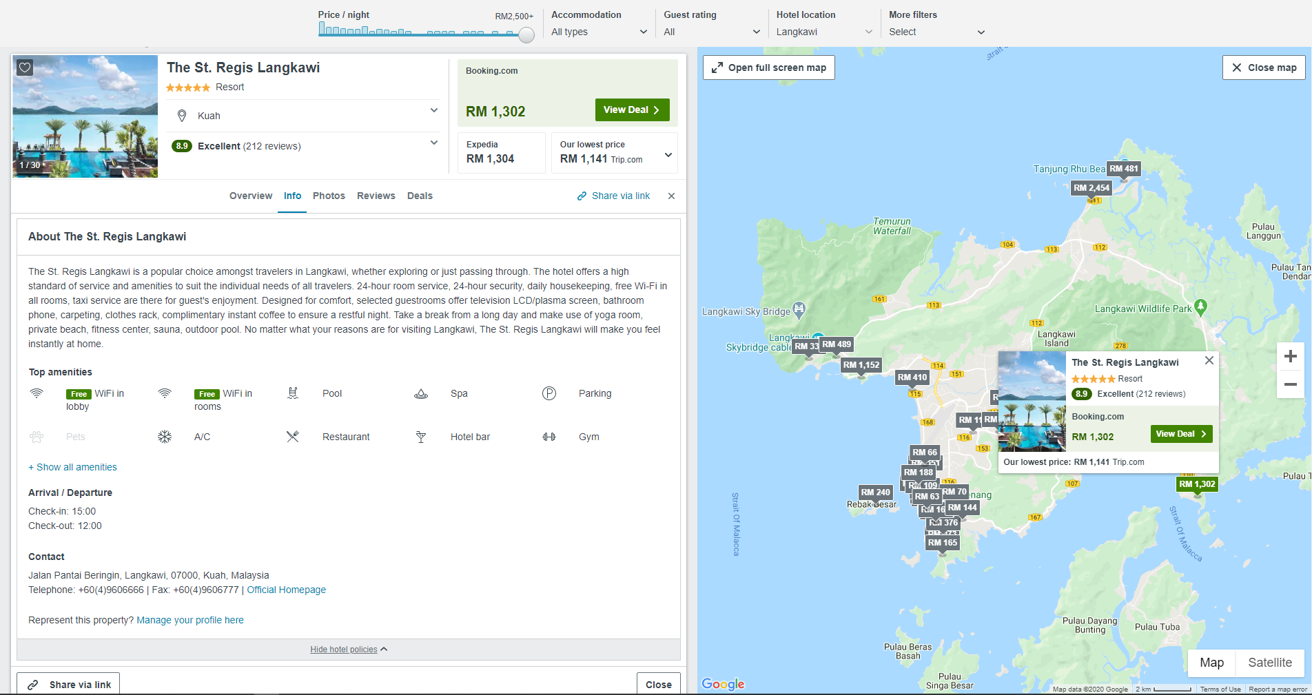

Figure 2‑5. Info tab on the selected hotel (Trivago, 2020)

Figure 2-5 shows the selected info tab on the particular hotel. When the info tab is clicked, it will shows the brief introduction about the particular hotel. It will also shows the top amenities, check in and check out date. In addition, it will also shows the contact info about the hotel.

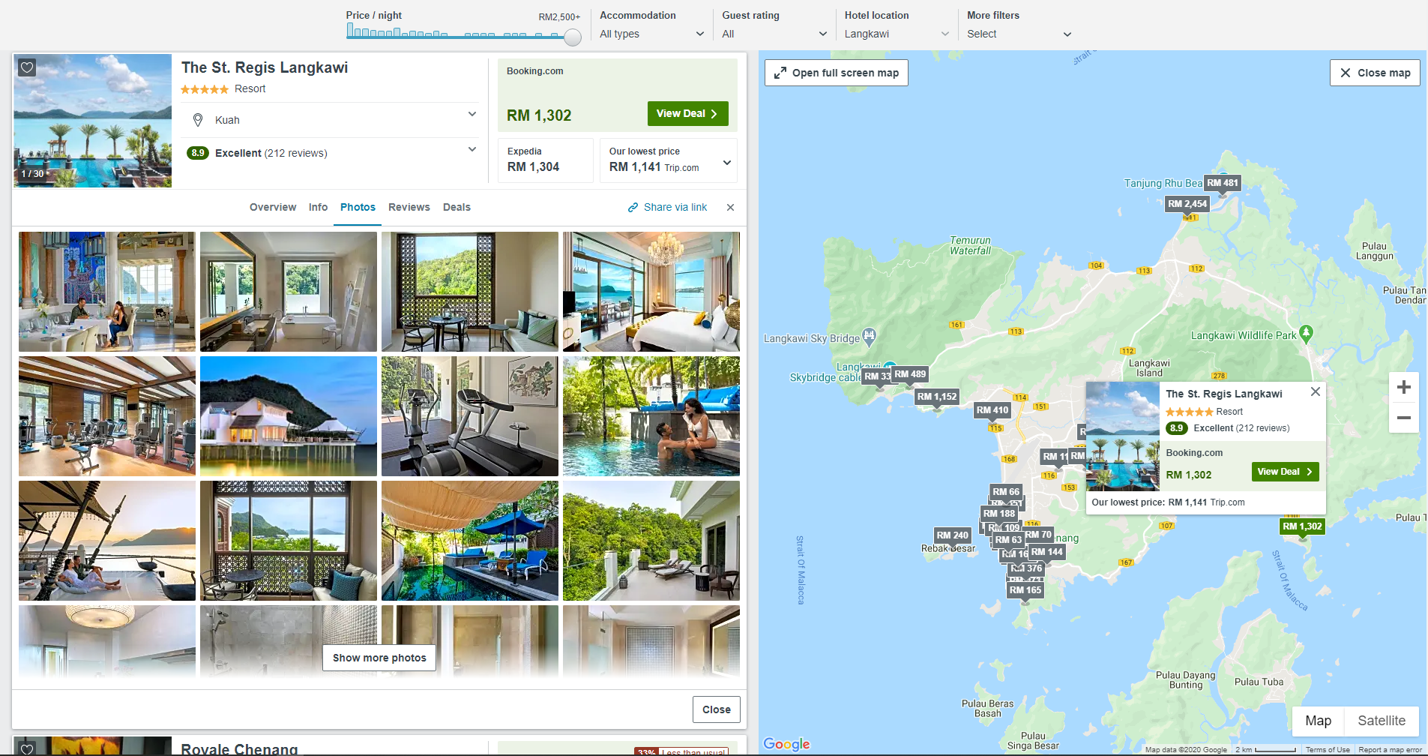

Figure 2‑6. Photos tab is selected (Trivago, 2020)

Figure 2-6 shows the photo tab is selected on trivago.com. When the photo tab is clicked and selected, the website will show the photos of the particular hotel.

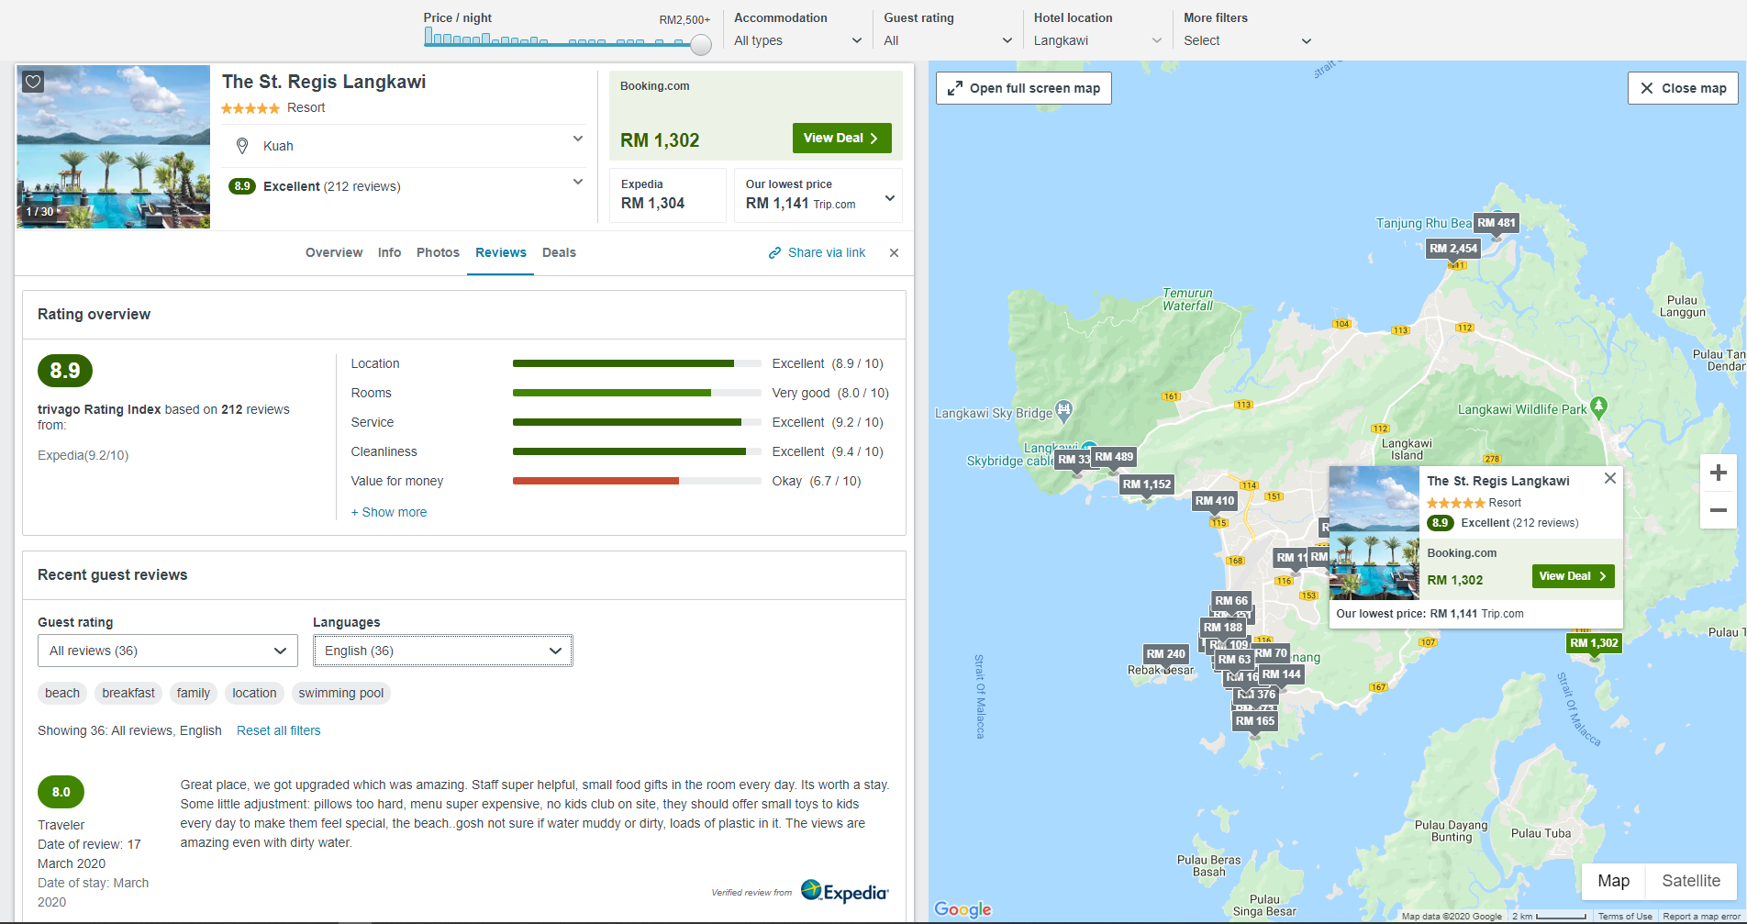

Figure 2‑7. Review tab is selected (Trivago, 2020)

Figure 2-7 shows the review tab is selected on trivago.com. When the review tab is selected, it will shows the overall rating and reviews by users and rating in different aspect. The aspects had included location, rooms, service, cleanliness, value for money. When the section is expanded, it will show additional ratings such as comfort, facilities, building, breakfast and food. The reviews also have filters such as positive or negative rating and languages.

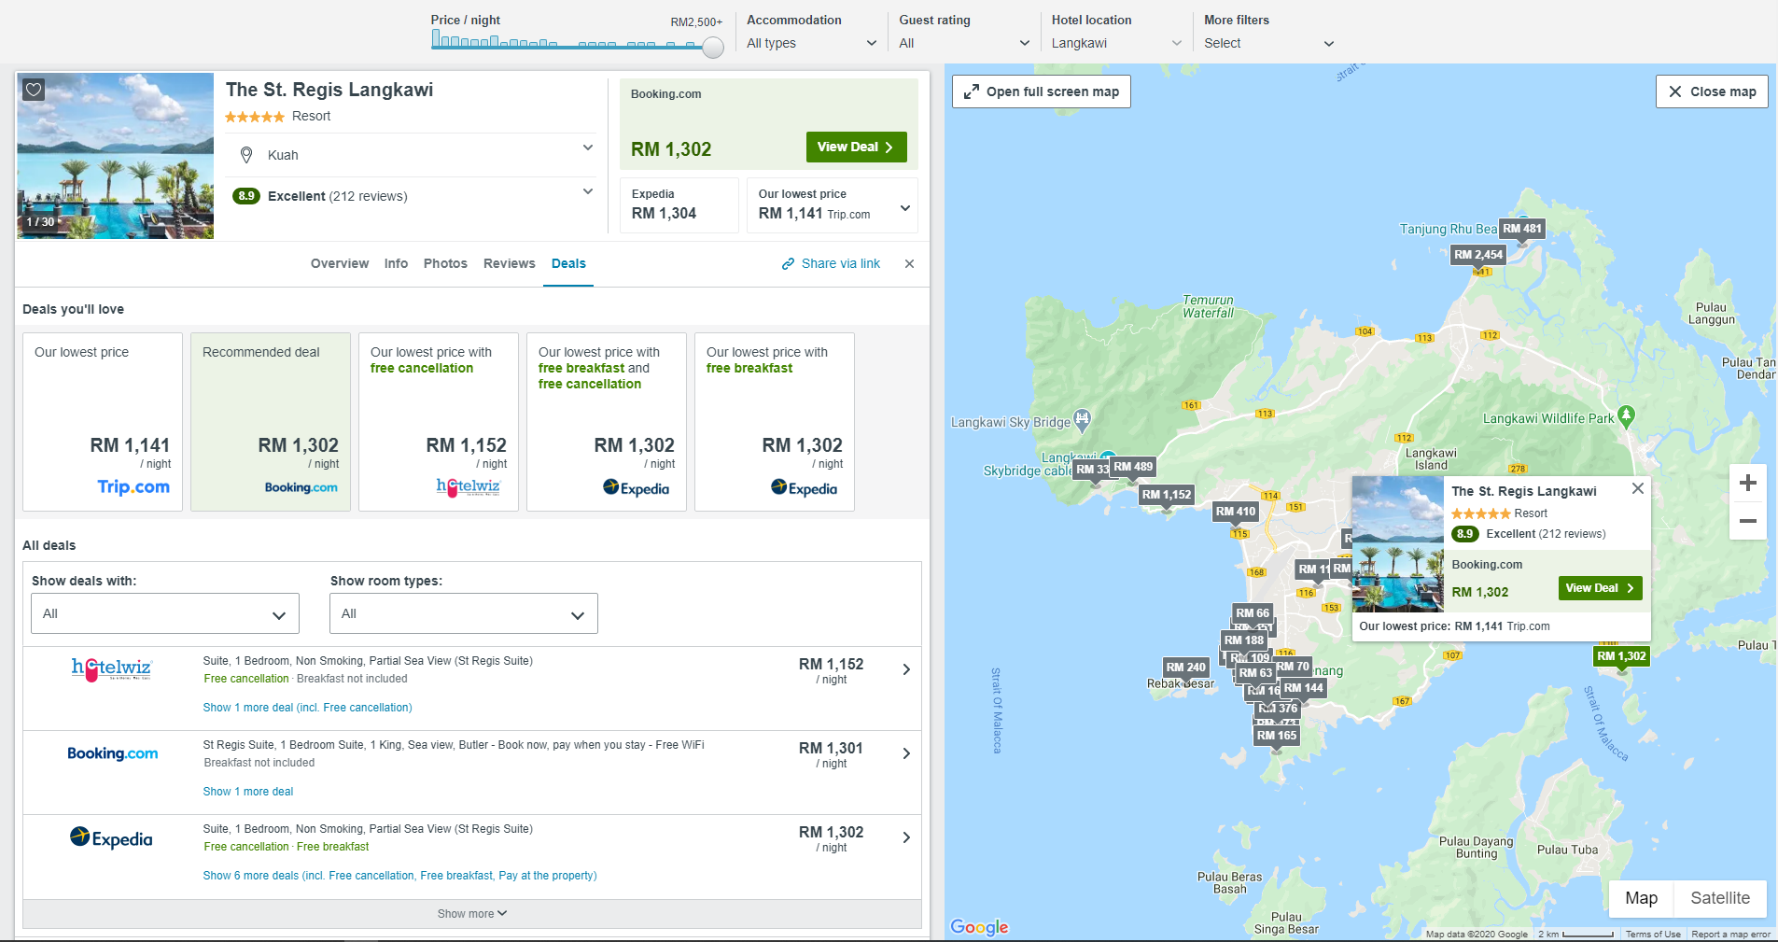

Figure 2‑8. Details tab is selected (Trivago, 2020)

Figure 2-8 shows the deals tab is selected on trivago.com. When the deals tab is selected, it will show all the prices from many different booking websites. It also have filters such as free cancellation, free breakfast, pay at the property and room types.

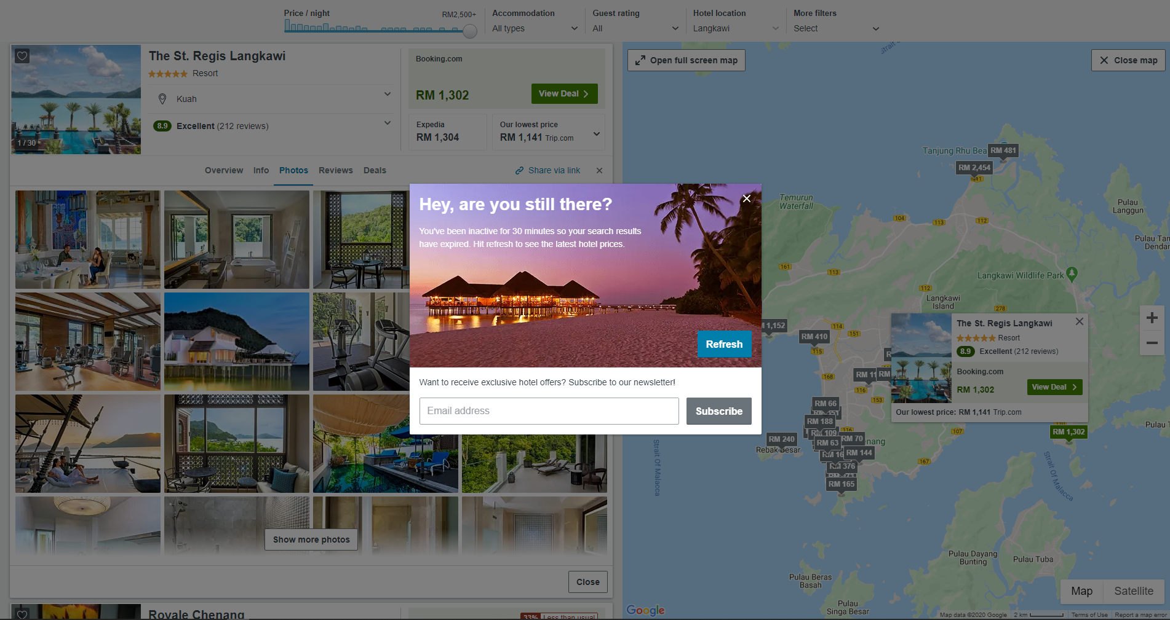

Figure 2‑9. Idle for 30 minutes (Trivago, 2020)

Figure 2-9 shows the pop up when the user is idled for 30 minutes. It will recommend the user to refresh the page in order to update and see the latest hotel prices.

Table 2‑1. Advantages and disadvantages of trivago.com

|  |  |  |
| --- | --- | --- |
|  | **Advantages** | **Disadvantages** |
| 1 | Variety ways to register and login | No direct booking |
| 2 | No registration is required | Booking of hotels will redirect you to another sites |
| 3 | Simple and User-friendly UI design | Didn’t show information about COVID-19 in that particular area |
| 4 | Shows the location of the hotel on map | Didn’t shows nearby attractions |
| 5 | Have varieties of sorting and filters |  |
| 6 | Shows the type of premises |  |
| 7 | Shows variety of prices from different booking websites |  |

### 2.1.2 Agoda

Agoda is an online booking website for accommodations, flights and more. Upon entering the website, the search bar will show up as the homepage. In the search bar, the user will be able to key in information for searching. Information for searching had included location, date and number of person. In the homepage of agoda.com, they also provided users to change the currency and language. The website also allow users to login or register their account by using email, Facebook and apple account.

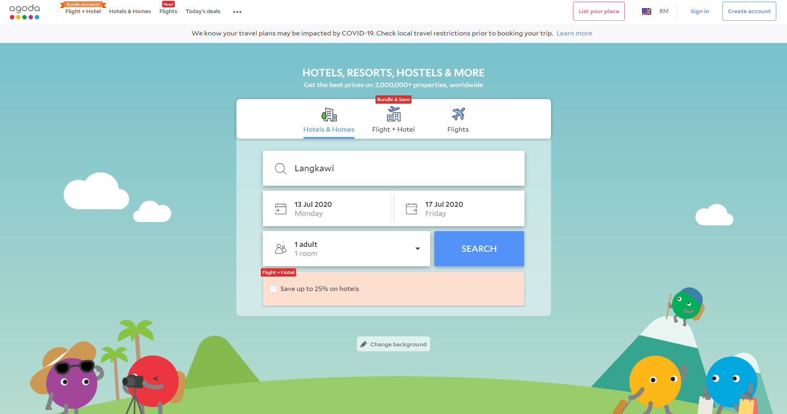

Figure 2‑10. Homepage of agoda.com (Agoda, 2020)

Figure 2-10 shows the homepage of agoada.com. Users can enter information such as location, date, number of people and room. User can also change the language and currency based on their likings. In addition, user can also login into their own account in this homepage.

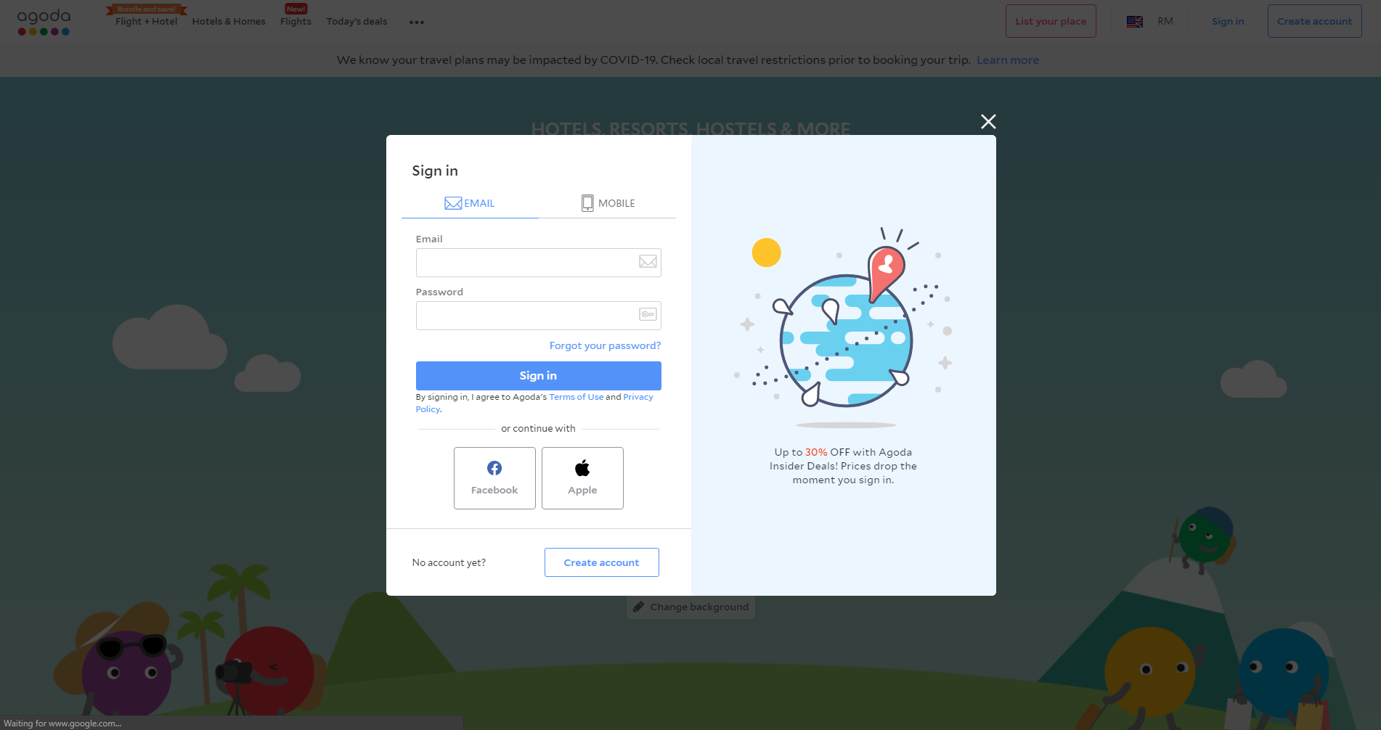

Figure 2‑11. Sign in and register page of agoda.com (Agoda, 2020)

Figure 2-11 shows the sign in and register page of agoda.com. Users can sign in or register by using email, Facebook or apple account.

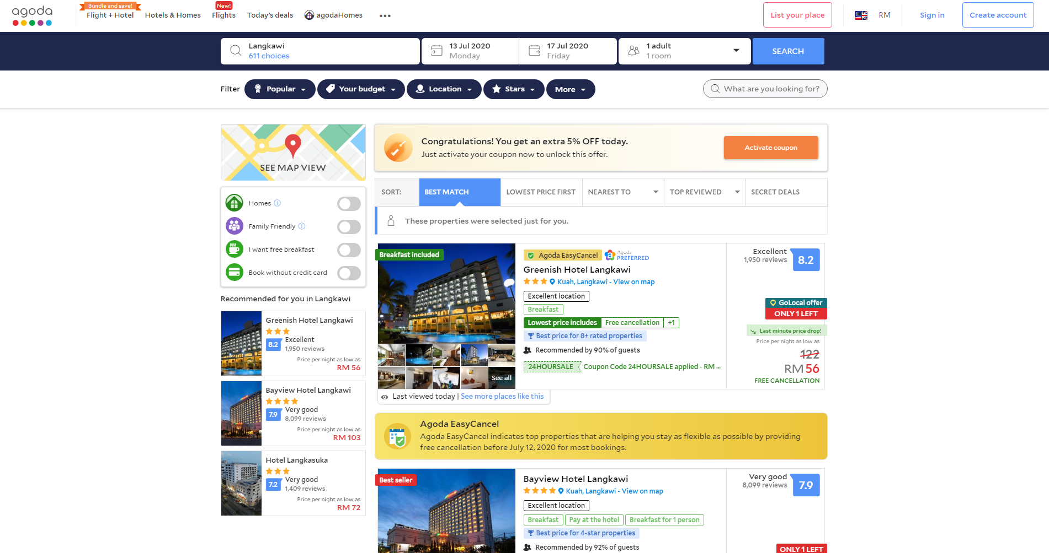

Figure 2‑12. Search result page (Agoda, 2020)

Figure 2-12 shows the search result of agoda.com. After entering the information in the homepage, the website will lead the user to the result page where all the result hotels are shown. The website also provide the user with sorting and filtering feature to ease the process of choosing the suitable hotel.

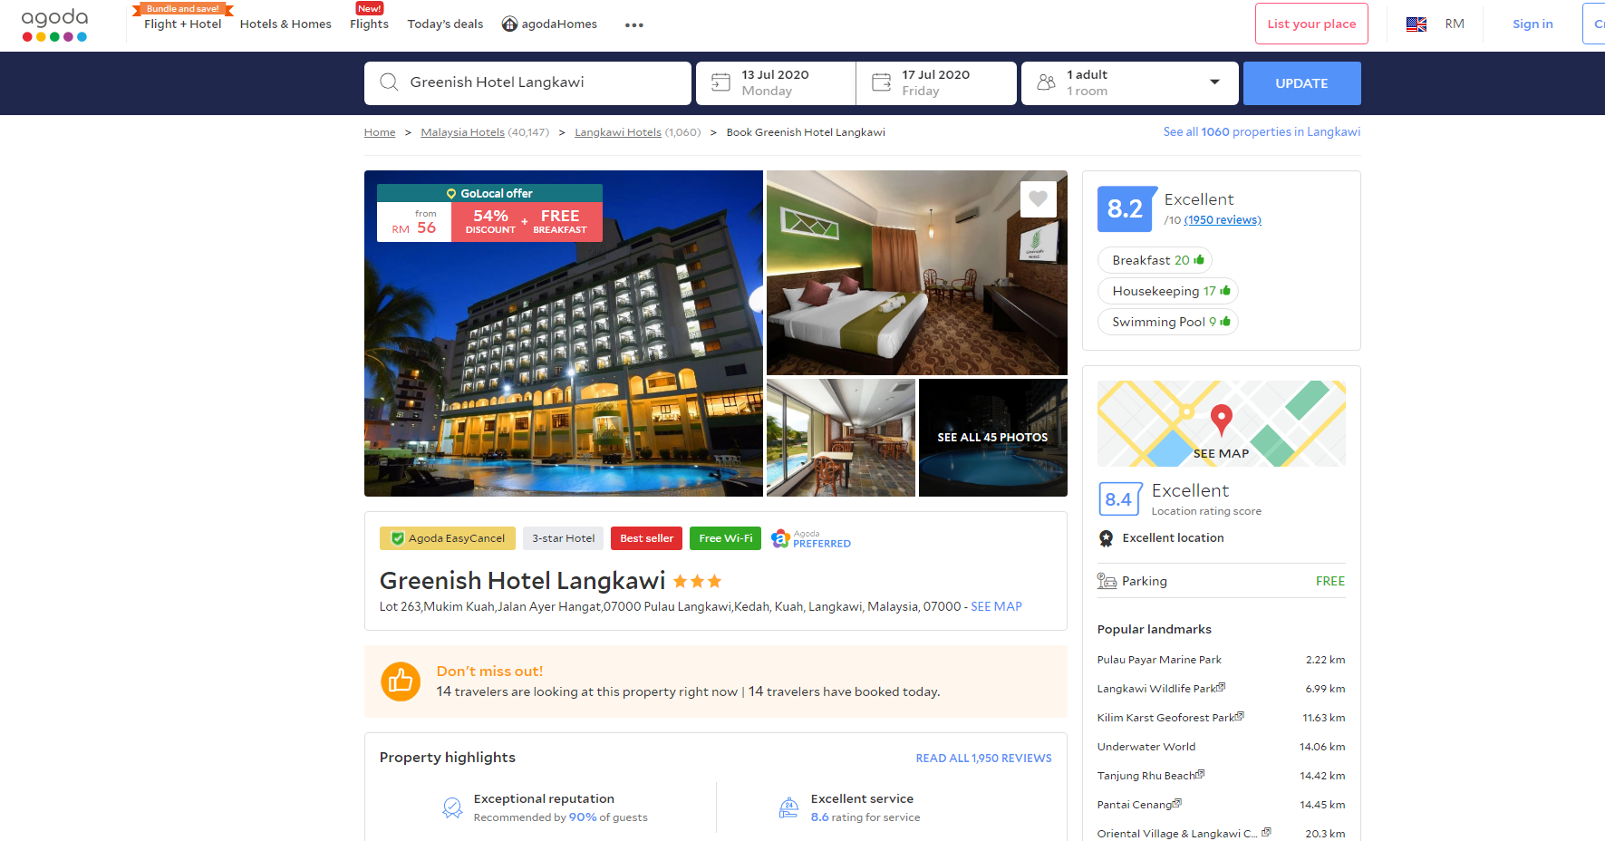

Figure 2‑13. Selected hotel page (Agoda, 2020)

Figure 2-13 shows the selected hotel page on agoda.com. When the desired hotel is selected by user, it will open up a new tab and showing all the details of the hotel. Those details had included star rating, location, photos, prices, nearby attractions, facilities, amenities and user ratings.

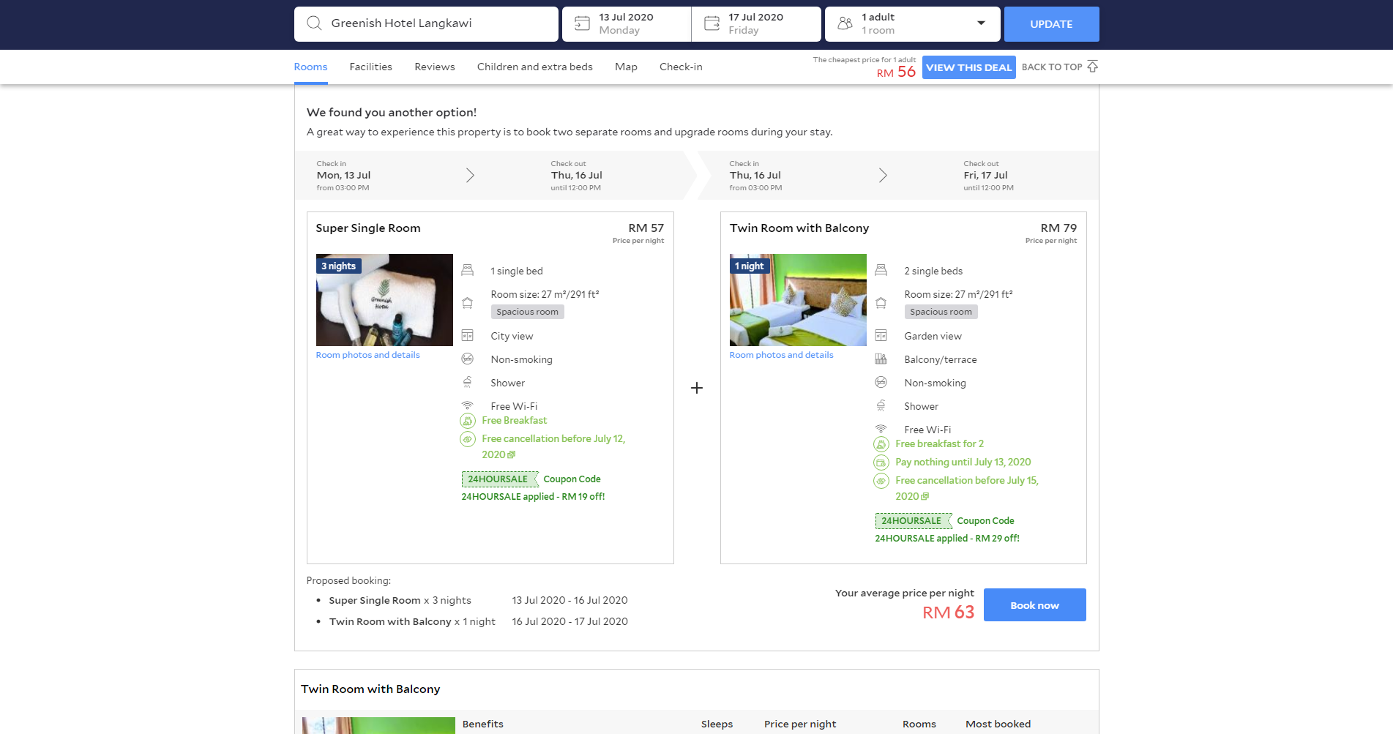

Figure 2‑14. Room tab selected (Agoda, 2020)

Figure 2-14 shows the room choices on selected hotel. When the user click the room tab or scroll down from the selected hotel page, the page will show the type of room and prices. It will also shows the room facilities such as number of beds, room size, room views and more. The website will also provide filters for better room selection.

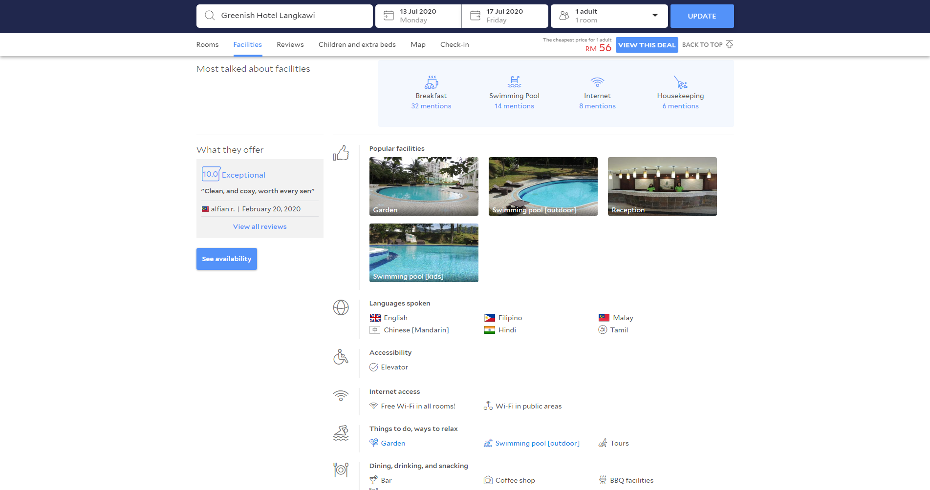

Figure 2‑15. Facilities tab is selected (Agoda, 2020)

Figure 2-15 shows the facilities information of the selected hotel. When the user click the facilities tab or scroll down from the room selection section, the page will shows all facilities of the hotel.

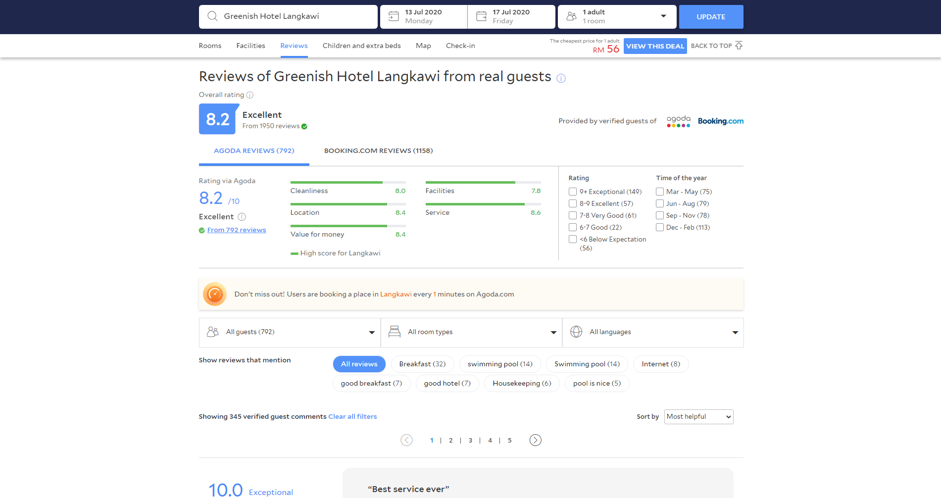

Figure 2‑16. Review tab is selected (Agoda, 2020)

Figure 2-16 shows the review section of the selected hotel. The review section will show the user the overall rating of the hotel. Ratings in different aspect are also displayed in this section. Those aspect had included cleanliness, facilities, location, service and value for money. Below the overall rating, user rating is shown with varies of filters and sorting.

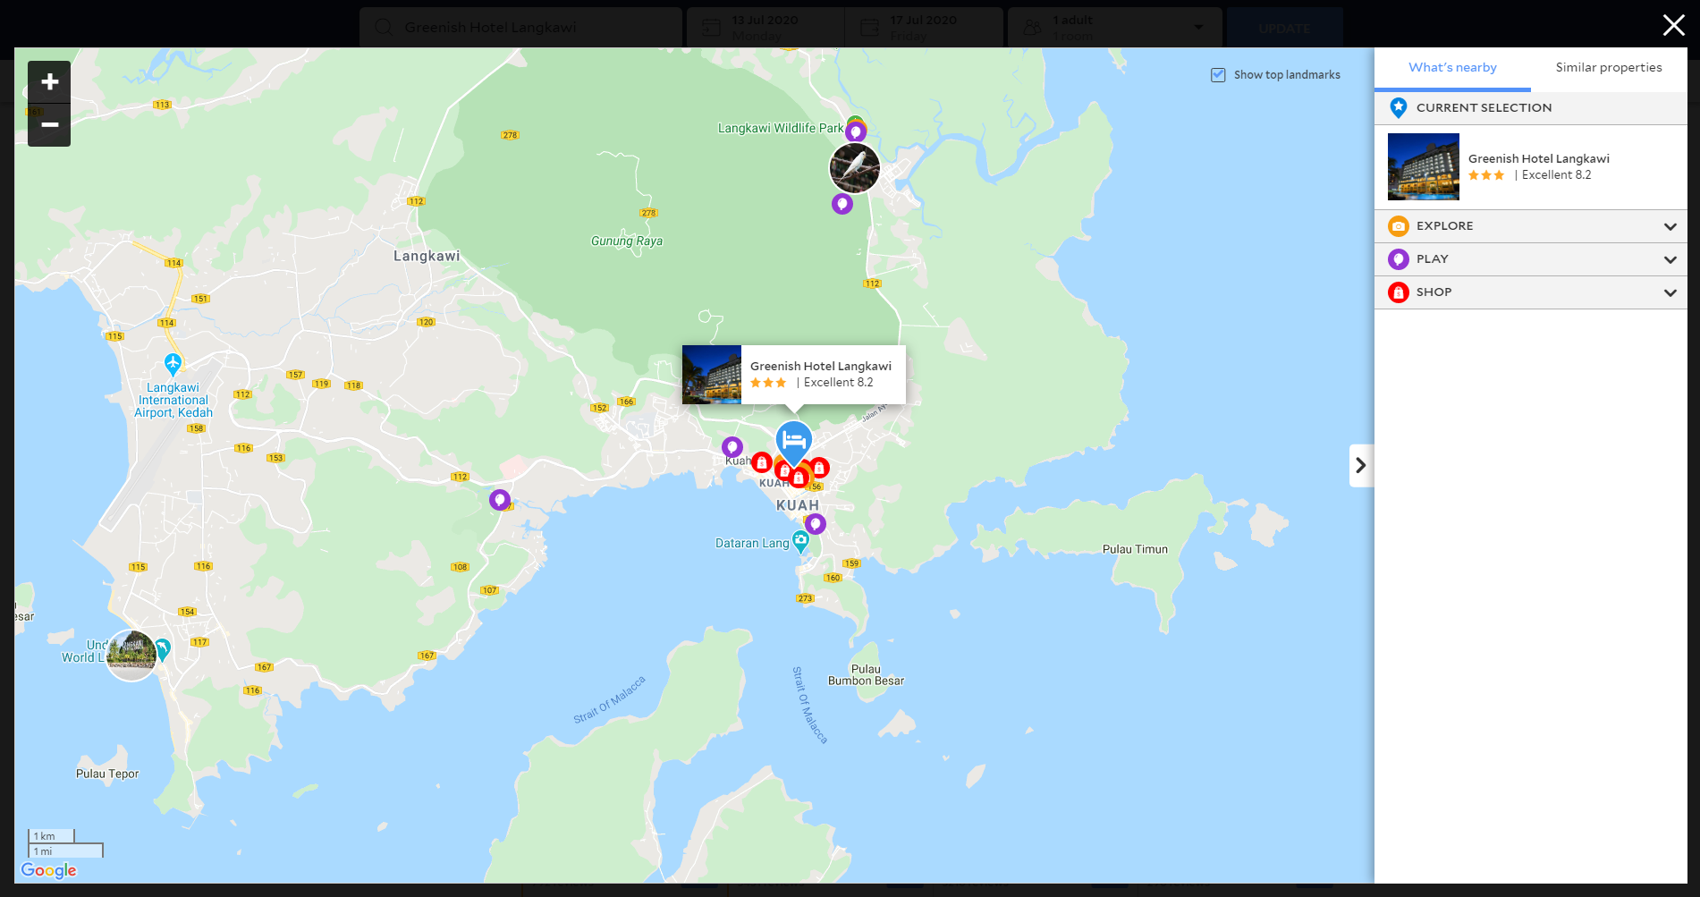

Figure 2‑17. Map tab is selected (Agoda, 2020)

Figure 2-17 shows the location of the hotel on the map. When the map tab is selected, a pop up will show up and the location of the hotel will show on the map.

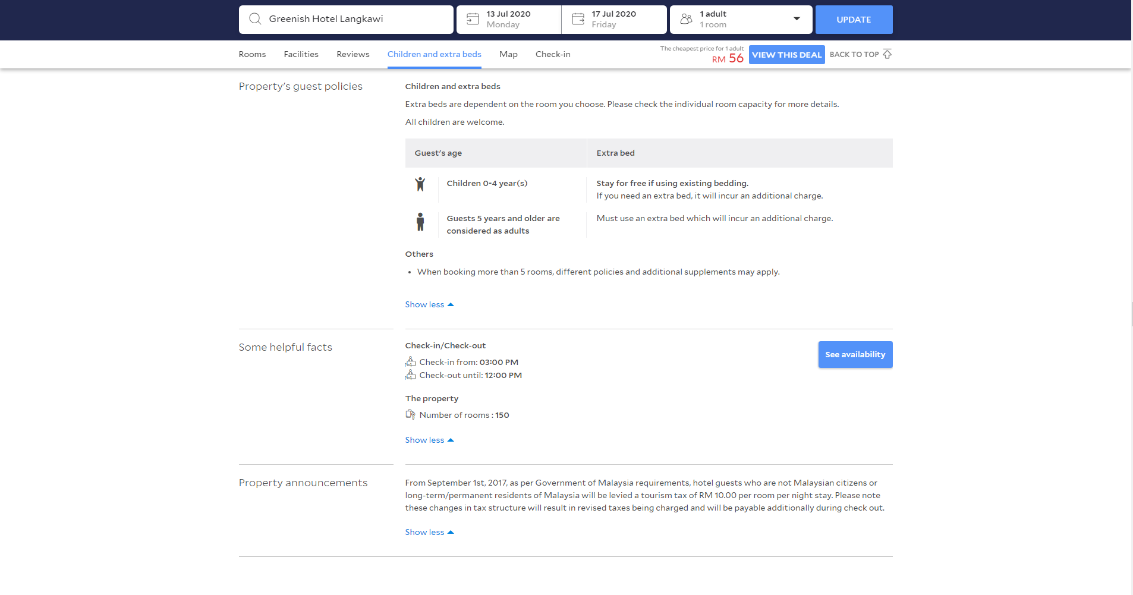

Figure 2‑18. Children and extra beds tab is selected (Agoda, 2020)

Figure 2-18 shows the policy of the particular hotel and the check in and check out time. In addition, this section will also show the total number of rooms in that particular hotel.

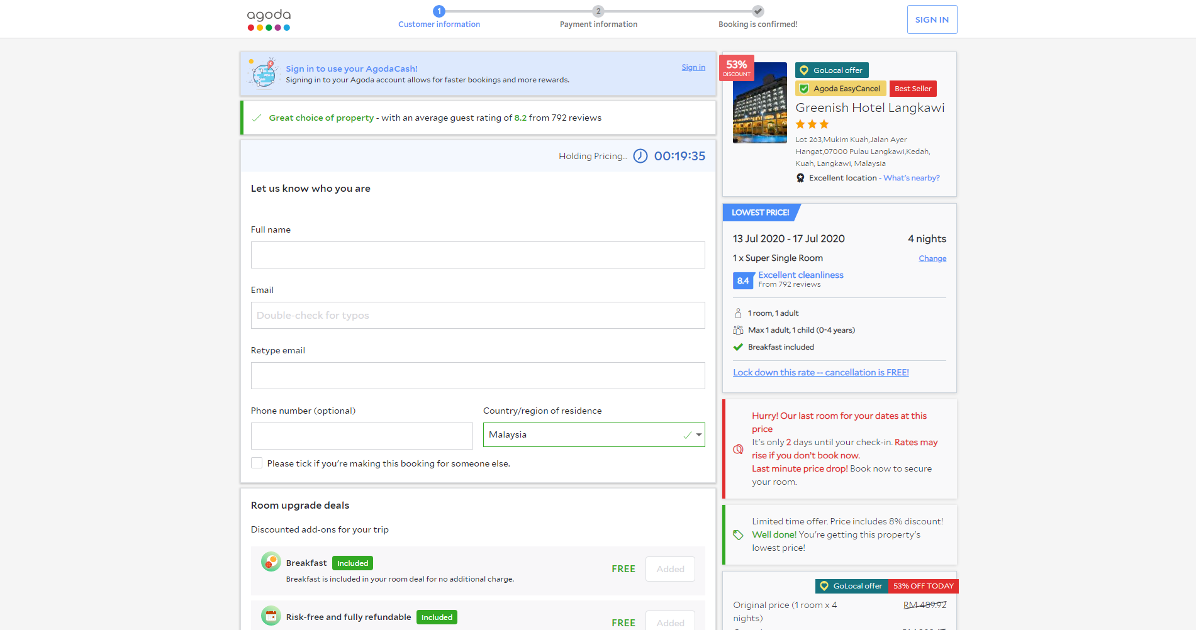

Figure 2‑19. Booking page of selected room (Agoda, 2020)

Figure 2-19 shows the booking page of agoda.com. When the reserve button is clicked on selected room, the website will redirect the user to the booking page. In this page, the selected room pricing will lock for 20 minutes for the user to complete the purchase. Information of the user is required to proceed to next step of the booking process.

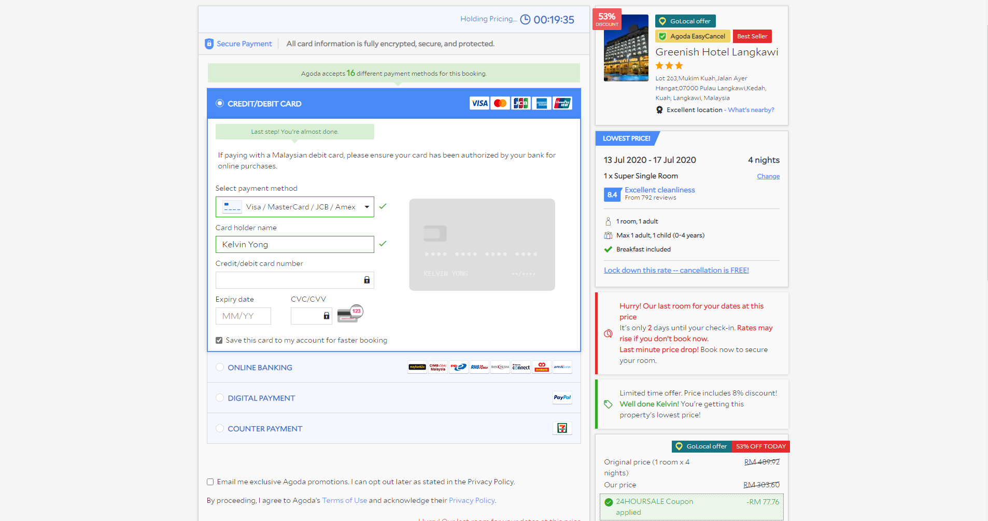

Figure 2‑20. Payment page (Agoda, 2020)

Figure 2-20 shows the payment page of agoda.com. Several payment method are provided for the user. Method such as credit or debit card, online banking, digital payment and counter payment.

Table 2‑2. Advantages and disadvantages of agoda.com

|  |  |  |
| --- | --- | --- |
|  | Advantages | Disadvantages |
| 1 | Colourful and user-friendly UI design | Messy search result page |
| 2 | Provide promo codes | Information is too packed in search result page |
| 3 | Didn’t show the type of premise | Have no information of COVID-19 displayed |
| 4 | Have the feature to view the hotel location on map | Displaying advertisement |
| 5 | Have price comparisons | Didn’t show the type of premise |
| 6 | Show amenities and facilities |  |
| 7 | Show nearby attractions |  |
| 8 | Have to feature to either reserve or book immediately |  |
| 9 | Allow users to register their places on the website |  |

### 2.1.3 Airbnb

Airbnb is an accommodation reservation website that primarily for homestays or tourism experience. The company itself did not own any property that are listed on the website, they only receive commissions from every arrangement that they have made. Upon entering the website, users will have to enter information such as location, date and number of person in order to search for accommodations. The homepage also allows users to sign up or log in to their account.

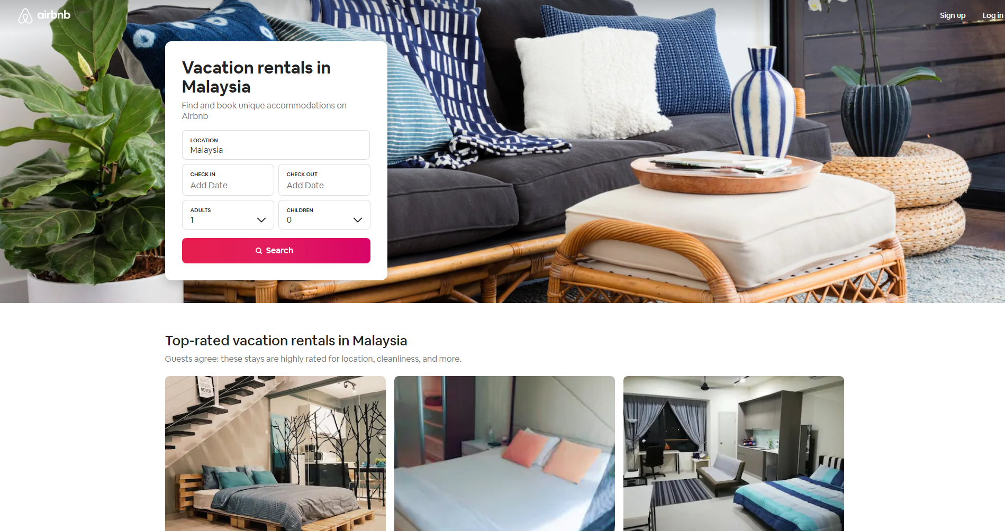

Figure 2‑21. Homepage of airbnb.com (Airbnb, 2020)

Figure 2-21 shows the homepage of Airbnb.com. Users will be able to login, sign up or search for stays by entering information such as location, date and number of people.

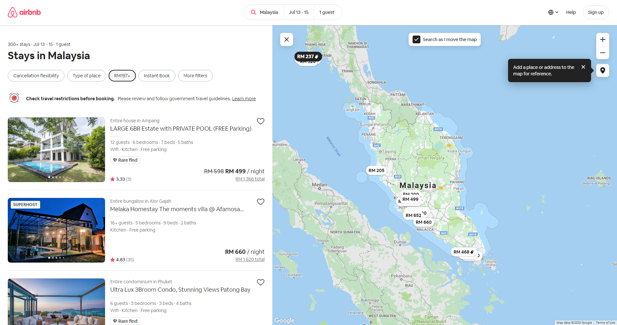

Figure 2‑22. Search result page (Airbnb, 2020)

Figure 2-22 shows the search results page. Users will able to view varieties of stays in that location. In addition, selected stays will also being highlighted in the map which located on the right side of the page. Furthermore, the map also included a feature where it will search for more stays as the user move the map.

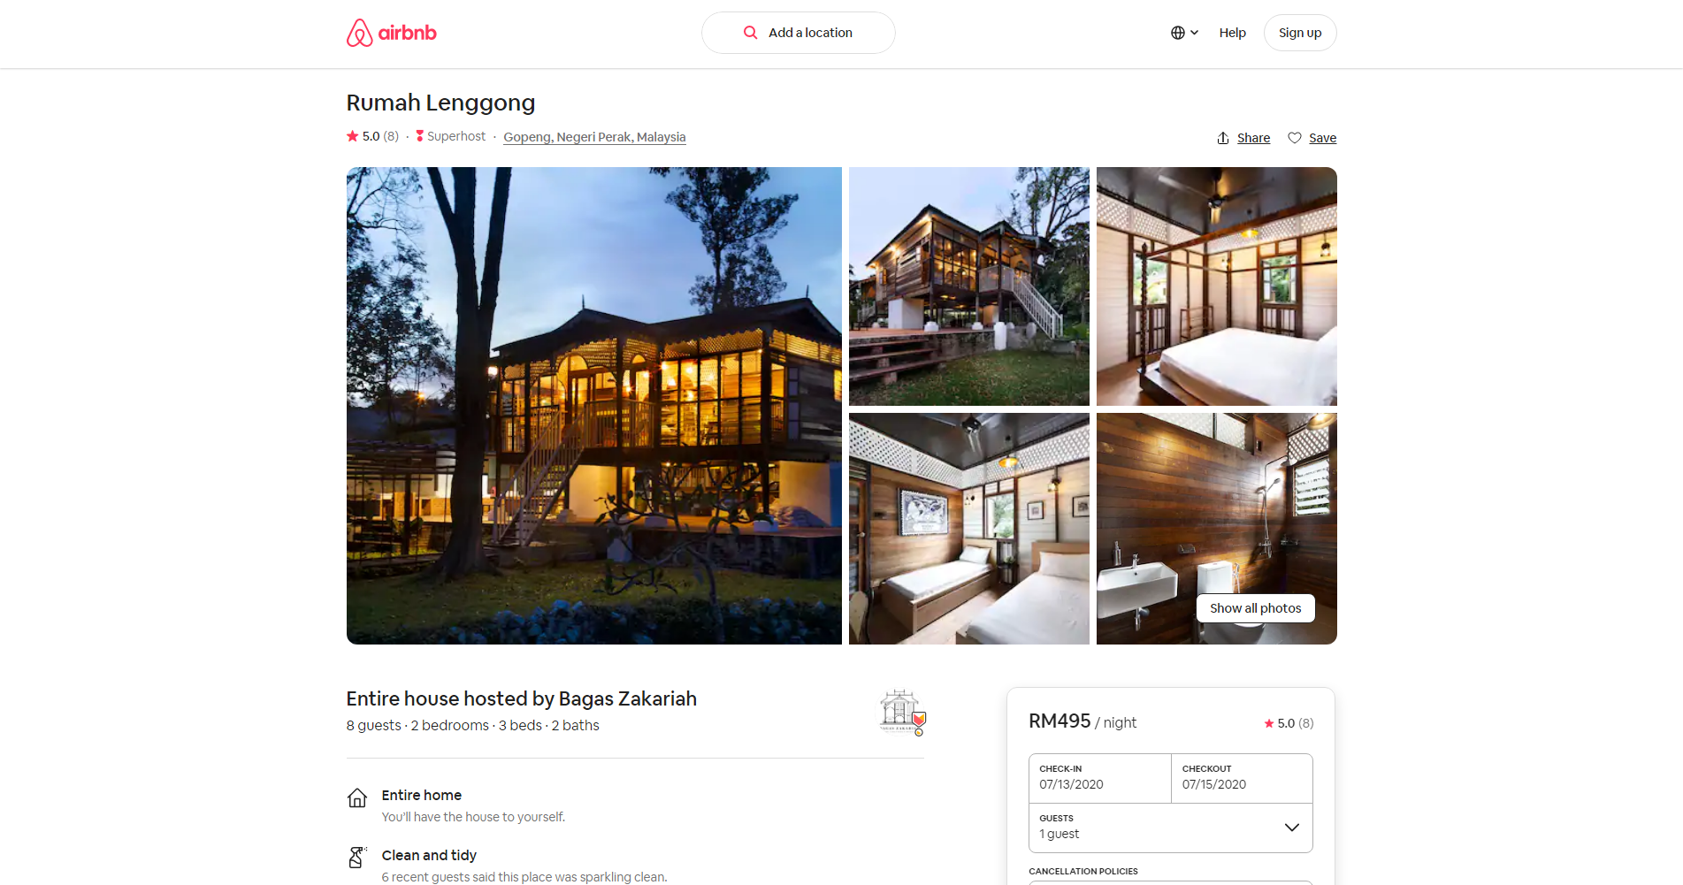

Figure 2‑23. Selected stays (Airbnb, 2020)

Figure 2-23 shows the stays that user had selected. Users will be able to view the photos of the stays.

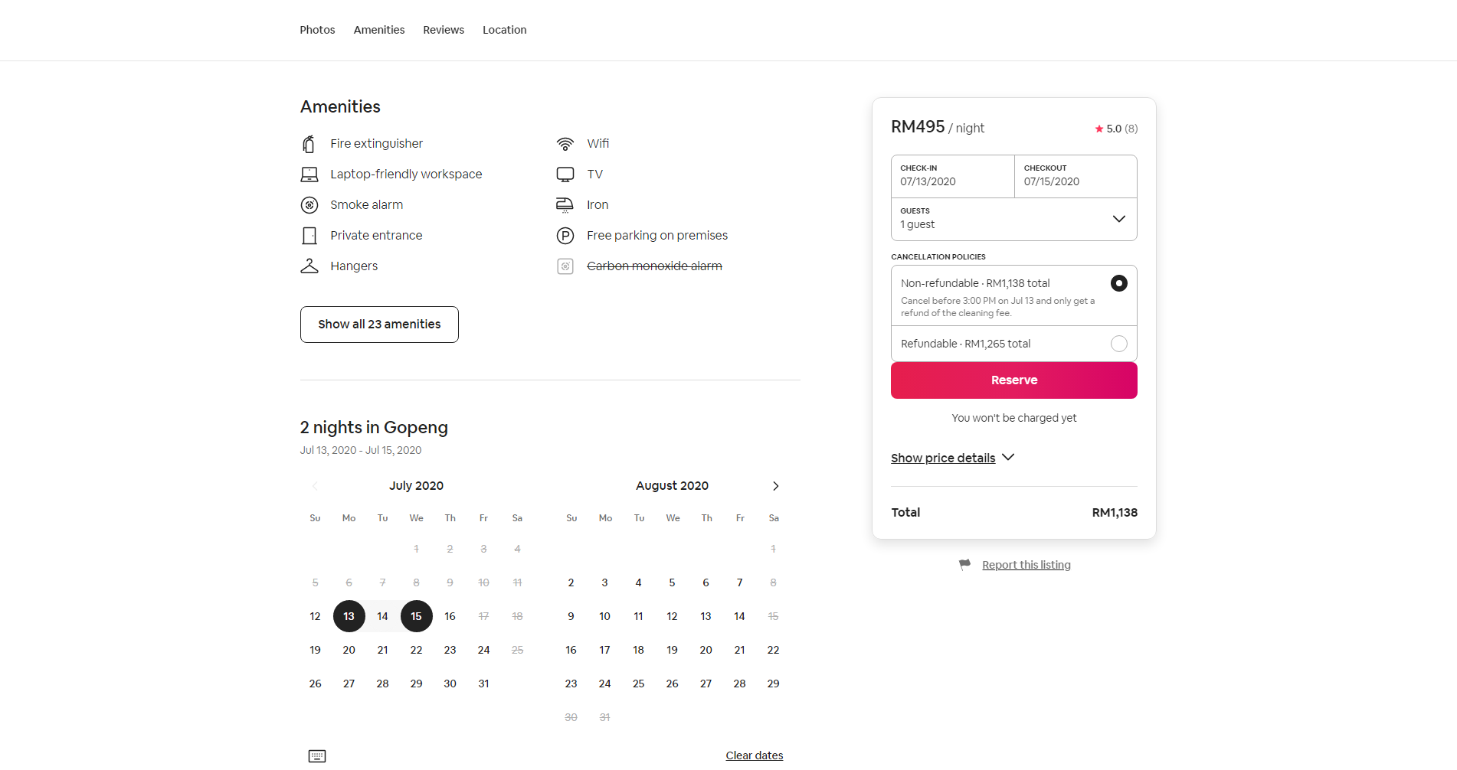

Figure 2‑24. Amenities tab is selected (Airbnb, 2020)

Figure 2-24 shows the amenities tab is selected. The website will move down to the section that shows the amenities. User will also have to option to view all amenities.

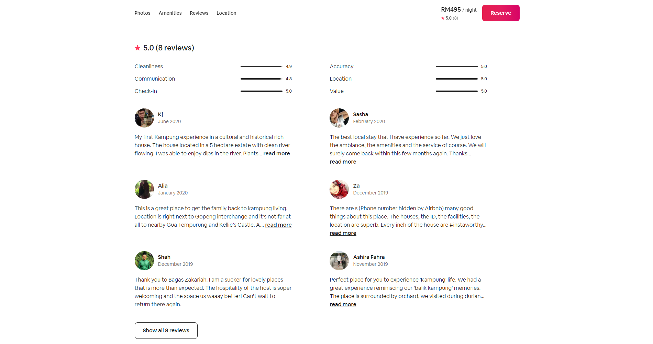

Figure 2‑25. Review tab is selected (Airbnb, 2020)

Figure 2-25 shows the review tab is selected. The website will move down to the review section where all the user comment and review are shown. It also shows rating in different aspect.

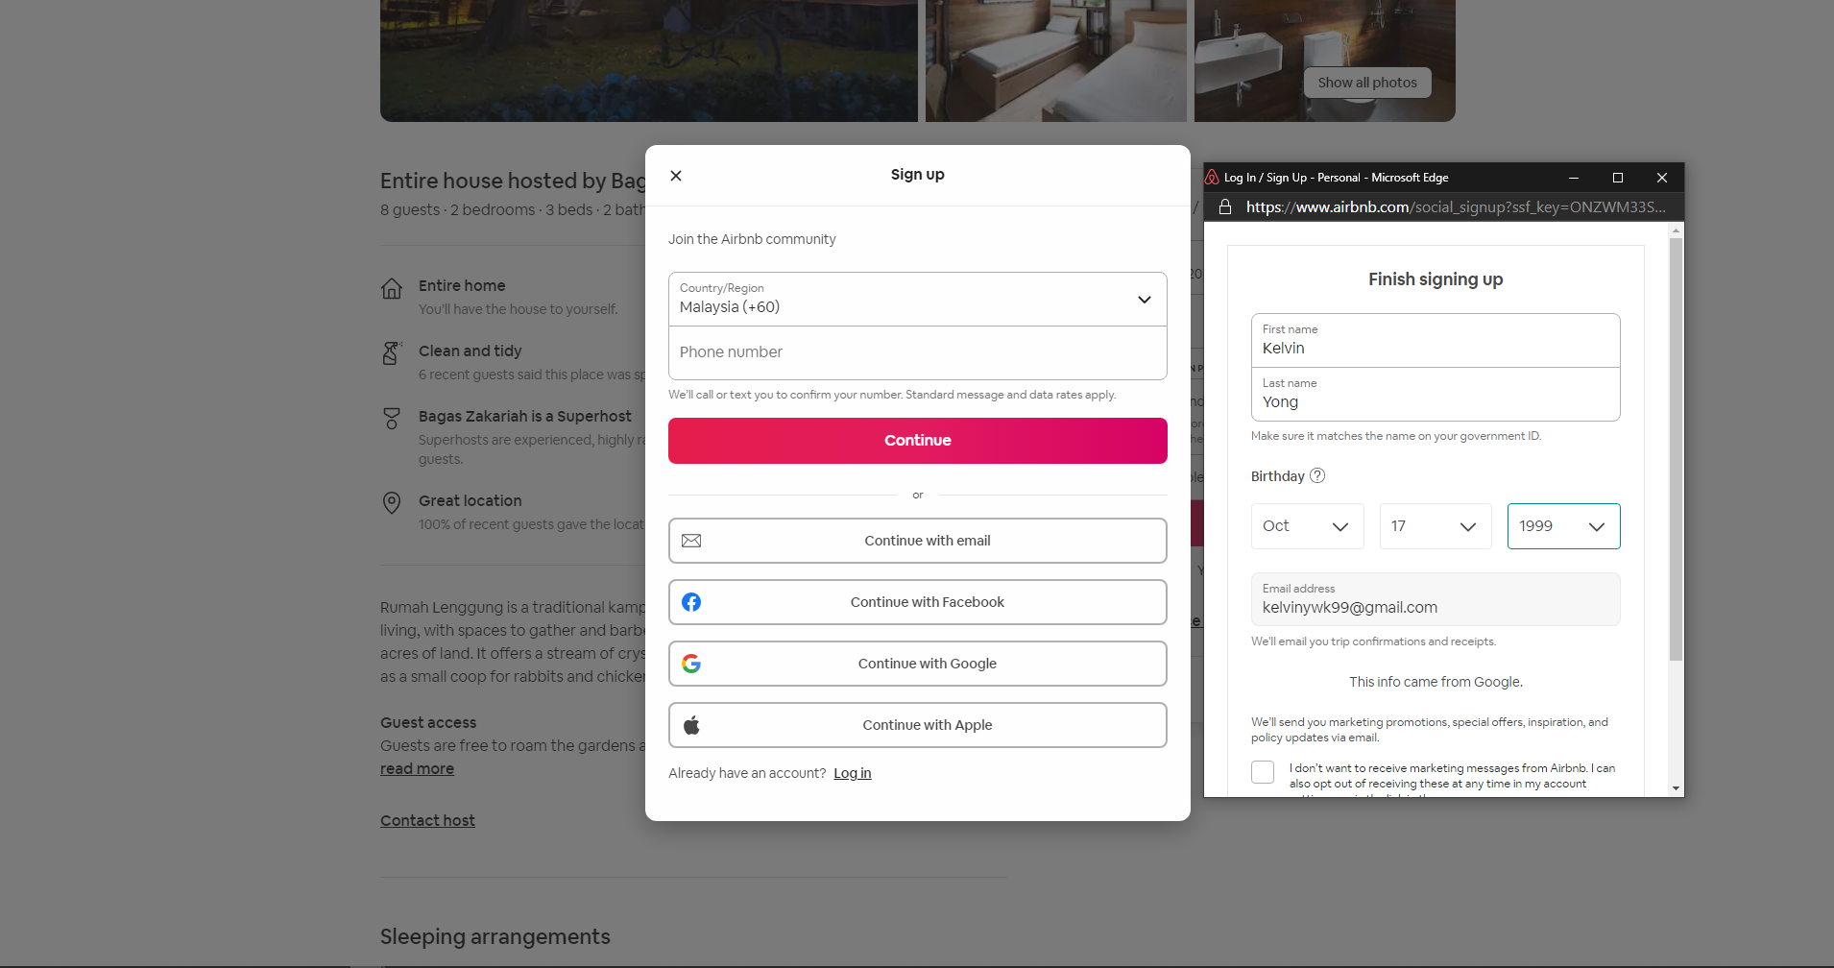

Figure 2‑26. Reserve button is clicked (Airbnb, 2020)

Figure 2-26 shows that an account is required to make reservation. Hence, the user must sign in or register to proceed.

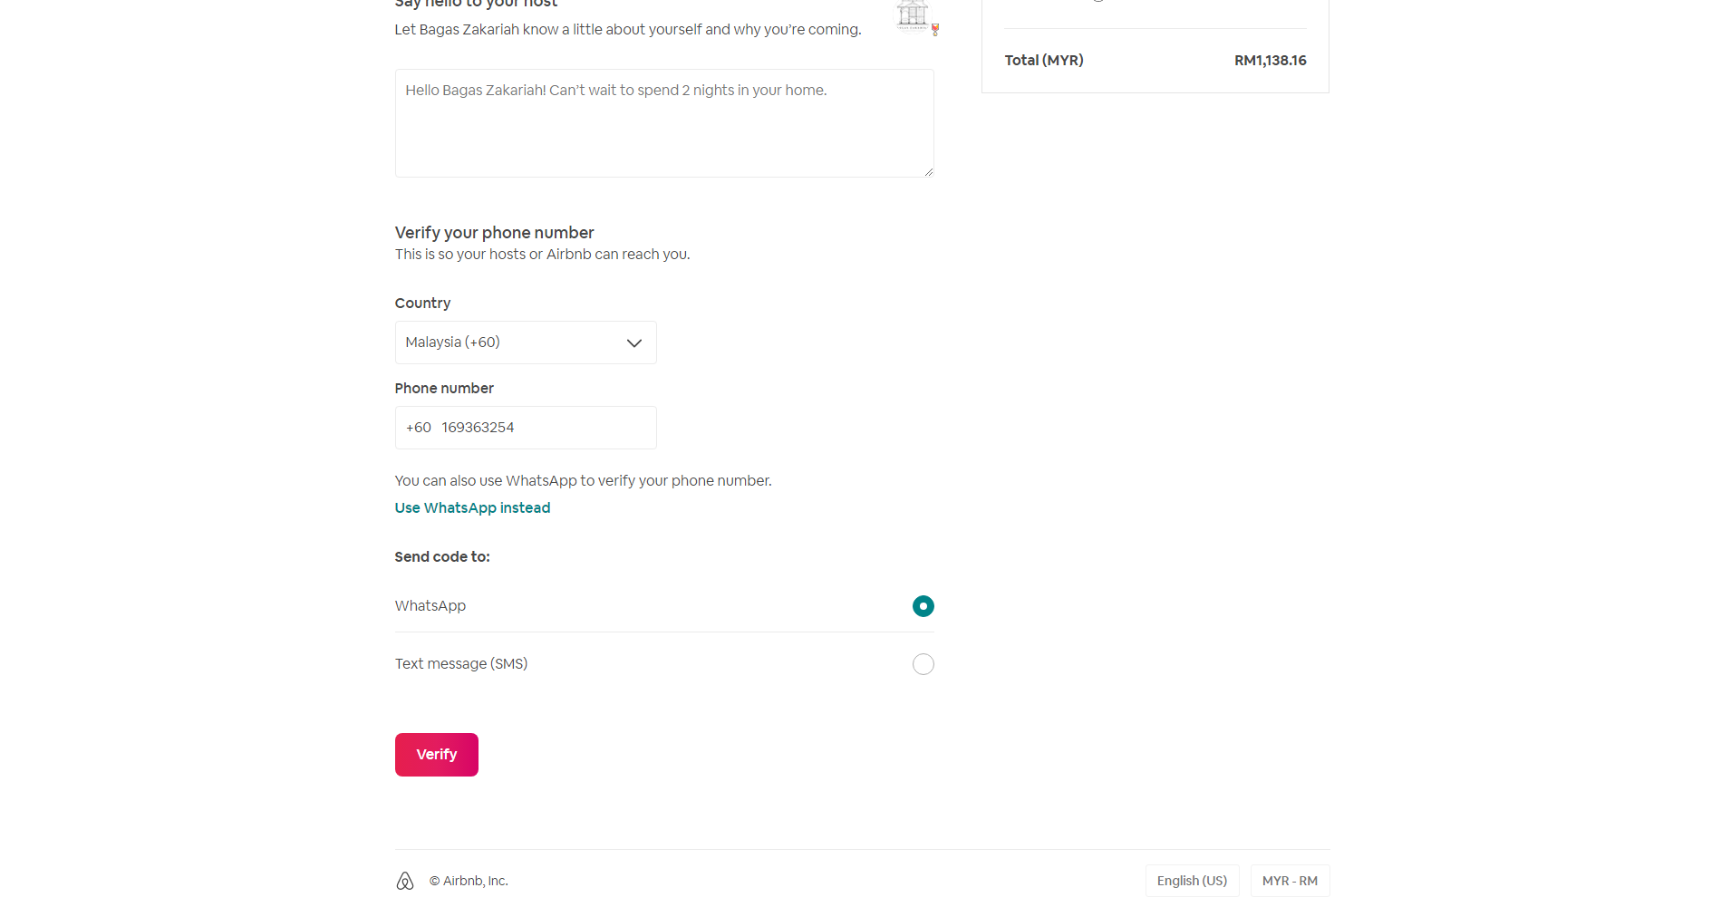

Figure 2‑27. Verification of mobile number is required for reservation (Airbnb, 2020)

Figure 2-27 shows that verification of mobile number is a must to proceed to reservation. Two ways of verification had included which is through WhatsApp or text messages.

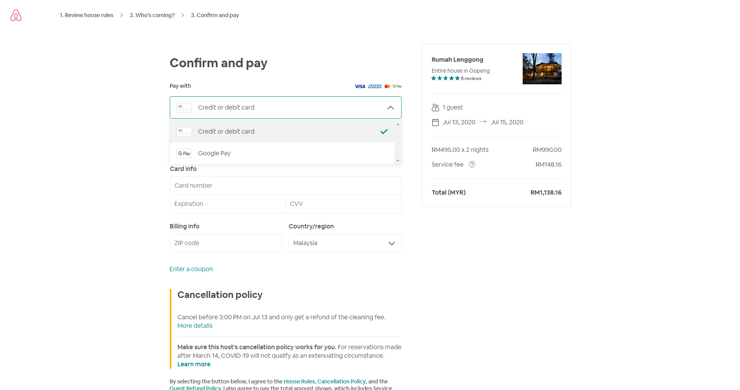

Figure 2‑28. Payment page (Airbnb, 2020)

Figure 2-28 shows that airbnb.com only accept two methods of payment which is by google pay and credit or debit card.

Table 2‑3. Advantages and disadvantages of Airbnb.com

|  |  |  |
| --- | --- | --- |
|  | Advantages | Disadvantages |
| 1 | Simple UI design | Didn’t show nearby attractions |
| 2 | Have variety of filters on searching | Didn’t have information on COVID-19 |
| 3 | Shows the location of the stays on map |  |
| 4 | Search alongside the map |  |

### 2.1.4 Comparisons between existing system and proposed system

Table 2‑4. Comparisons between proposed system and existing system

|  |  |  |  |  |
| --- | --- | --- | --- | --- |
| **Features** | **Trivago** | **Agoda** | **Airbnb** | **Proposed System** |
| Account registration | Y | Y | Y | Y |
| Sort search result | Y | Y | Y | Y |
| Filter search result | Y | Y | Y | Y |
| Show ratings | Y | Y | Y | Y |
| Show photos | Y | Y | Y | Y |
| Show reviews | Y | Y | Y | Y |
| Show amenities and facilities | Y | Y | Y | Y |
| Currency selection | Y | Y | Y | Y |
| Promo codes |  | Y |  | Y |
| Show nearby attractions |  | Y |  | Y |
| Reminder through email |  | Y |  | Y |
| Personality matching |  |  |  | Y |
| Displaying COVID-19 info |  |  |  | Y |

Table 2-4 shows the comparisons between existing system and proposed system. Features such as account registration, sort search result, filter search result, show ratings, show photos, show reviews, show amenities and facilities and currency selection are able to perform by all system while promo codes, show nearby attractions, reminder through email are able to perform by agoda and proposed system and lastly personality matching are able to perform by proposed system.

## 2.2 Programming Language for Building Hotel Reservation Website

1. Client Side

Hypertext Markup Language (HTML), Cascading Style Sheets (CSS) and JavaScript will be used to implement the proposed system. HTML will be used to design and build the website, CSS will be used to define the styles of the HTML document and JavaScript will be used to control the behavior of the website (INTERNETING IS HARD, 2020).

1. Server Side

Hypertext Preprocessor as known as PHP will be used to implement the server side of the proposed project. PHP will be a required scripting language for making a dynamic website. PHP is a widely-used open source general-purpose scripting language that can be embedded into HTML (w3schools, 2020).

1. Database

Structured Query Language (SQL) will be used to implement the database of the proposed system. SQL is a standard query language to access to databases. Open source database management system such as MySQL will be very good software to help in implementing the database.

## 2.3 Web Server and Database Server for Hotel Reservation Website

XAMPP will be a web server solution for proposed project. XAMPP is a free and open source web server solution stack package that are developed by Apache Friends. XAMPP consist mainly of the Apache HTTP server, MariaDB database and interpreters for script that are written in PHP and pearl programming language (Wikipedia, 2020). The advantages of having XAMPP to implement this project is that we do not need to install a separate database server and a web server. By installing XAMPP, it will include the database and web server which is sufficient for this project. Moreover, we do not need to find and purchase hosting server which are very pricey.

# Chapter 3: REQUIREMENTS

## 3.1 Software Development Methodology

The iterative waterfall model is one of the software development methodology that are widely been used in these days. Unlike the classical waterfall model, iterative waterfall model had made some changes from the classical waterfall model to increase the efficiency of the methodology. (Pal, 2018) stated that the iterative waterfall model provides feedback paths from every phase to its preceding phases, which is the main difference from the classical waterfall model. The main advantages of iterative waterfall model is that it allow us to check back the earlier stages whenever something had gone wrong in the later stages. This will help in risk reduction and will also able to increase the software quality. The iterative waterfall model consist of six stages, which is feasibility study, requirement analysis and specification, design, coding and unit testing, integrating and system testing and maintenance. Figure 3-1. shows the iterative waterfall model.

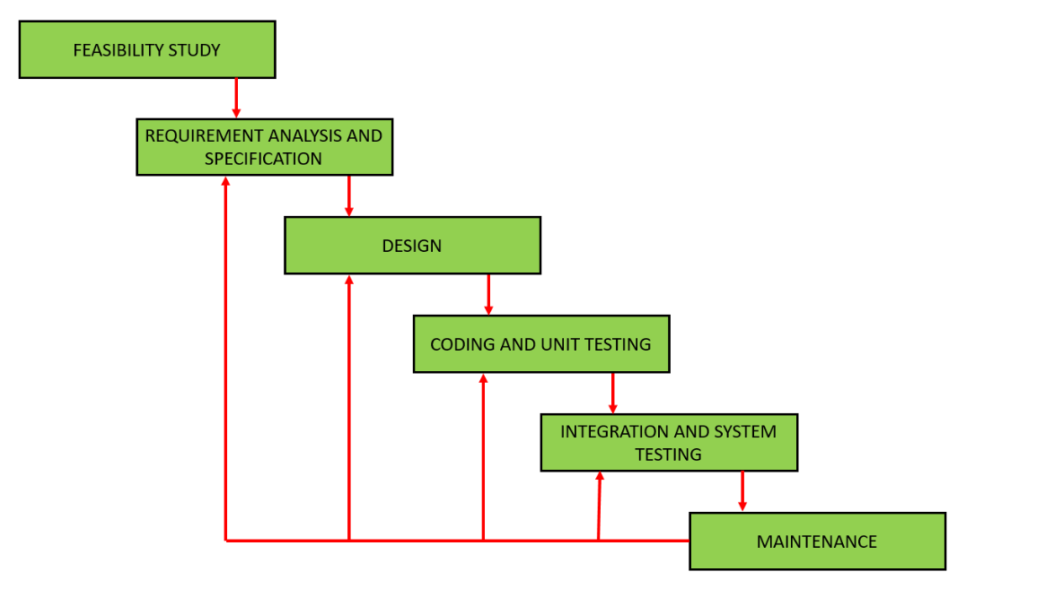

Figure 3‑1. Iterative waterfall model (Pal, 2018)

1. Feasibility Study

In the feasibility study phase, the understanding of the project title and determining several of approach to implement it are carried out. Additionally, the project schedule is created in a form of Gantt chart in order to keep track of the overall progress.

1. Requirements analysis and specification

In the requirements analysis and specification phase, the user survey is send out to identify and gather requirements as well as understand the user needs fort the system.

1. Design

In the design phase, the requirement that are gathered will be analysed and convert into representative diagram. Those diagram includes use case diagram, context diagram, data flow diagram level 0, entity-relationship diagram and deployment diagram.

1. Coding and unit testing

In the coding and unit testing phase, the design of the software is translated into source code in suitable programming language. Then each of the module is tested in order to ensure its functionality

1. Integrating and system testing

In the integrating and system testing phase, three kind of testing is carried out to ensure that the system is working well and bug free. Those three testing includes alpha testing, beta testing and user acceptance testing.

1. Maintenance

In the maintenance phase, three types of maintenance is carried out which is corrective maintenance, perfective maintenance and adaptive maintenance. Corrective maintenance is to correct out errors that are found in the system. Perfective maintenance is to further enhance the system by adding more functions. Adaptive maintenance is carried when the system required a new environment.

## 3.2 Market Survey

The main purpose of the survey is to identify the user’s issues and preferences. This survey is important for the development of the project as it helps in understanding the users. The survey consist of ten question as shown in Figure 3-2, Figure 3-3, Figure 3-4, Figure 3-5 and Figure 3-6. In Figure 3-2, the questionnaire is aimed to identify the users group. In Figure 3-3, the questions are aimed to identify the user’s experience of using any hotel reservation website. In Figure 3-4 and Figure 3-5, the questions is to identify the user’s preference. In Figure 3-6, the question is aimed to identify the user’s opinion on hotel reservation websites. The survey involved 75 people of all ages and genders. The survey is done through Google Form.

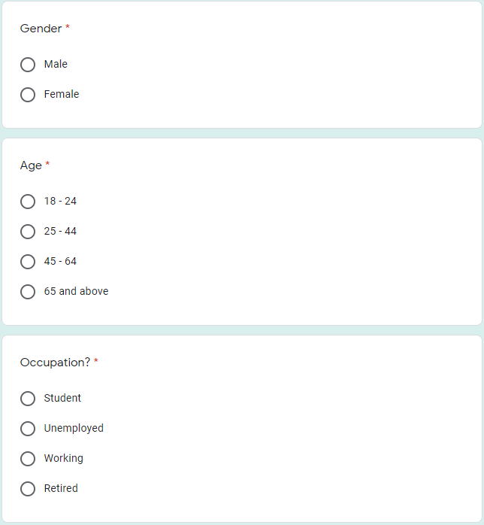

Figure 3‑2. Questions one, two and three of the survey

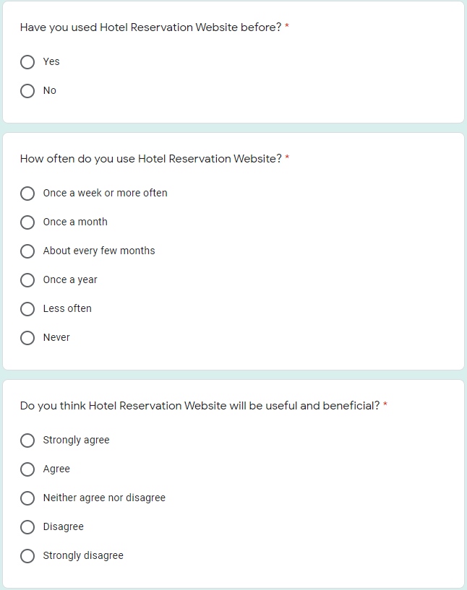

Figure 3‑3. Questions four, five and six of the survey

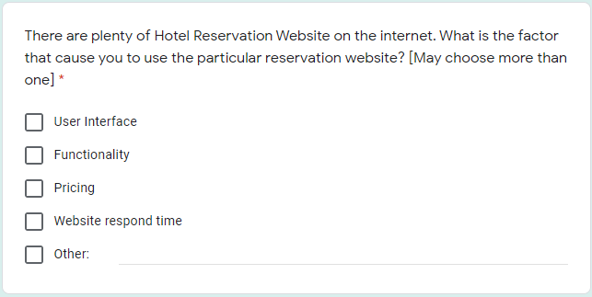

Figure 3‑4. Question seven of the of the survey

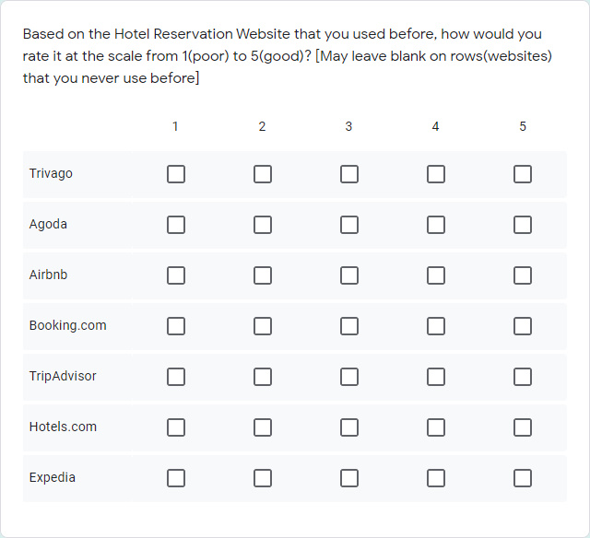

Figure 3‑5. Question eight of the survey

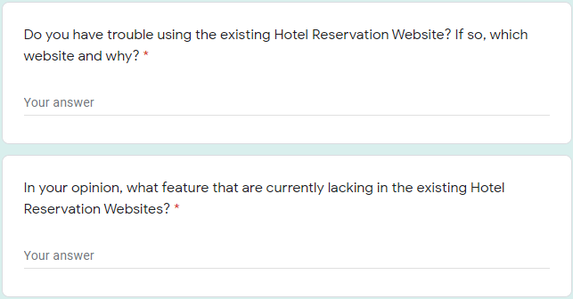

Figure 3‑6. Questions nine and ten of the survey

### 3.2.1 Survey Analysis

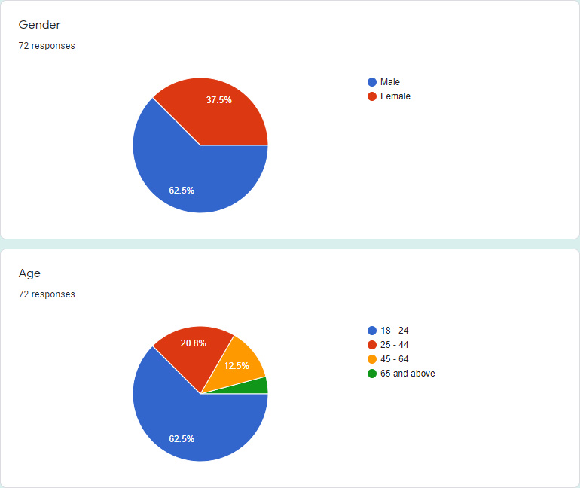

Figure 3‑7. Gender and age of respondents

The result in Figure 3-7 shows that the survey was participated by 62.5% male and 37.5% female. The age group of these participants are as follow: 62.5% for 18 to 24 years old, 20.8% for 25 to 44 years old, 12.5% for 45 to 64 years old and 4.2% for 65 years old and above.

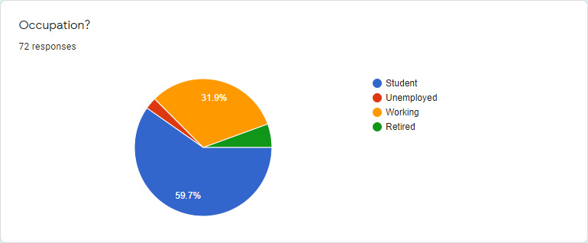

Figure 3‑8. Occupation of the participants

The result in Figure 3-8 shows the Occupation of the participants. The survey was taken part by 59.7% of students, 31.9% of participants who are currently working, 2.8% of participants are currently unemployed and 5.6% are retired.

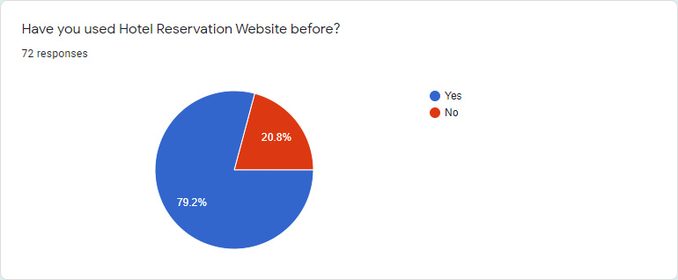

Figure 3‑9. “Have you used Hotel Reservation Website before?”

Figure 3-9 shows that 79.2% of participants have used Hotel Reservation Website before while only 20.8% of them have no experience of using the Hotel Reservation Website. As a conclusion, majority of the participants prefer to use Hotel Reservation Website than other booking and reserve method.

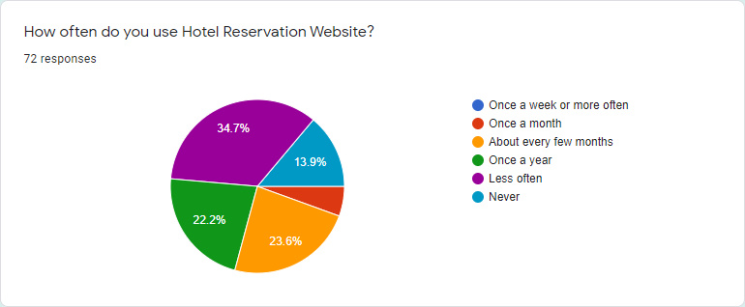

Figure 3‑10. “How often does the participants use Hotel Reservation Website”

Figure 3-10 shows the frequency of the participants uses Hotel Reservation Website. 34.7 % of them does not use the Hotel Reservation Website that often, 22.2% of them only use the website once a year, 23.6% of them uses the website about every few months, 5.6% of them uses the website once a month and 13.9% of them never used before.

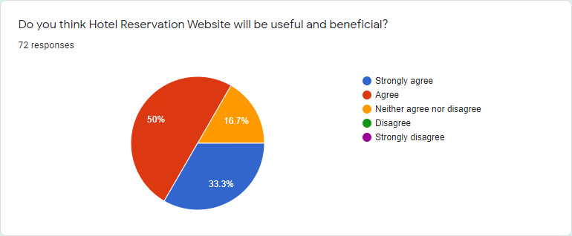

Figure 3‑11. “Do you think Hotel Reservation Website will be useful and beneficial?”

Figure 3-11 shows that 33.3% of the participants strongly agree that Hotel Reservation Website is useful and beneficial while 50% of them agree and 16.7% of them neither agree nor disagree.

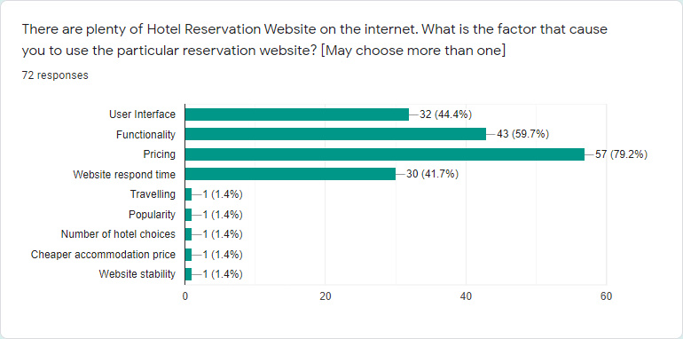

Figure 3‑12. Factor that cause the participants to use a particular website

Figure 3-12 shows the factor that cause the participants to use a particular Hotel Reservation Website. As shown in Figure 3-12, pricing is considered one of the highest rated factor that cause the participants to use a particular website whereby it has 80.6% voting from the participants. Secondly, functionality is also considered as an important factor. It has 59.7% of voting from the participants. Moreover, website respond time and user interface is also considered essential factors to the participants. They have 41.7% and 44.4% of voting respectively. Besides that, others factors that are also considered are the website popularity, content choices, stability and travelling. All of them weight 1.4% respectively out of 100%.

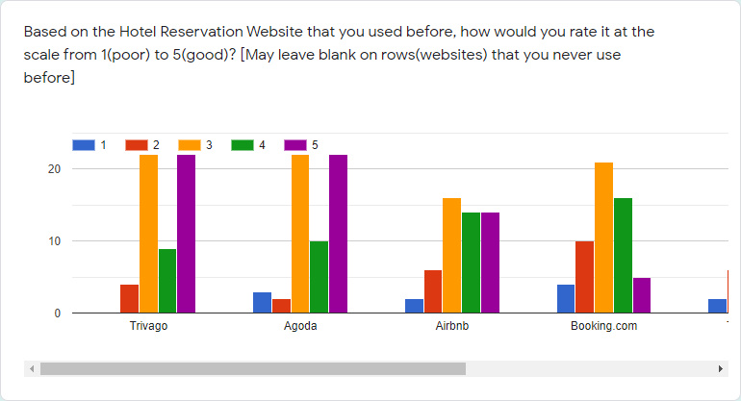

Figure 3‑13. Existing system rating part one

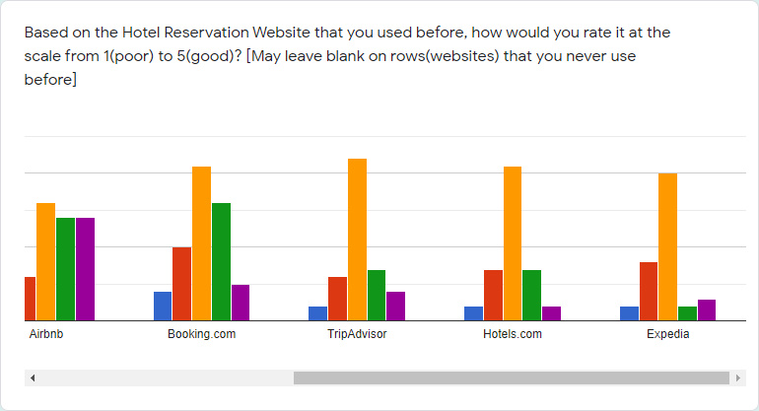

Figure 3‑14. Existing system rating part two

Figure 3-13 and Figure 3-14 shows the rating of existing system by the participants. The results are 220 rating score for Trivago, 223 rating score Agoda, 188 rating score for Airbnb, 176 rating score for Booking.com, 128 rating score for TripAdvisor, 117 rating score for Hotels.com and 101 rating score for Expedia. As a conclusion, Agoda are the most favourite website for these participants.

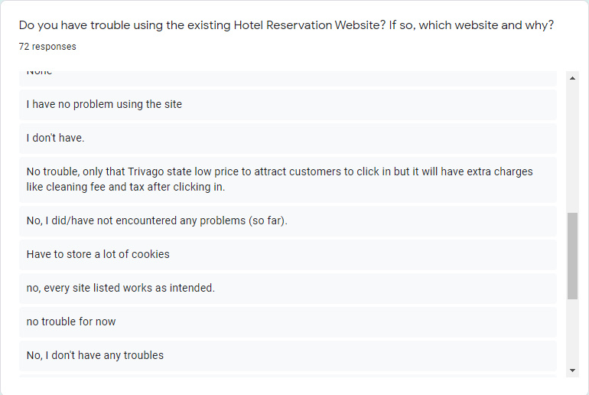

Figure 3‑15. Partial result of the question “Do you have trouble using the existing Hotel Reservation Websites? If so, which website and why?”

Figure 3-15 shows the partial results of the question on trouble of participants using existing system. As a summary, majority or the participants have no problem or issues when using the website. But there are a few participants who are facing some problems when using the website. These problems are as follow: not able to perform booking cancellation, bad user interface on Booking.com, extra charges did not stated clearly on Trivago, could not make a payment on Booking.com, the information shown on website did not synchronize with the actual hotel and the website had to store a lot of cookies.

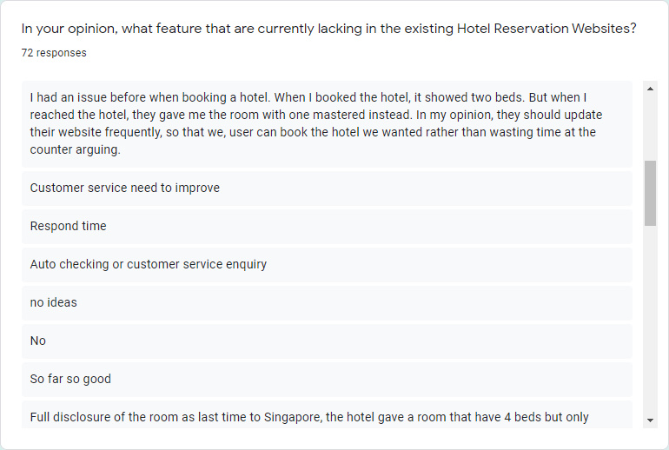

Figure 3‑16. Partial result of participant’s opinion on feature lacking in existing Hotel Reservation Websites

Figure 3-16 shows the partial result of the opinion on lacking feature in existing systems. As a conclusion, feature that are lacking in the existing system that responded by the participants are as follow: a Virtual Reality view of the room, clearly state the amenities on the website, improvement on customer service, QR code to check in to hotel, frequent update of the website information, having promotions or points that can be exchanged with something, having the room to preview like cinema seating to allow the users to have knowledge on the location of the room in the hotel, showing activity that can be done in the specific area of the hotel, good first impression, easy search option, chatbot for the website, website respond time, price comparisons and better user interface.

## 3.3 System Minimum Requirements

* OS: Windows 7/8/10 either 32-bit or 64-bit
* CPU: Intel I3-2100 or AMD A10-9600P or equivalent or better
* RAM: 2GB RAM and up
* Screen Resolution: 1280x720 or higher
* Internet Browser: Google Chrome, Microsoft Edge
* Input Device: Mouse and Keyboard
* Displaying Device: Generic PnP Monitor

## 3.4 Use Case Diagram

### 3.4.1 User Module

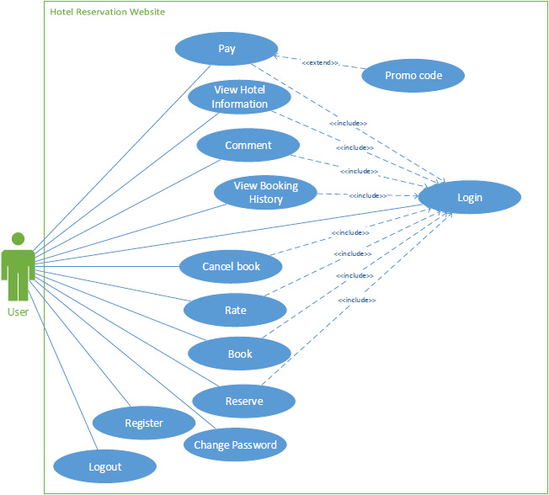

Figure 3-17. Use case diagram for User module

Figure 3-17 shows the UML use case diagram for the Hotel Reservation Website for user entity. As shown in the diagram, the user will be able to perform pay, view hotel information, register, change password, comment, view booking history, rate, book, reserve, logout and login. For pay function, the user will have the extra choice to choose whether the use want to use the promo code. Moreover, all the function above will require the user to login first except the change password and register function.

### 3.4.2 Hotelier Module

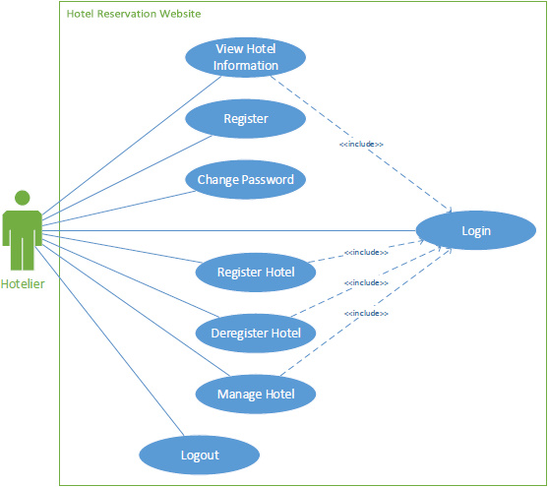

Figure 3-18. Use case Diagram for Hotelier module

Figure 3-18 shows the UML use case diagram for the Hotel Reservation Website for hotelier entity. As shown in the diagram, the hotelier will be able to perform view hotel information, register, change password, register hotel, deregister hotel, manage hotel logout and login. All the function above will require the hotelier to login in first except register and change password function.

### 3.4.3 Admin Module

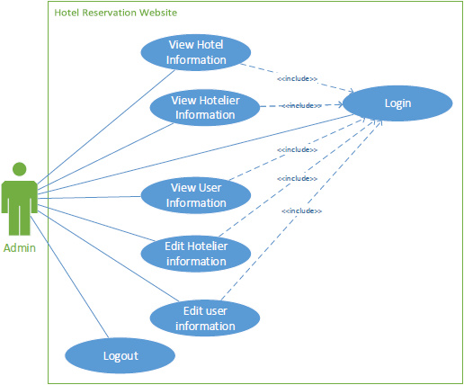

Figure 3-19. Use case diagram for Admin module

Figure 3-19 shows the use case diagram for the Hotel Reservation Website for Admin entity. As shown in the diagram, the admin will be able to perform view hotel information, view hotelier information, view user information, login and logout. All the function will require the admin to login first.

## 3.5 Data Flow Diagram

### 3.5.1 Context Diagram

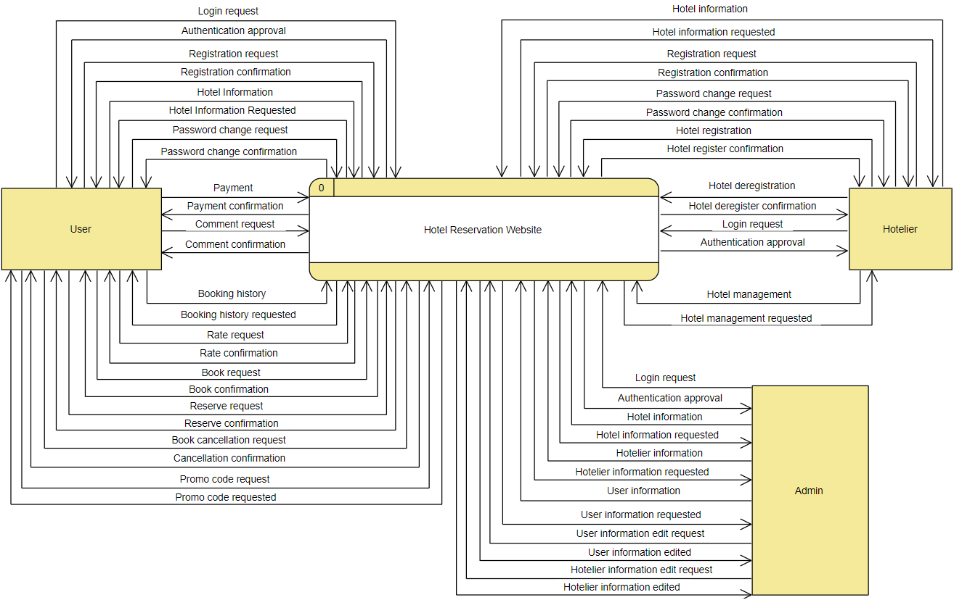

Figure 3-20. Context diagram for Hotel Reservation Website

Figure 3-20 shows the context diagram for the Hotel Reservation Website. The details of the diagram will be explained below:

1. The system receives data from the user are: login request, register request, hotel information, password change request, payment, comment request, booking history, rate request, book request, reserve request, book cancellation request and promo code request.
2. The user receives data from the system are: authenticate approval, register confirmation, hotel information requested, password change confirmation, payment confirmation, comment confirmation, booking history requested, rate confirmation, book confirmation, reserve confirmation, cancellation confirmation, promo code requested.
3. The system receives data from the hotelier are: hotel information, register request, password change request, hotel registration, hotel deregistration, login request and hotel management.
4. The hotelier receives data from the system are: hotel information requested, register confirmation, password change confirmation, hotel register confirmation, hotel deregister confirmation, authenticate approval and hotel management requested.
5. The system receives data from the admin are: login request, hotel information, hotelier information, user information, user information edit request and hotelier information edit request.
6. The admin receives data from the system are: authenticate approval, hotel information requested, hotelier information requested, user information requested, user information edited and hotelier information edited.

### 3.5.2 Data Flow Diagram Level 0 for User

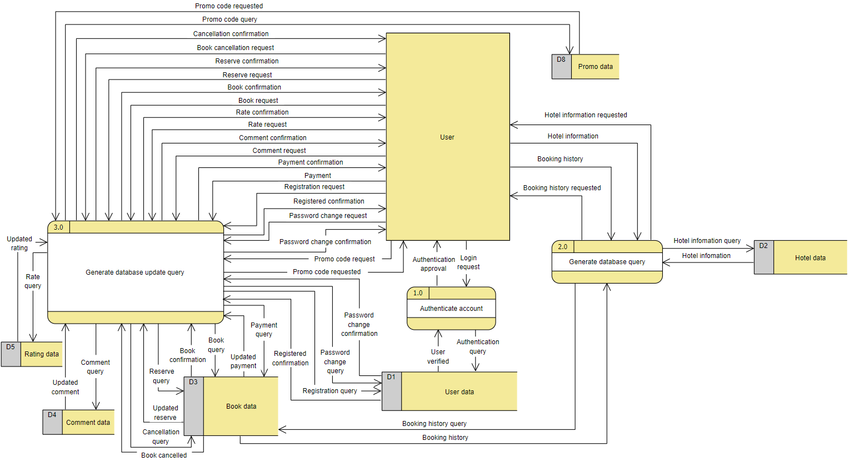

Figure 3-21. Data flow diagram level 0 for User

Figure 3-21 illustrates the data flow diagram level 0 for User.

1. Process 1.0 “Authenticate account”

The process “Authenticate account” receives login request from the “User”. The process then access the data store “User data” by authenticate query and retrieves data that are matching to the user for verification. Lastly, it will output the information “authenticate approval” to the user after the user is verified.

1. Process 2.0 “Generate database query”

The process “Generate database query” receives hotel information and booking history from the user. The process then access the data store “Hotel data” and “Book data” by hotel information query and booking history query respectively to retrieve necessary data and output to the user.

1. Process 3.0 “Generate database update query”

The process “Generate database update query” receives promo code request, password change request, register request, payment, comment request, rate request, book request, reserve request, and book cancellation request from the user. The process then access “Promo data”, “User data”, “Book data”, “Comment data”, “Rating data” by promo code query, password change query, register query, payment query, comment query, rate query, book query, reserve query and cancellation query to update necessary data and output comfirmation to the user.

### 3.5.3 Data Flow Diagram Level 0 for Hotelier

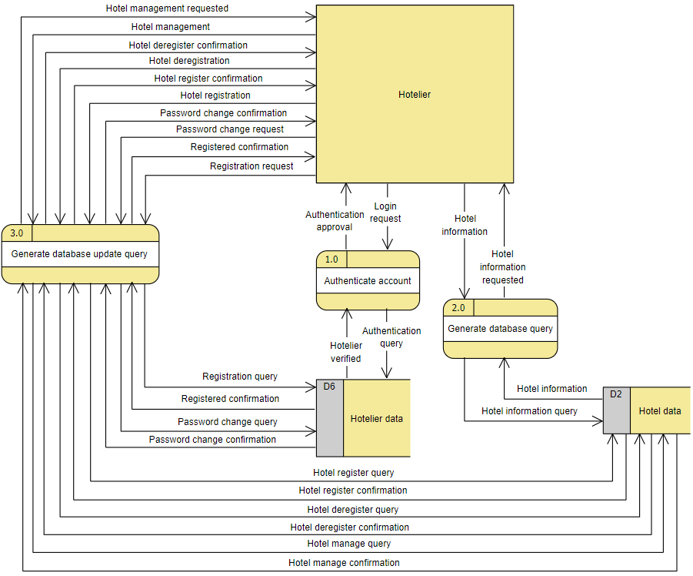

Figure 3-22. Data flow diagram level 0 for Hotelier

Figure 3-22 illustrates the data flow diagram level 0 for Hotelier.

1. Process 1.0 “Authenticate account”

The process “Authenticate account” receives login request from the “Hotelier”. The process then access the data store “Hotelier data” by authenticate query and retrieves data that are matching to the hotelier for verification. Lastly, it will output the information “authenticate approval” to the hotelier after the user is verified.

1. Process 2.0 “Generate database query”

The process “Generate database query” receives hotel information from the hotelier. The process then access the data store “Hotel data” by hotel information query to retrieve necessary data and output to the hotelier.

1. Process 3.0 “Generate database update query”

The process “Generate database update query” receives register request, password change request, hotel registration, hotel deregistration and hotel management form the hotelier. The process then access the data store, “Hotelier data” and “Hotel data” by register query, password change query, hotel register query, hotel deregister query and hotel manage query to update necessary data and output confirmation to the hotelier.

### 3.5.4 Data Flow Diagram Level 0 for Admin

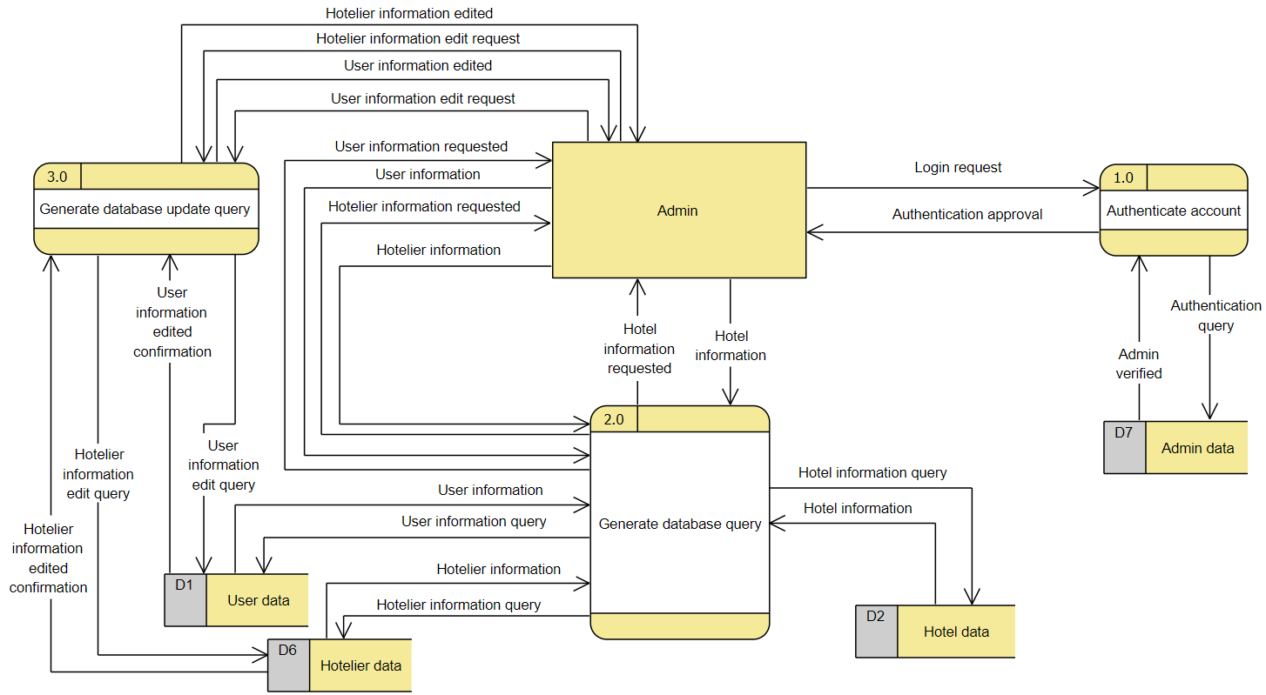

Figure 3-23. Data flow diagram level 0 for Admin

Figure 3-23 illustrates the data flow diagram level 0 for Admin.

1. Process 1.0 “Authenticate account”

The process “Authenticate account” receives login request from the “Admin”. The process then access the data store “Admin data” by authenticate query and retrieves data that are matching to the Admin for verification. Lastly, it will output the information “authenticate approval” to the Admin after the Admin is verified.

1. Process 2.0 “Generate database query”

The process “Generate database query” receives hotel information, user information and hotelier information from the admin. The process then access the data store “Hotel data”, “Hotelier data”, “User data” by hotel information query, hotelier information query and user information query to retrieve necessary data and output to the admin.

1. Process 3.0 “Generate database update query”

The process “Generate database update query” receives user information edit request and hotelier information edit request form the admin. The process then access the data store, “Hotelier data” and “User data” by hotelier information edit query and user information edit query to update necessary data and output confirmation to the admin.

### 3.5.5 Data Flow Diagram Level 1 for User

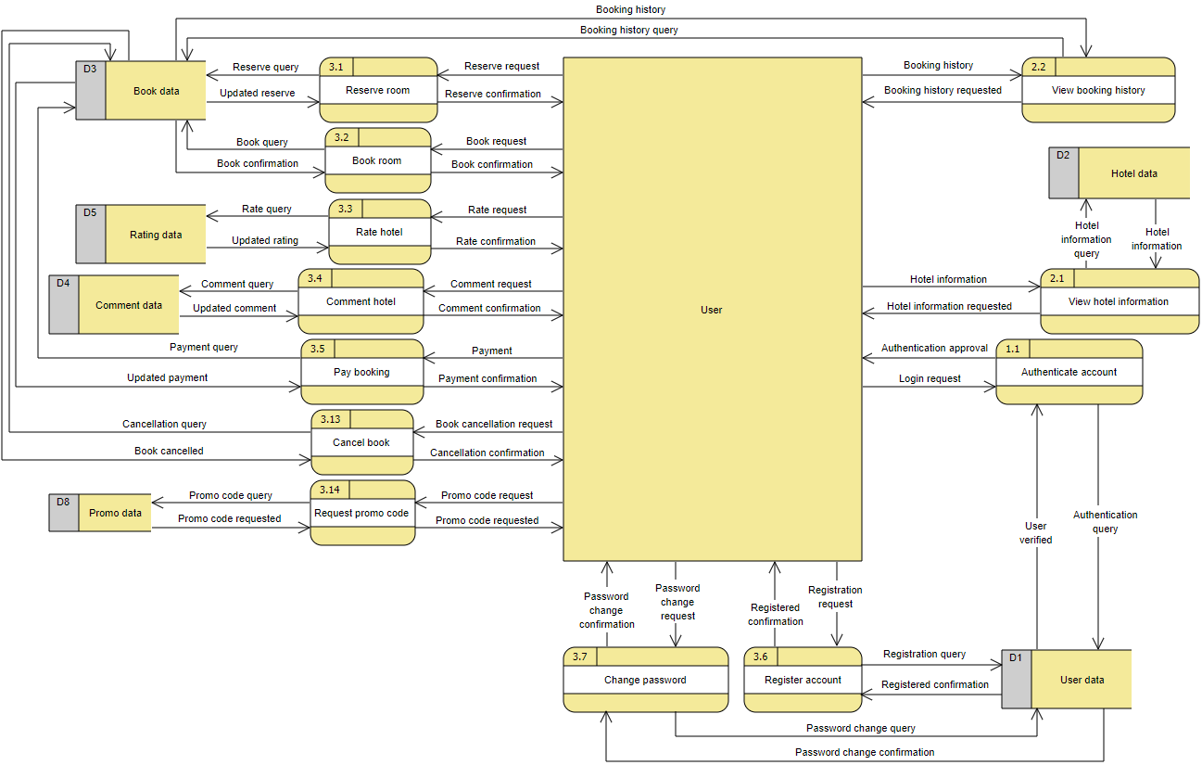

Figure 3-24. Data flow diagram level 1 for User

Figure 3-24 illustrates the data flow diagram level 1 for User.

1. Process 1.1 “Authenticate”

The process “Authenticate” receives login request from the “User”. The process then access the data store “User data” by authenticate query and retrieves data that are matching to the User for verification. Lastly, it will output the information “authenticate approval” to the User after the User is verified.

1. Process 2.1 “View hotel information”

The process “View hotel information” receives hotel information from the “User”. The process then access the data store “Hotel data” by hotel information query to retrieves necessary data and output to the User.

1. Process 2.2 “View booking history”

The process “View booking history” receives booking history from the “User”. The process then access the data store “Book data” by booking history query to retrieves necessary data and output to the User.

1. Process 3.1 “Reserve”

The process “Reserve” receives reserve request from the “User”. The process then access the data store “Book data” by reserve query to update necessary data and output confirmation to the User.

1. Process 3.2 “Book”

The process “Book” receives book request from the “User”. The process then access the data store “Book data” by book query to update necessary data and output confirmation to the User.

1. Process 3.3 “Rate”

The process “Rate” receives rate request from the “User”. The process then access the data store “Rating data” by rate query to update necessary data and output confirmation to the User.

1. Process 3.4 “Comment”

The process “Comment” receives comment request from the “User”. The process then access the data store “Comment data” by comment query to update necessary data and output confirmation to the User.

1. Process 3.5 “Pay”

The process “Pay” receives payment from the “User”. The process then access the data store “Book data” by payment query to update necessary data and output confirmation to the User.

1. Process 3.6 “Register”

The process “Register” receives register request from the “User”. The process then access the data store “User data” by register query to update necessary data and output confirmation to the User.

1. Process 3.7 “Change password”

The process “Change password” receives password change request from the “User”. The process then access the data store “User data” by password change query to update necessary data and output confirmation to the User.

1. Process 3.13 “Cancel book”

The process “Cancel book” receives book cancellation request from the “User”. The process then access the data store “Book data” by cancellation query to update necessary data and output confirmation to the User.

1. Process 3.14 “Request promo code”

The process “Request promo code” receives promo code request from the “User”. The process then access the data store “Promo data” by promo code query to update necessary data and output confirmation to the User.

### 3.5.6 Data Flow Diagram Level 1 for Hotelier

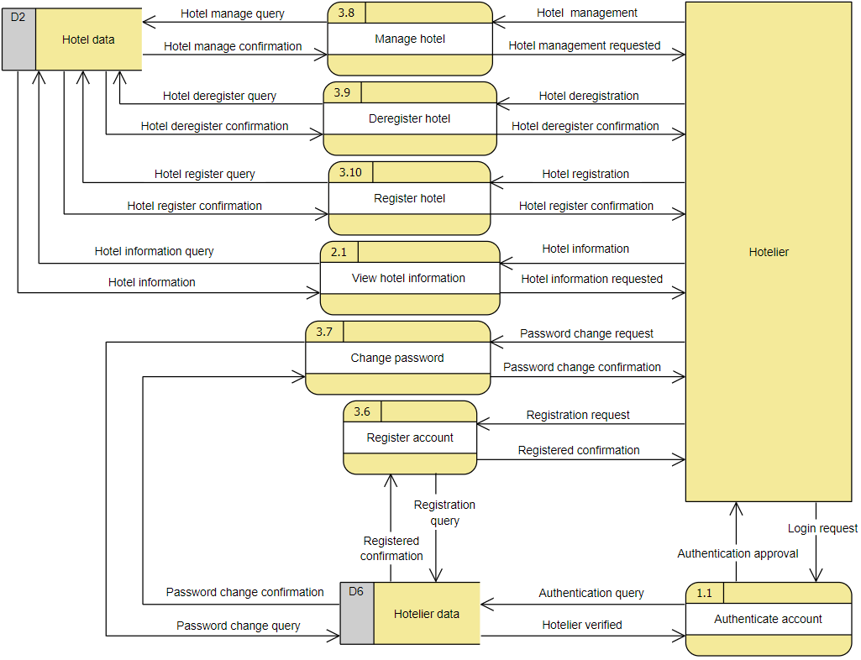

Figure 3-25. Data flow diagram level 1 for Hotelier

Figure 3-25 illustrates the data flow diagram level 1 for Hotelier

1. Process 1.1 “Authenticate”

The process “Authenticate” receives login request from the “Hotelier”. The process then access the data store “Hotelier data” by authenticate query and retrieves data that are matching to the Hotelier for verification. Lastly, it will output the information “authenticate approval” to the Hotelier after the Hotelier is verified.

1. Process 2.1 “View hotel information”

The process “View hotel information” receives hotel information from the “Hotelier”. The process then access the data store “Hotel data” by hotel information query to retrieves necessary data and output to the Hotelier.

1. Process 3.6 “Register”

The process “Register” receives register request from the “Hotelier”. The process then access the data store “Hotelier data” by register query to update necessary data and output confirmation to the Hotelier.

1. Process 3.7 “Change password”

The process “Change password” receives password change request from the “Hotelier”. The process then access the data store “Hotelier data” by password change query to update necessary data and output confirmation to the Hotelier.

1. Process 3.8 “Manage hotel”

The process “Manage hotel” receives hotel management from the “Hotelier”. The process then access the data store “Hotel data” by hotel manage query to update necessary data and output confirmation to the Hotelier.

1. Process 3.9 “Deregister hotel”

The process “Deregister hotel” receives hotel deregistration from the “Hotelier”. The process then access the data store “Hotel data” by hotel deregister query to update necessary data and output confirmation to the Hotelier.

1. Process 3.10 “Register hotel”

The process “Register hotel” receives hotel registration from the “Hotelier”. The process then access the data store “Hotel data” by hotel register query to update necessary data and output confirmation to the Hotelier.

### 3.5.7 Data Flow Diagram Level 1 for Admin

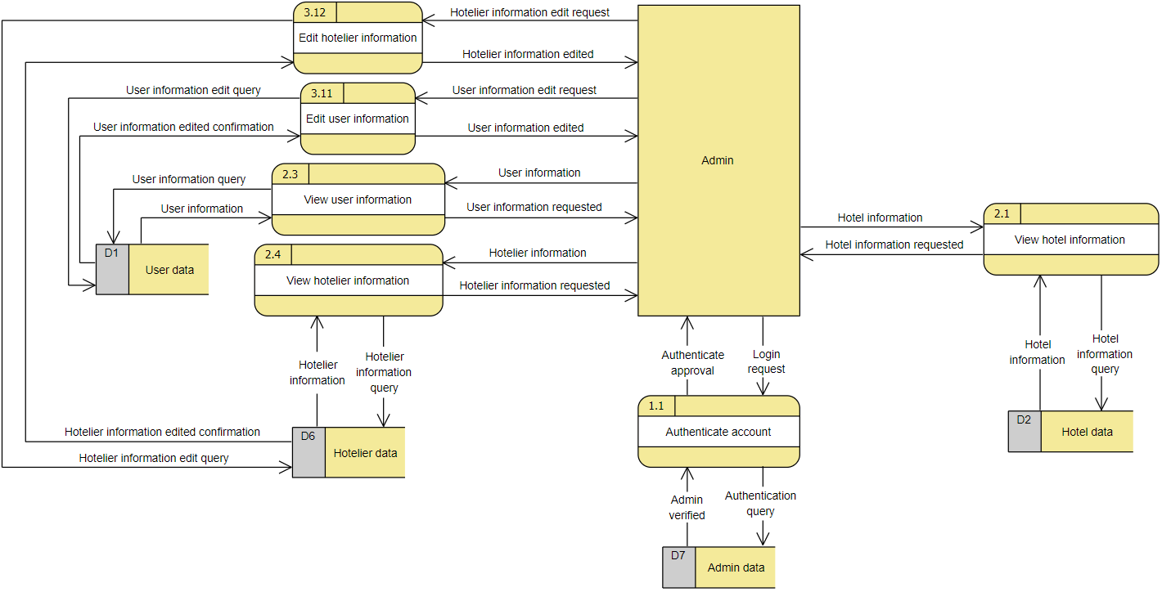

Figure 3-26. Data flow diagram level 1 for Admin

Figure 3-26 illustrates the data flow diagram level 1 for Admin

1. Process 1.1 “Authenticate”

The process “Authenticate” receives login request from the “Admin”. The process then access the data store “Admin data” by authenticate query and retrieves data that are matching to the Admin for verification. Lastly, it will output the information “authenticate approval” to the Admin after the Admin is verified.

1. Process 2.1 “View hotel information”

The process “View hotel information” receives hotel information from the “Admin”. The process then access the data store “Hotel data” by hotel information query to retrieves necessary data and output to the Admin.

1. Process 2.3 “View user information”

The process “View user information” receives user information from the “Admin”. The process then access the data store “User data” by user information query to retrieves necessary data and output to the Admin.

1. Process 2.4 “View hotelier information”

The process “View hotelier information” receives hotelier information from the “Admin”. The process then access the data store “hotelier data” by hotelier information query to retrieves necessary data and output to the Admin.

1. Process 3.11 “Edit user information”

The process “Edit user information” receives user information edit request from the “Admin”. The process then access the data store “User data” by user information edit query to update necessary data and output confirmation to the Admin.

1. Process 3.12 “Edit hotelier information”

The process “Edit hotelier information” receives hotelier information edit request from the “Admin”. The process then access the data store “Hotelier data” by hotelier information edit query to update necessary data and output confirmation to the Admin.

## 3.6 Entity Relationship Diagram

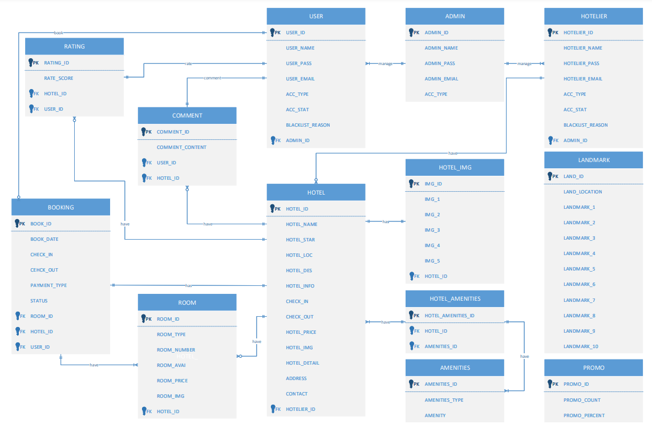

Figure 3-27. Entity Relationship Diagram for Hotel Reservation Website

Figure 3-27 shows the Entity Relationship Diagram for Hotel Reservation Website. The Entity Relationship Diagram shows the relationship between entities. Table 3-1, 3-2, 3-3 shows the data dictionary along with the business rules

Table 3-1. Data Dictionary for Hotel Reservation System part one

|  |  |  |  |  |  |  |
| --- | --- | --- | --- | --- | --- | --- |
| **Table Name** | **Attribute Name** | **Contents** | **Data Types** | **Null** | **PK/**  **FK** | **FK Referenced Table** |
| USER | USER_ID  USER_NAME  USER_PASS  USER_EMAIL  ACC_TYPE  ACC_STAT  BLACKLIST_REASON  ADMIN_ID | User ID  User name  User password  User email  Account type (0 for admin, 1 for user, 2 for hotelier)  Account status (0 for normal, 1 for blacklisted)  Reason for blacklisted  Admin ID | Integer(10)  Varchar(30)  Varchar(255)  Varchar(30)  Enum  Enum  Varchar(200)  Integer(10) | No  No  No  No  No  No  Yes  No | PK  FK | ADMIN |
| HOTELIER | HOTELIER_ID  HOTELIER_NAME  HOTELIER_PASS  HOTELIER_EMAIL  ACC_TYPE  ACC_STAT  BLACKLIST_REASON  HOTEL_ID  ADMIN_ID | Hotelier ID  Hotelier name  Hotelier password  Hotelier email  Account type (0 for admin, 1 for user, 2 for hotelier)  Account status (0 for normal, 1 for blacklisted)  Reason for blacklisted  Hotel ID  Admin ID | Integer(10)  Varchar(30)  Varchar(255)  Varchar(30)  Enum  Enum  Varchar(200)  Integer(10)  Integer(10) | No  No  No  No  No  No  Yes  Yes  No | PK  FK  FK | HOTEL  ADMIN |
| ADMIN | ADMIN_ID  ADMIN_NAME  ADMIN_PASS  ADMIN_EMAIL  ACC_TYPE | Admin ID  Admin name  Admin password  Admin email  Account type (0 for admin, 1 for user, 2 for hotelier) | Integer(10)  Varchar(30)  Varchar(255)  Varchar(30)  Enum | No  No  No  No  No | PK |  |

Table 3-2. Data Dictionary for Hotel Reservation System part two

|  |  |  |  |  |  |  |
| --- | --- | --- | --- | --- | --- | --- |
| **Table Name** | **Attribute Name** | **Contents** | **Data Types** | **Null** | **PK/**  **FK** | **FK Referenced Table** |
| PROMO | PROMO_ID  PROMO_COUNT  PROMO_PERCENT | Promo ID  Counter for each promo usage  Percentage of promo | Integer(10)  Integer(10)  Integer(3) | No  No  No | PK |  |
| ROOM | ROOM _ID  ROOM_TYPE  ROOM _NUMBER  ROOM_AVAI  ROOM_PRICE  ROOM_IMG  HOTEL_ID | Room ID  Type of room  Number of the room  Room availability  Price of the room  Image of the room  Hotel ID | Integer(10)  Enum  Varchar(5)  Enum  Integer(5)  Mediumblob  Integer(10) | No  No  No  No  No  No  No | PK  FK | HOTEL |
| HOTEL | HOTEL_ID  HOTEL_NAME  HOTEL_STAR  HOTEL_LOC  HOTEL_DES  HOTEL_INFO  CHECK_IN  CHECK_OUT  HOTEL_PRICE  HOTEL_IMG  HOTEL_DETAIL  ADDRESS CONTACT  HOTELIER_ID | Hotel ID  Hotel name  Hotel star rating  Hotel location  Hotel description  Hotel information  Check-in time  Check-out time  Hotel price  Hotel image  Hotel detail  Hotel address  Hotel contact  Hotelier ID | Integer(10)  Varchar(30)  Enum  Varchar(30)  Varchar(100)  Varchar(500)  Time  Time  Integer(10)  Mediumblob  Varchar(500)  Varchar(200)  Varchar(15)  Intege(10) | No  No  No  No  No  No  No  No  No  No  No  No  No  No | PK  FK | HOTELEIR |

Table 3-3. Data Dictionary for Hotel Reservation System part three

|  |  |  |  |  |  |  |
| --- | --- | --- | --- | --- | --- | --- |
| **Table Name** | **Attribute Name** | **Contents** | **Data Types** | **Null** | **PK/**  **FK** | **FK Referenced Table** |
| BOOKING | BOOK_ID  BOOK_DATE  CHECK_IN  CHECK_OUT  PAYMENT_TYPE  STATUS  HOTEL_ID  ROOM_ID  USER_ID | Booking ID  Booking date  Check-in time  Check-out time  Type of payment  Status of the booking  Hotel ID  Room ID  User ID | Integer(10)  Date  Date  Date  Enum  Enum  Integer(10)  Integer(10)  Integer(10) | No  No  No  No  No  No  No  No  No | PK  FK  FK  FK | HOTEL  ROOM  USER |
| COMMENT | COMMENT_ID  COMMENT_CONTENT  USER_ID  HOTEL_ID | Comment ID  Content of comment  Hotel ID  User ID | Integer(10)  Varchar(1000)  Integer(10)  Integer(10) | No  No  No  No | PK  FK  FK | USER  HOTEL |
| RATING | RATING_ID  RATE_SCORE  HOTEL_ID  USER_ID | Rating ID  Rating score  Hotel ID  User ID | Integer(10)  Enum  Integer(10)  Integer(10) | No  No  No  No | PK  FK  FK | HOTEL  USER |

Table 3-4. Data Dictionary for Hotel Reservation System part four

|  |  |  |  |  |  |  |
| --- | --- | --- | --- | --- | --- | --- |
| **Table Name** | **Attribute Name** | **Contents** | **Data Types** | **Null** | **PK/**  **FK** | **FK Referenced Table** |
| AMENITIES | AMENITIES_ID  AMENITIES_TYPE  AMENITY | Amenity ID  Type of amenity  Name of amenity | Integer(10)  Enum  Varchar(50) | No  No  No | PK |  |
| HOTEL_  AMENITIES | HOTEL_AMENITIES_ID  HOTEL_ID  AMENITIES_ID | Hotel amenities ID  Hotel ID  Amenities ID | Integer(10)  Integer(10)  Integer(10) | No  No  No | PK  FK  FK | HOTEL  AMENITIES |
| HOTEL_IMG | IMG_ID  IMG_1  IMG_2  IMG_3  IMG_4  IMG_5  HOTEL_ID | Image ID  Image 1  Image 2  Image 3  Image 4  Image 5  Hotel ID | Integer(10)  Mediumblob  Mediumblob  Mediumblob  Mediumblob  Mediumblob  Integer(10) | No  No  No  No  No  No  No | PK  FK | HOTEL |
| LANDMARK | LAND_ID  LAND_LOACTION  LANDMARK_1  LANDMARK_2  LANDMARK_3  LANDMARK_4  LANDMARK_5  LANDMARK_6  LANDMARK_7  LANDMARK_8  LANDMARK_9  LANDMARK_10 | Landmark ID  Landmark location  Landmark 1  Landmark 2  Landmark 3  Landmark 4  Landmark 5  Landmark 6  Landmark 7  Landmark 8  Landmark 9  Landmark 10 | Integer(5)  Varchar(50)  Varchar(50)  Varchar(50)  Varchar(50)  Varchar(50)  Varchar(50)  Varchar(50)  Varchar(50)  Varchar(50)  Varchar(50)  Varchar(50) | No  No  No  No  No  No  No  No  No  No  No  No |  |  |

Business rules:

* Each user may book one or more hotel
* One or more hotel can be booked by each user
* Each user may write at least one comment
* Each comment can be written by only one user
* Each user may rate one or more hotel
* One or more hotel can be rated by each users
* Each hotelier may register one or more hotel
* One or more hotel can be registered by each hotelier
* Each booking has a hotel information
* Each hotel information is attached to a booking
* Each booking have a room information
* Each room information is attached to a booking
* Each hotel have a rating
* Each rating is attached to a hotel
* Each hotel have one or more comments
* One or more comments is attached to a hotel
* An admin may manage one or more user
* One or more user is managed by an admin
* An admin may manage one or more hotelier
* One or more hotelier is managed by an admin
* Each hotel have one or more room
* One or more room is attached to a hotel
* Each hotel has one hotel image
* Each hotel image is attached to a hotel
* Each hotel have one hotel amenities
* Each hotel amenities is attached at one hotel
* Each hotel amenities have one or more amenities
* Each amenities have one hotel amenities

# Chapter 4: DESIGN

## 4.1 Sequence Diagrams

### 4.1.1 Sequence Diagram for Login

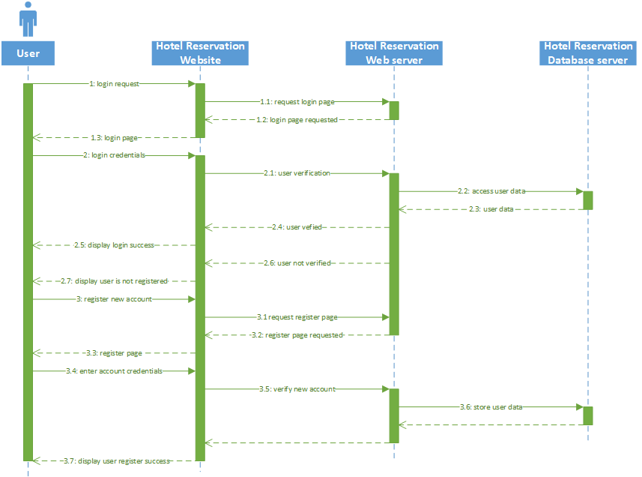

Figure 4-1. Sequence diagram for Login

Figure 4-1 shows the sequence diagram for Login. The user will click the login button to request the login page. After that, the user will enter his/her username and password to login. The Hotel Reservation Web Server will find take the username and password that user had entered and match it with the Hotel Reservation Database Server. If the username and password matches the one in the database, the user will be granted to login. If the username and password does not matches the one in the database, the system will display the user is not registered and will redirect the user to the register page to register a new account.

### 4.1.2 Sequence Diagram for Logout

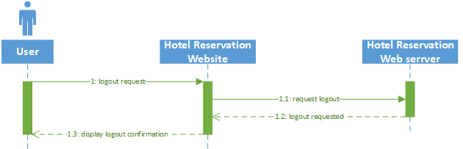

Figure 4-2. Sequence Diagram for Logout

Figure 4-2 shows the sequence diagram for logout. The user will press the logout button to request to logout from the system. The button will then trigger the logout operation from the Hotel Reservation Web Server and the server will logout the user accordingly. After a successful logout, the system will display a logout confirmation for the user.

### 4.1.3 Sequence Diagram for Reserve

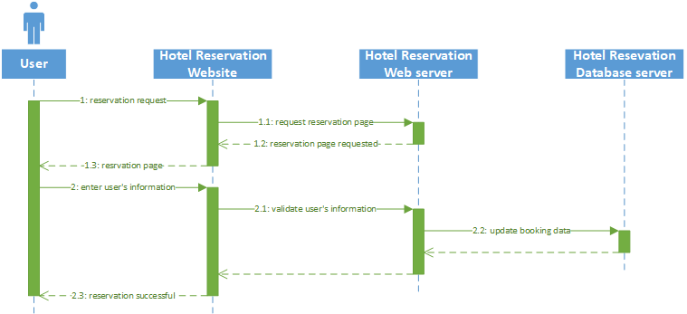

Figure 4-3. Sequence Diagram for Reserve

Figure 4-3 shows the sequence diagram for reserve. The user will click the reserve button to make a reservation request. After that the Hotel Reservation Web Server will redirect the user to the reservation page. After being redirected, the user will enter their information in the form provided. After that, the user input will be verified by the Web Server. After validated, those information will pass to the database server for update. Lastly, it will display a reservation success to the user after all operation is successful.

### 4.1.4 Sequence Diagram for Register

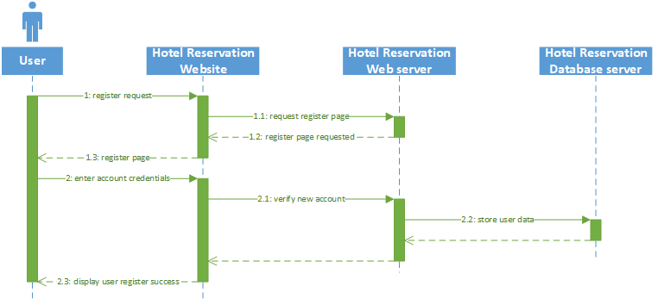

Figure 4-4. Sequence Diagram for Register

Figure 4-4 shows the sequence diagram for register. The user will click the register button to request the register page from the Hotel Reservation Web Server. After that, the user will enter his/her account credentials and those information will be verified by the Hotel Reservation Web Server. After verified, the user account will be store into the Hotel Reservation Database server. Lastly, the system will display the account had been successfully registered to the user.

### 4.1.5 Sequence Diagram for Rate

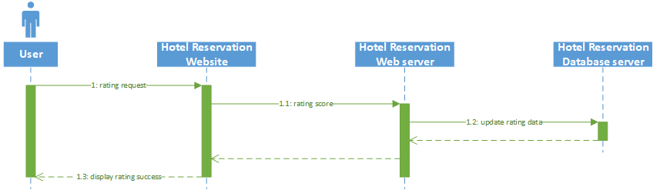

Figure 4-5. Sequence Diagram for Rate

Figure 4-5 shows the sequence diagram for rate. The user will click the rate button to request to rate a particular hotel followed by entering the rating score. The rating score will be processed by the Hotel Reservation Web Server and finally store it into the Hotel Reservation Database Server. Finally, the system will display the rate is successful after all the operation is done.

### 4.1.6 Sequence Diagram for Pay

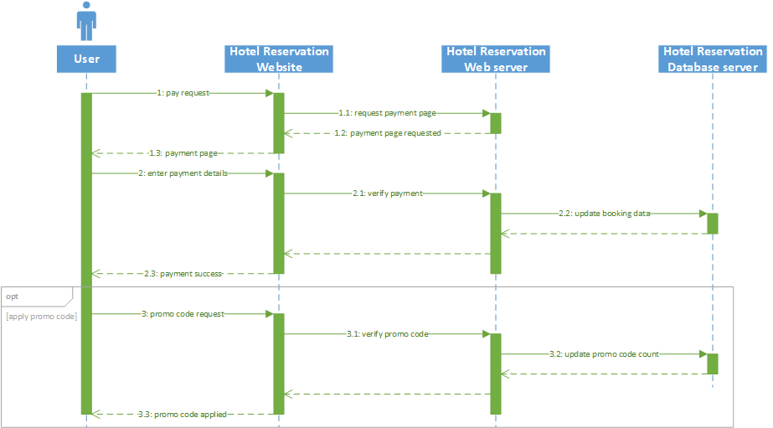

Figure 4-6. Sequence Diagram for Pay

Figure 4-6 shows the sequence diagram for pay. The user will click the pay button to request the payment page from the Hotel Reservation Web Server. Upon clicking the button, the user will be redirected to the payment page. In the payment page, the user will enter his/her payment information and those information will be verified by the web server. After being verified, the booking data in the Hotel Reservation Database Server will be updated accordingly. Finally, the system will display a payment success message to the user. Alternatively, the user will have the choice to apply the promo code if available. The user will click the promo code button to enter the promo code. Then the promo code will be verified by the web server. Upon verified, the promo code use count will be updated in the database server. Finally, the system will display the promo code have been applied successfully to the user.

### 4.1.7 Sequence Diagram for Comment

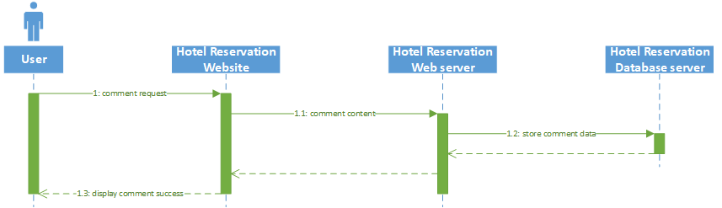

Figure 4-7. Sequence Diagram for Comment

Figure 4-7 shows the sequence diagram for Comment. The user will enter the comment by typing in the comment box. The content will then be stored into the Hotel Reservation Database Server. Finally, the system will display comment successful to the user.

### 4.1.8 Sequence Diagram for Book

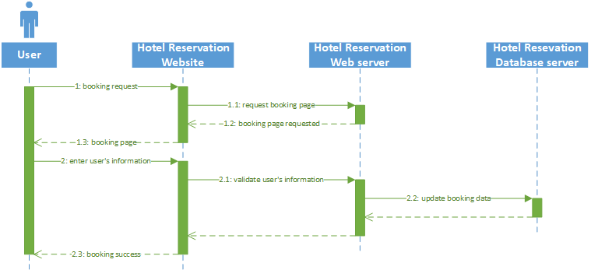

Figure 4-8. Sequence Diagram for Book

Figure 4-8 shows the sequence diagram for book. The user will click the book button to request the booking page from the Hotel Reservation Web Server. After being redirected to the booking page, the user will enter his/her information. The information will then be verified by the web server. After being verified, the booking information will then be updated in the Hotel Reservation Database Server. Finally, the system will display a booking success message to the user.

### 4.1.9 Sequence Diagram for Cancel Book

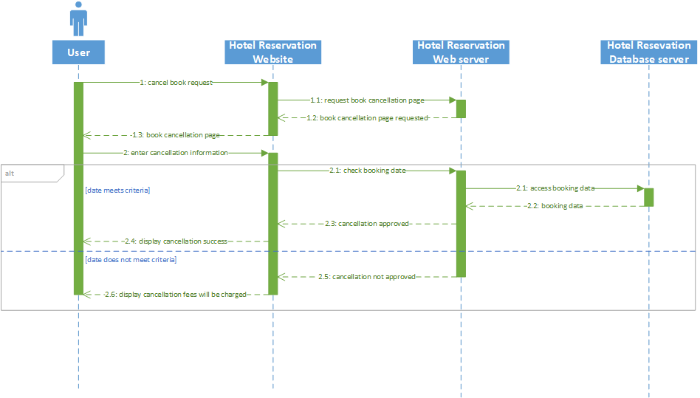

Figure 4-9. Sequence Diagram for Cancel Book

Figure 4-9 shows the sequence diagram for cancel book. The user will click the cancel book button to make cancellation of the particular bookings. Upon clicking the button, the user will be redirected to a book cancellation page by the Hotel Reservation Web Server. There are two condition of book cancellation, which is with or without cancellation fees. The difference between the booking date and cancellation date will decide whether the user will be charged with cancellation or not. The user start the cancellation process by entering the cancellation information. After that, the web server will then check the booking date by accessing the Hotel Reservation Web Server. If the date meets the criteria, the cancellation will be approved and cancellation success message will be displayed to the user. If the date does not meet the criteria, the system will not approve the cancellation and display to the user that cancellation fees will be charged.

### 4.1.10 Sequence Diagram for Change Password

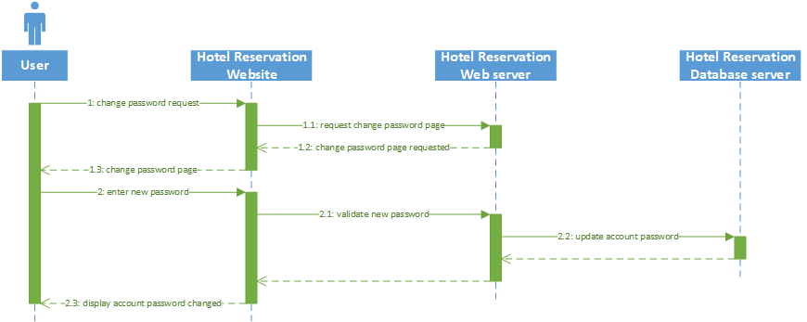

Figure 4-10. Sequence Diagram for Change Password

Figure 4-10 shows the sequence diagram for change password. The user will click the change password button to request the change password page from the Hotel Reservation Web Server. Upon the user being redirected to the page, the sure enter the new password for his/her account. The password will then be validated by the web server and update the user password in the Hotel Reservation Database Server. Finally, the system will display the password has been successfully changed to the user.

### 4.1.11 Sequence Diagram for Register Hotel

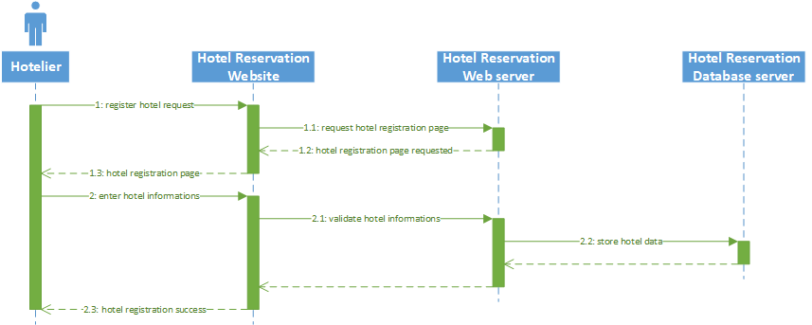

Figure 4-11. Sequence Diagram for Register Hotel

Figure 4-11 shows the sequence diagram for register hotel. The hotelier will click the register hotel button to request the hotel registration page from the Hotel Reservation Web Server. The hotelier will then enter the hotel information. Those information will then be validated by the web server. Once validated, the hotel data will be stored into the Hotel Reservation Web Server. Lastly, the hotelier will receive a hotel registration success message from the system indicating the hotel have been successfully registered.

### 4.1.12 Sequence Diagram for Deregister Hotel

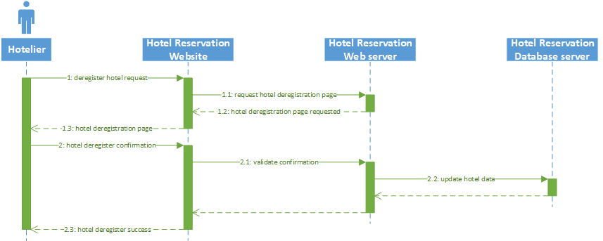

Figure 4-12. Sequence Diagram for Deregister Hotel

Figure 4-12 shows the sequence diagram for deregister hotel. The hotelier will request the hotel deregistration page from the Hotel Reservation Web Server by clicking the deregister hotel button. The system will then prompt the hotelier whether he/she wants to deregister the hotel. Once confirmed, the hotel data will be updated in the Hotel Reservation Database Server. Lastly, the system will display hotel deregistration success to the hotelier.

### 4.1.13 Sequence Diagram for Manage Hotel

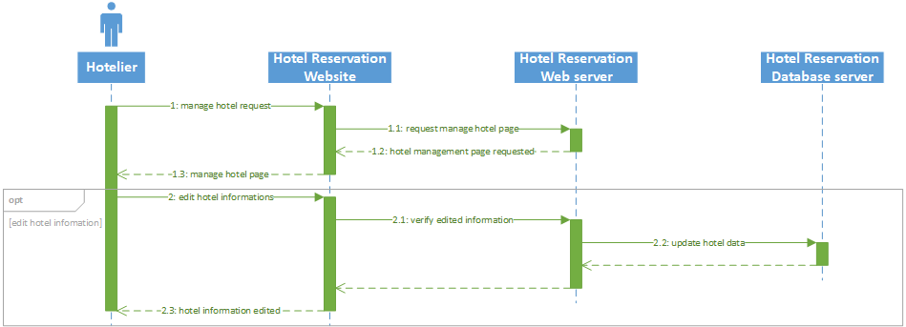

Figure 4-13. Sequence Diagram for Manage Hotel

Figure 4-13 shows the sequence diagram for manage hotel. The hotelier will request the manage hotel page from the Hotel Reservation Web Server by clicking the manage hotel button. Upon being redirected to the management page, it is optional that the hotelier will edit the information of the particular hotel. In the case of the hotelier edit the hotel information, the edited information will then be verified by the web server. After being verified, the hotel data will be updated in the Hotel Reservation Database server. Lastly, the system will display the hotel have been edited successfully to the hotelier.

### 4.1.14 Sequence diagram for Edit User Information

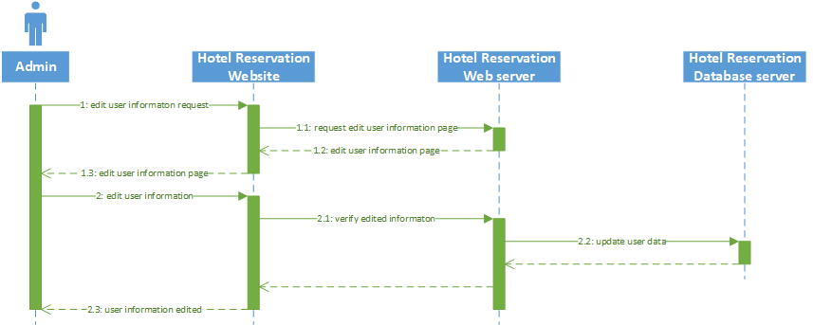

Figure 4-14. Sequence Diagram for Edit User Information

Figure 4-14 shows the sequence diagram for edit user information. The admin will request the edit user information page from the Hotel Reservation Web Server by clicking the edit user information button. Upon being redirected to edit user information page, the admin will then edit the user information. Those information will then be verified by the web server and update the user data in the Hotel Reservation Database Server accordingly. Finally, the system will display the user information have been edited to the admin.

### 4.1.15 Sequence Diagram for Edit Hotelier Information

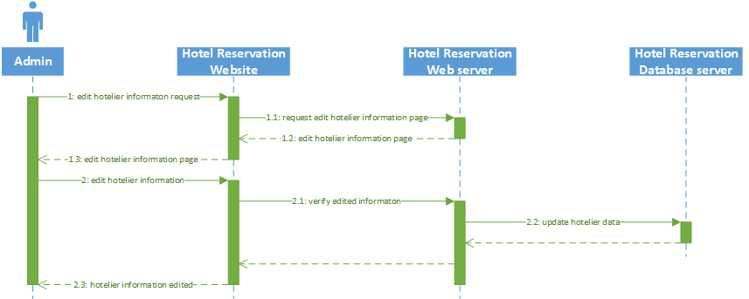

Figure 4-15. Sequence Diagram for Edit Hotelier Information

Figure 4-15 shows the sequence diagram for edit hotelier information. The admin will request the edit hotelier information page from the Hotel Reservation Web Server by clicking the edit hotelier information button. Upon being redirected to edit hotelier information page, the admin will then edit the hotelier information. Those information will then be verified by the web server and update the hotelier data in the Hotel Reservation Database Server accordingly. Finally, the system will display the hotelier information have been edited to the admin.

### 4.1.16 Sequence Diagram for View User Information

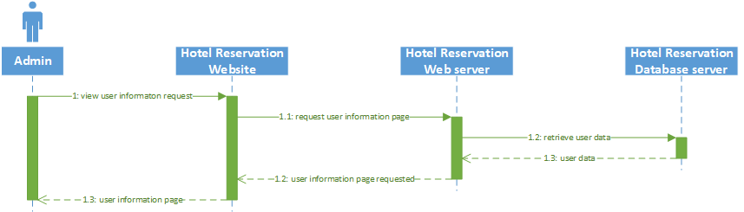

Figure 4-16. Sequence Diagram for View User Information

Figure 4-16 shows the sequence diagram for view user information. The admin will request the view user information from the Hotel Reservation Web Server by clicking the view user information button. After being redirected to the page, the web server will then retrieve the user data from the Hotel Reservation Database Server and display it to the admin.

### 4.1.17 Sequence Diagram for View Hotelier Information

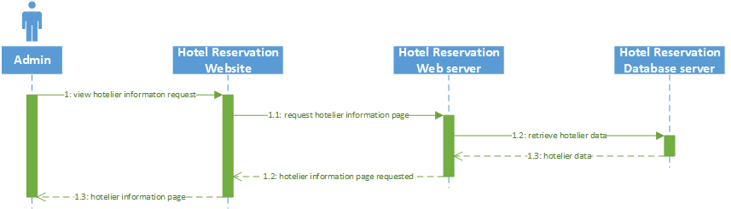

Figure 4-17. Sequence Diagram for View Hotelier Information

Figure 4-17 shows the sequence diagram for view hotelier information. The admin will request the view hotelier information from the Hotel Reservation Web Server by clicking the view hotelier information button. After being redirected to the page, the web server will then retrieve the hotelier data from the Hotel Reservation Database Server and display it to the admin.

### 4.1.18 Sequence Diagram for View Hotel Information

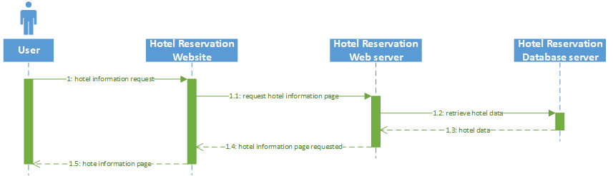

Figure 4-18. Sequence Diagram for View Hotel Information

Figure 4-18 shows the sequence diagram for view hotel information. The user will click the hotel information button to request the hotel information page from the Hotel Reservation Web Server. Upon being redirected to the hotel information page, the web server will then retrieve the hotel data from the Hotel Reservation Database Server and display it to the user.

### 4.1.19 Sequence Diagram for View Booking History

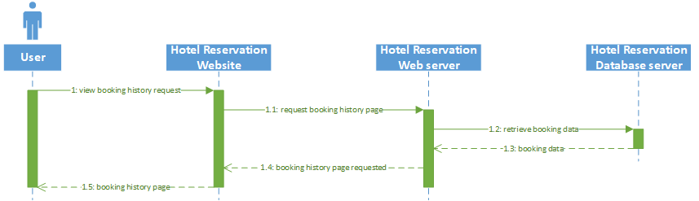

Figure 4-19. Sequence Diagram for View Booking History

Figure 4-19 shows the sequence diagram for view booking history. The user will request the booking history page from the Hotel Reservation Web Server by clicking the view booking history button. Upon being redirected to the booking history page, the web server will then retrieve the booking history from the Hotel Reservation Web Server and display it to the user.

## 4.3 Screen Design

### 4.3.1 Hotel Reservation Website homepage

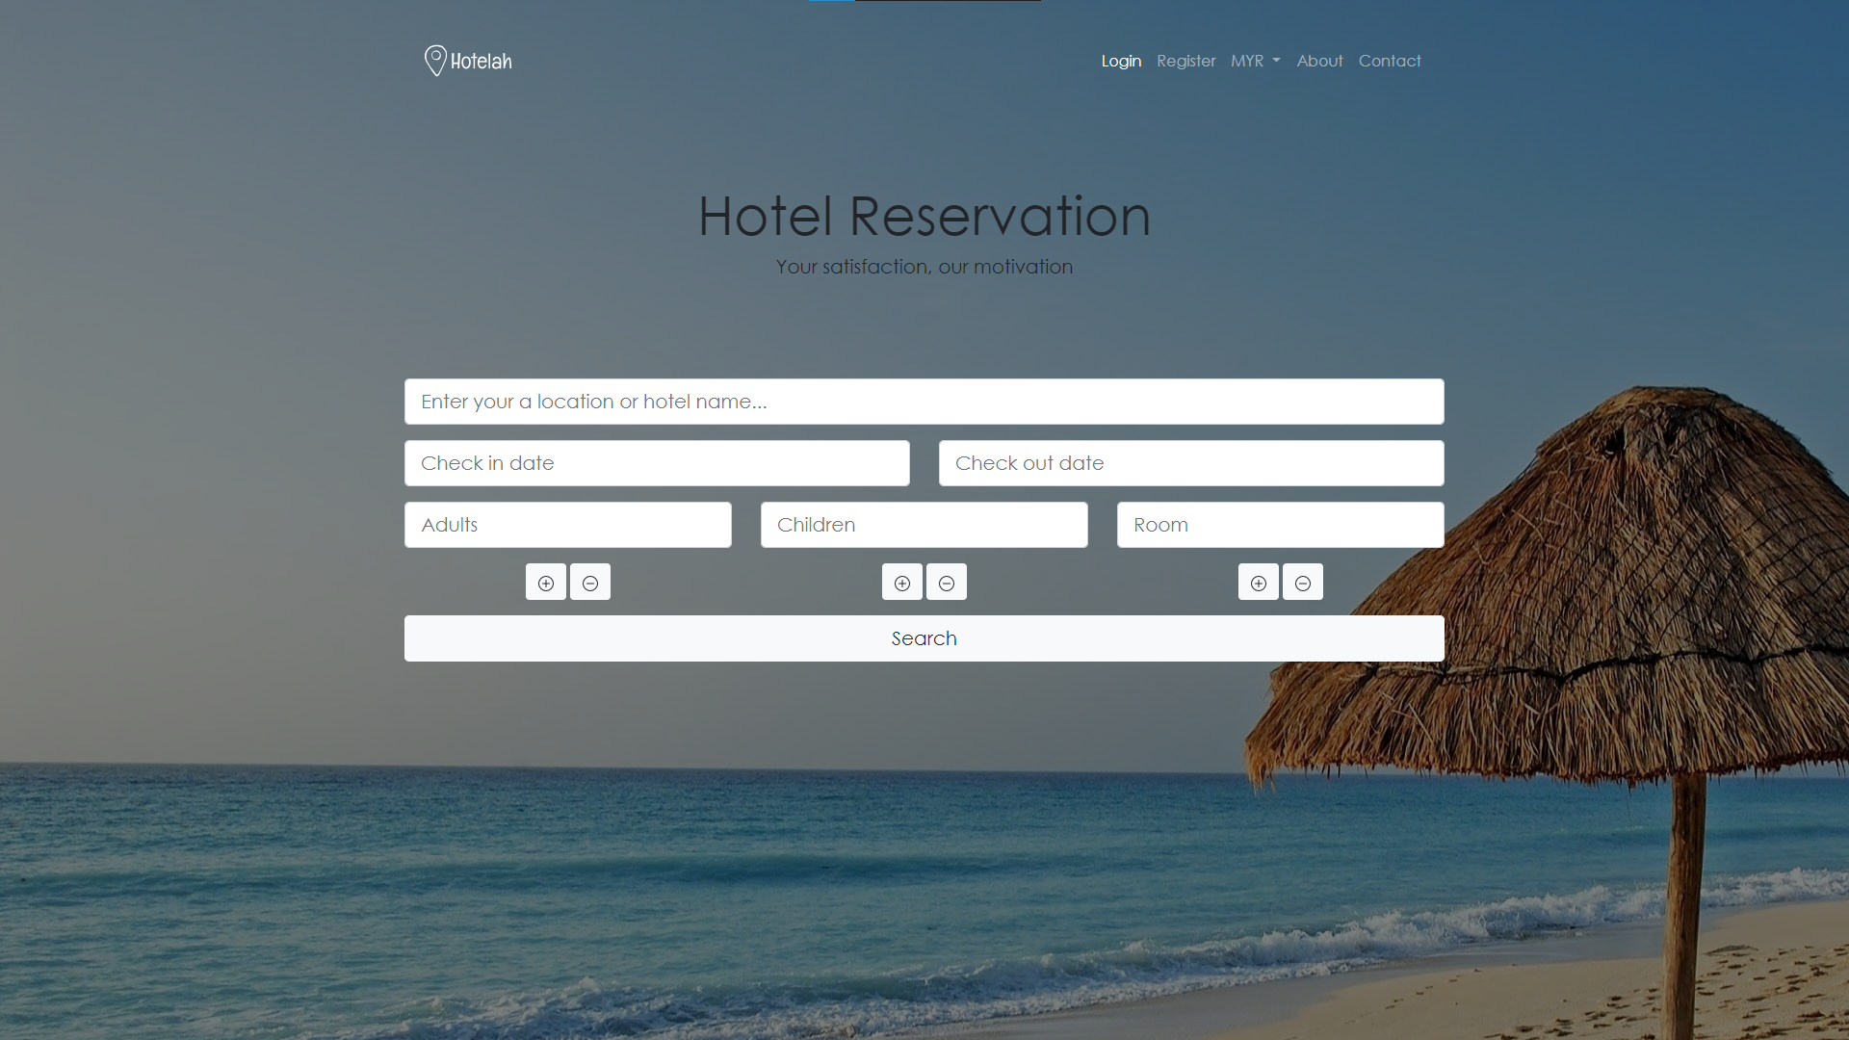

Figure 4-20. Hotel Reservation Website homepage

Figure 4-20 shows the Hotel Reservation Website homepage. The user can login, change currency, view about us, contact us and lastly enters the criteria for hotel searching

### 4.3.2 Hotel Reservation Website login/register page

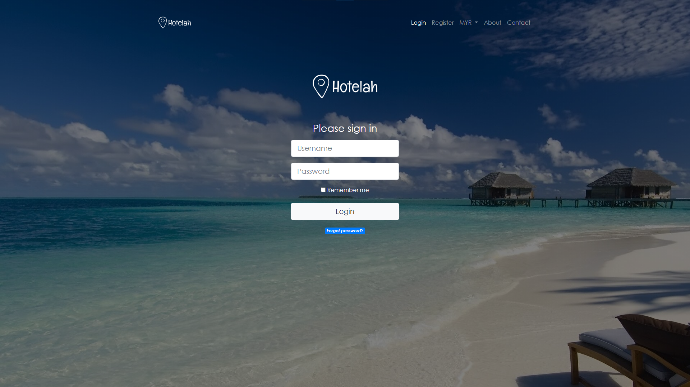

Figure 4-21. Hotel Reservation Website login/register page

Figure 4-21 shows the Hotel Reservation Website login/register page. The user can login to their own at here. Moreover, the user can also click the “forgot password” link to request for password changes.

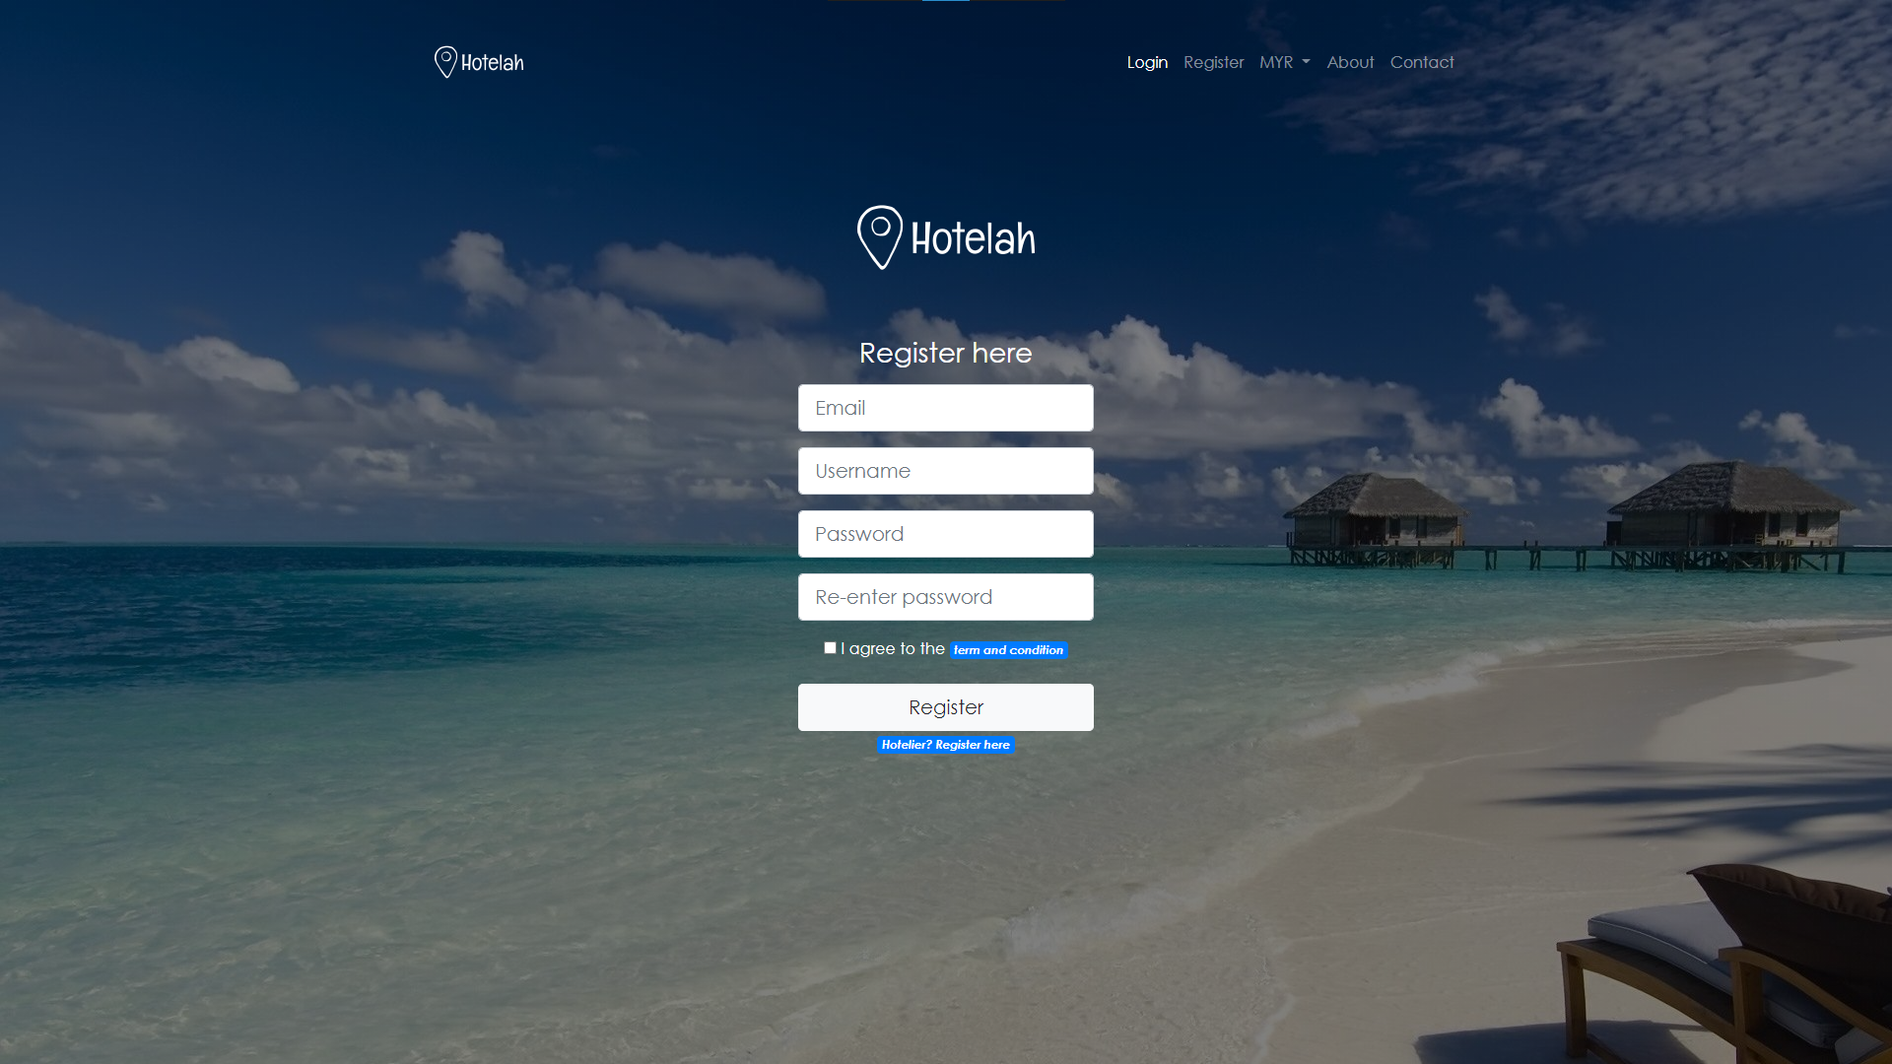

Figure 4-22. Hotel Reservation Website register page

Figure 4-22 shows the Hotel Reservation Website register page. The user will be able to register a new account at this page.

### 4.3.3 Hotel Reservation Website forgot password page

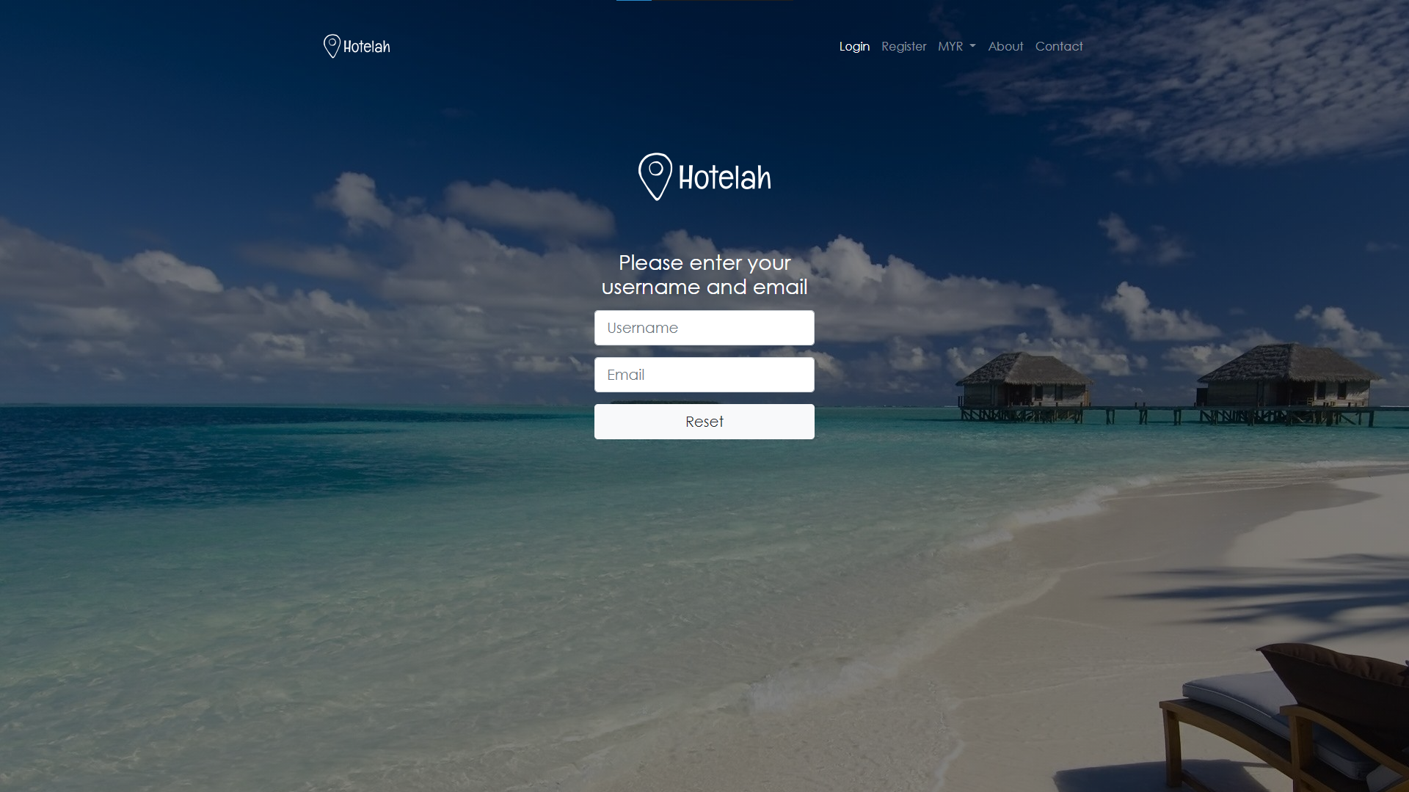

Figure 4-23. Hotel Reservation Website forgot password page

Figure 4-23 shows the Hotel Reservation Website forgot password page. In this page, the user will be able to reset or change their password by entering their username and email. Further steps will be carried out once the email is confirmed.

### 4.3.4 Hotel Reservation about us page

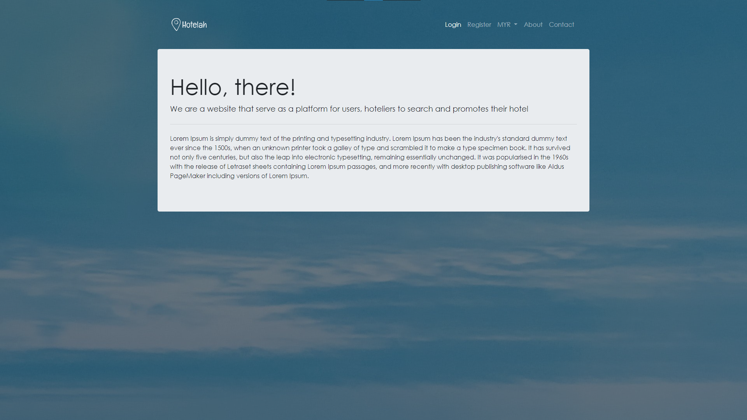

Figure 4-24. Hotel Reservation Website about us page

Figure 4-24 shows the Hotel Reservation Website about us page. In this page, the user will have an information about the website regarding its purpose and objectives.

### 4.3.5 Hotel Reservation Website contact us page

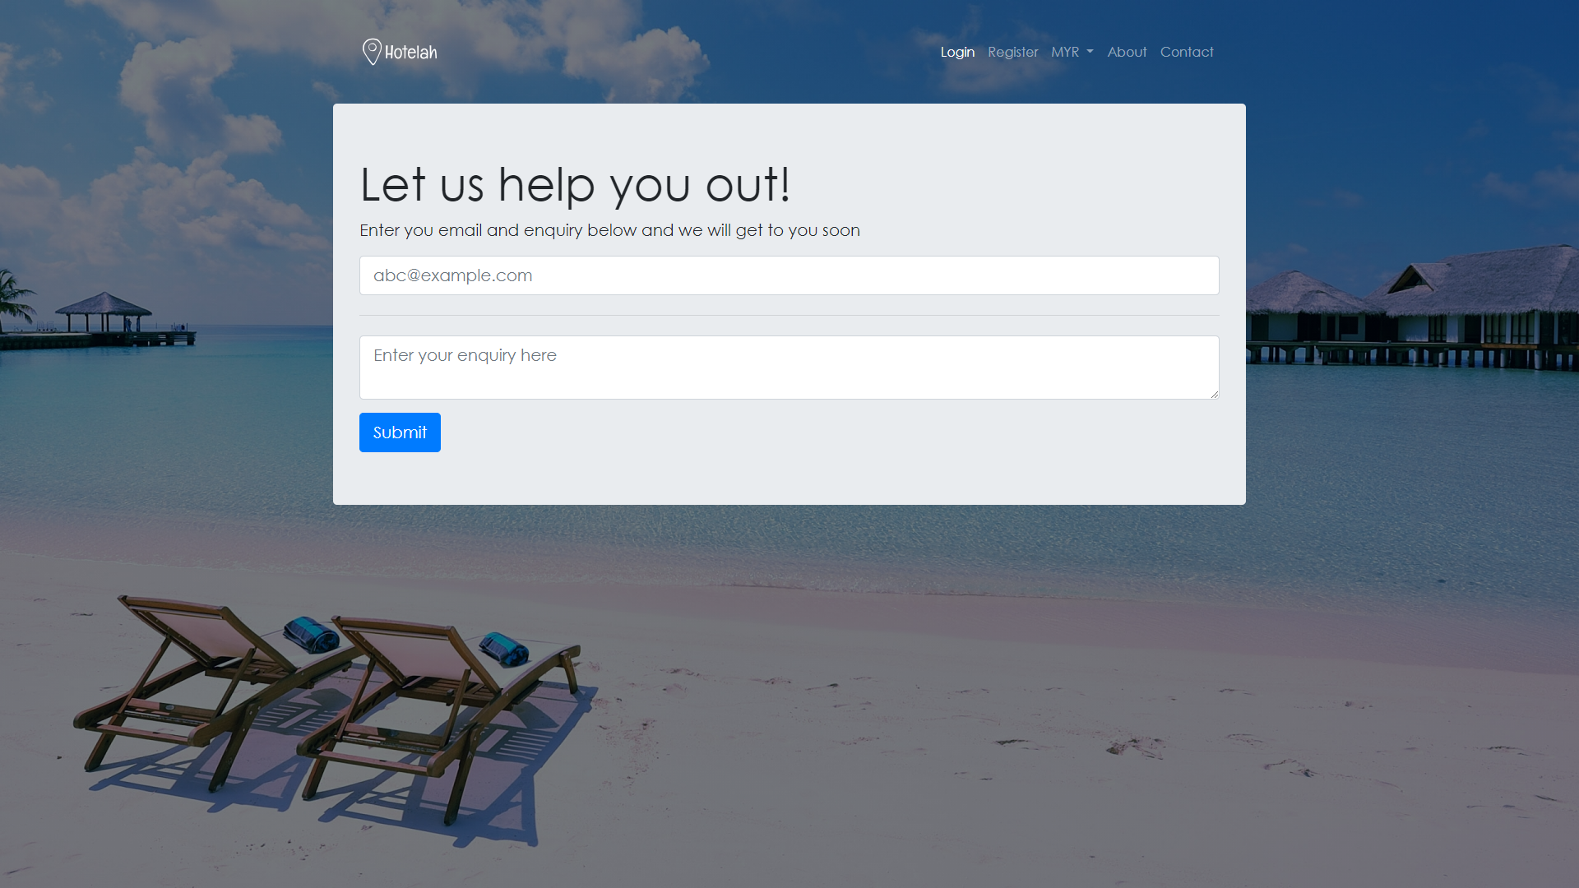

Figure 4-25. Hotel Reservation Website contact us page

Figure 4-25 shows the Hotel Reservation Website contact us page. The user will be able to contact the by entering their email. Once the email is entered and submitted, the admin will reply to the email.

### 4.3.6 Hotel Reservation Website search result page

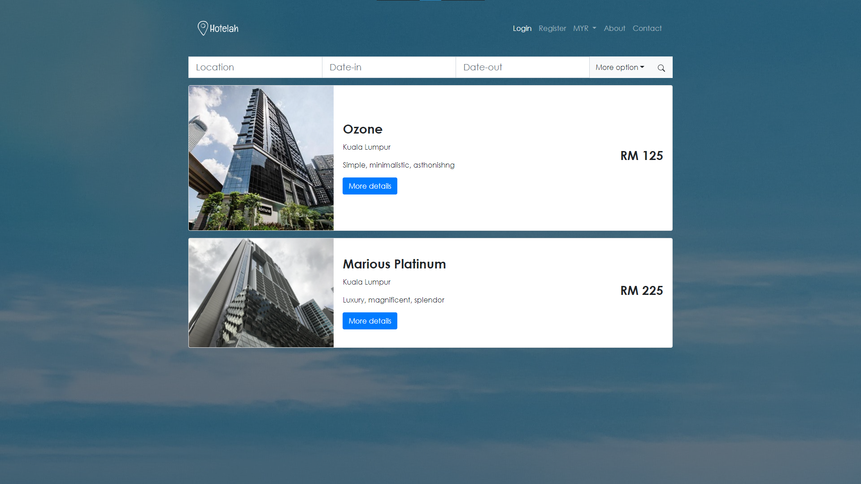

Figure 4-26. Hotel Reservation Website search result page

Figure 4-26 shows the Hotel Reservation Website search result page. The user will able to view the hotels based on the information that user entered. If the user wanted to search with another information, they can do so at the top search bar.

### 4.3.7 Hotel Reservation Website hotel detail page

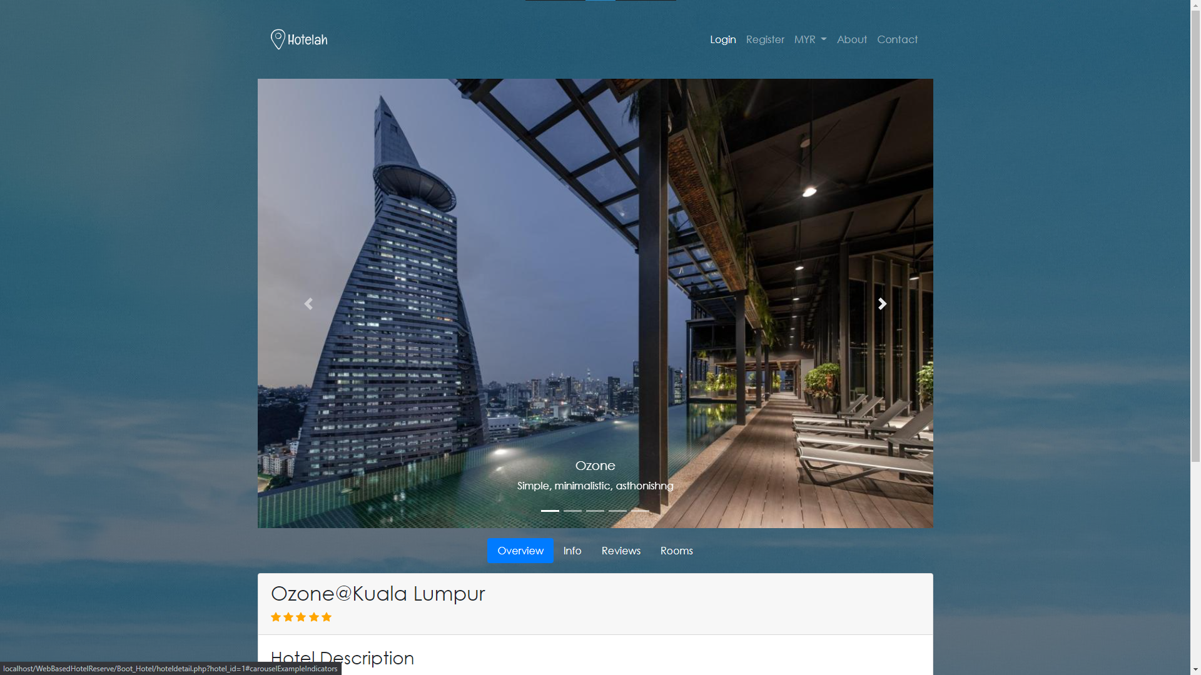

Figure 4-27. Hotel Reservation Website hotel detail page (1)

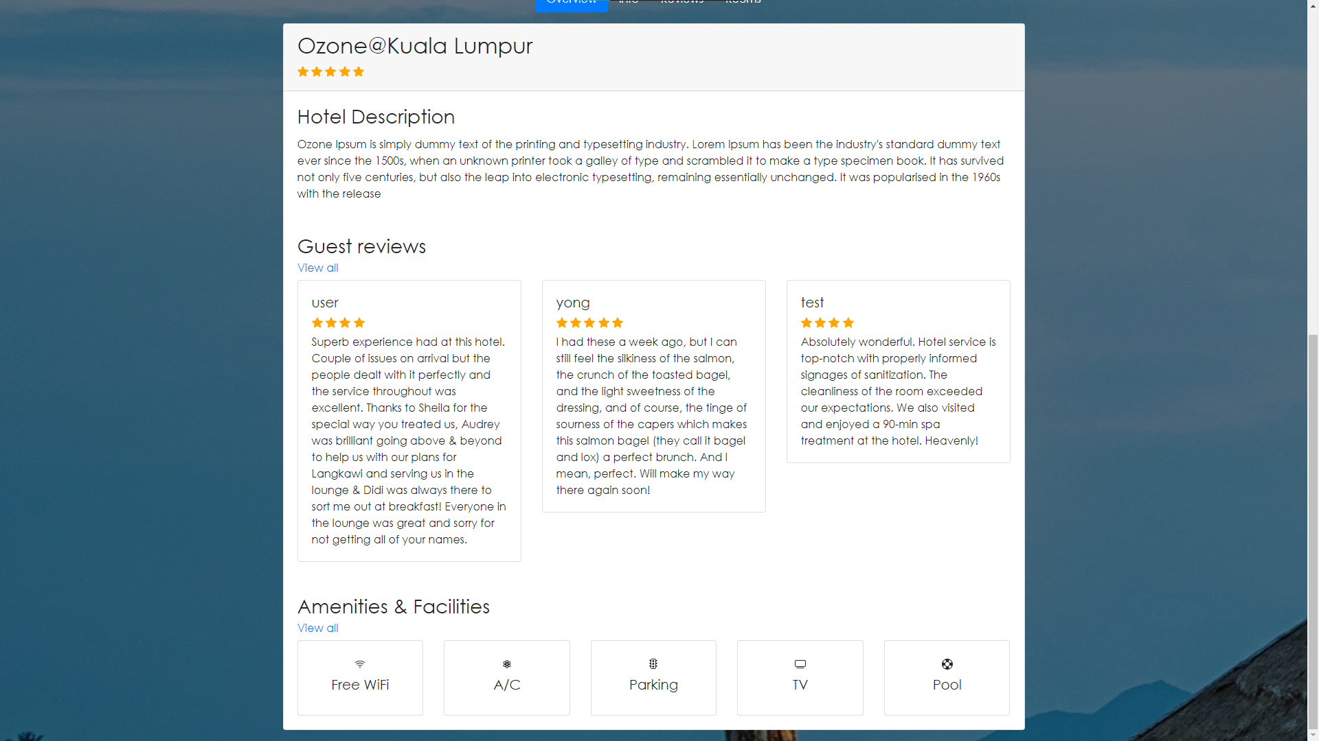

Figure 4-28. Hotel Reservation Website hotel detail page (2)

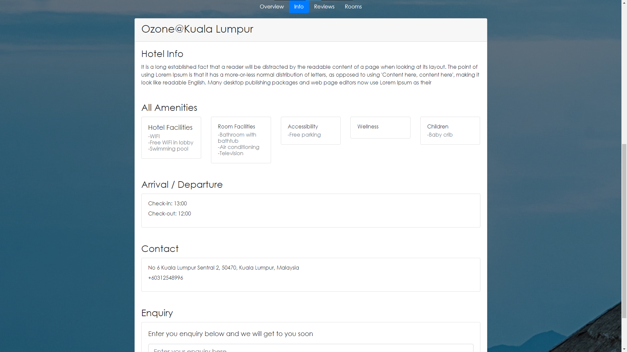

Figure 4-29. Hotel Reservation Website hotel detail page (3)

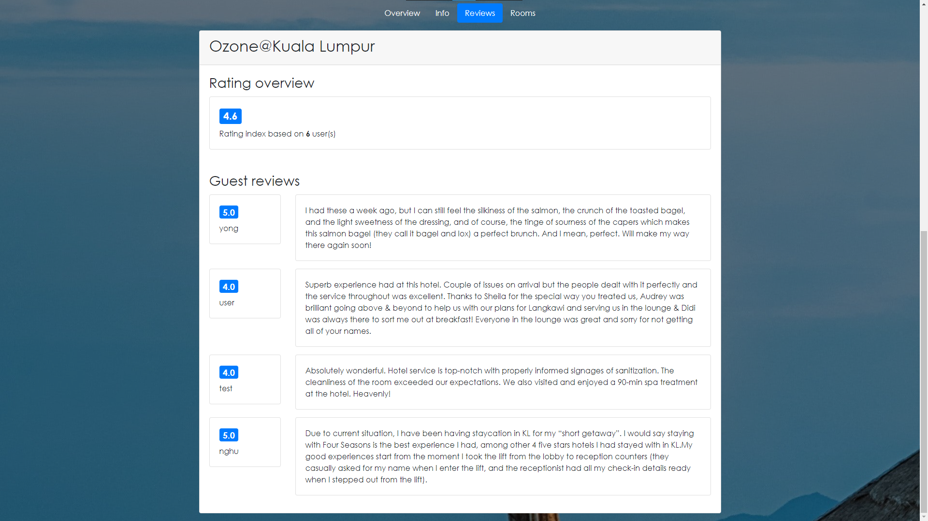

Figure 4-30. Hotel Reservation Website hotel detail page (4)

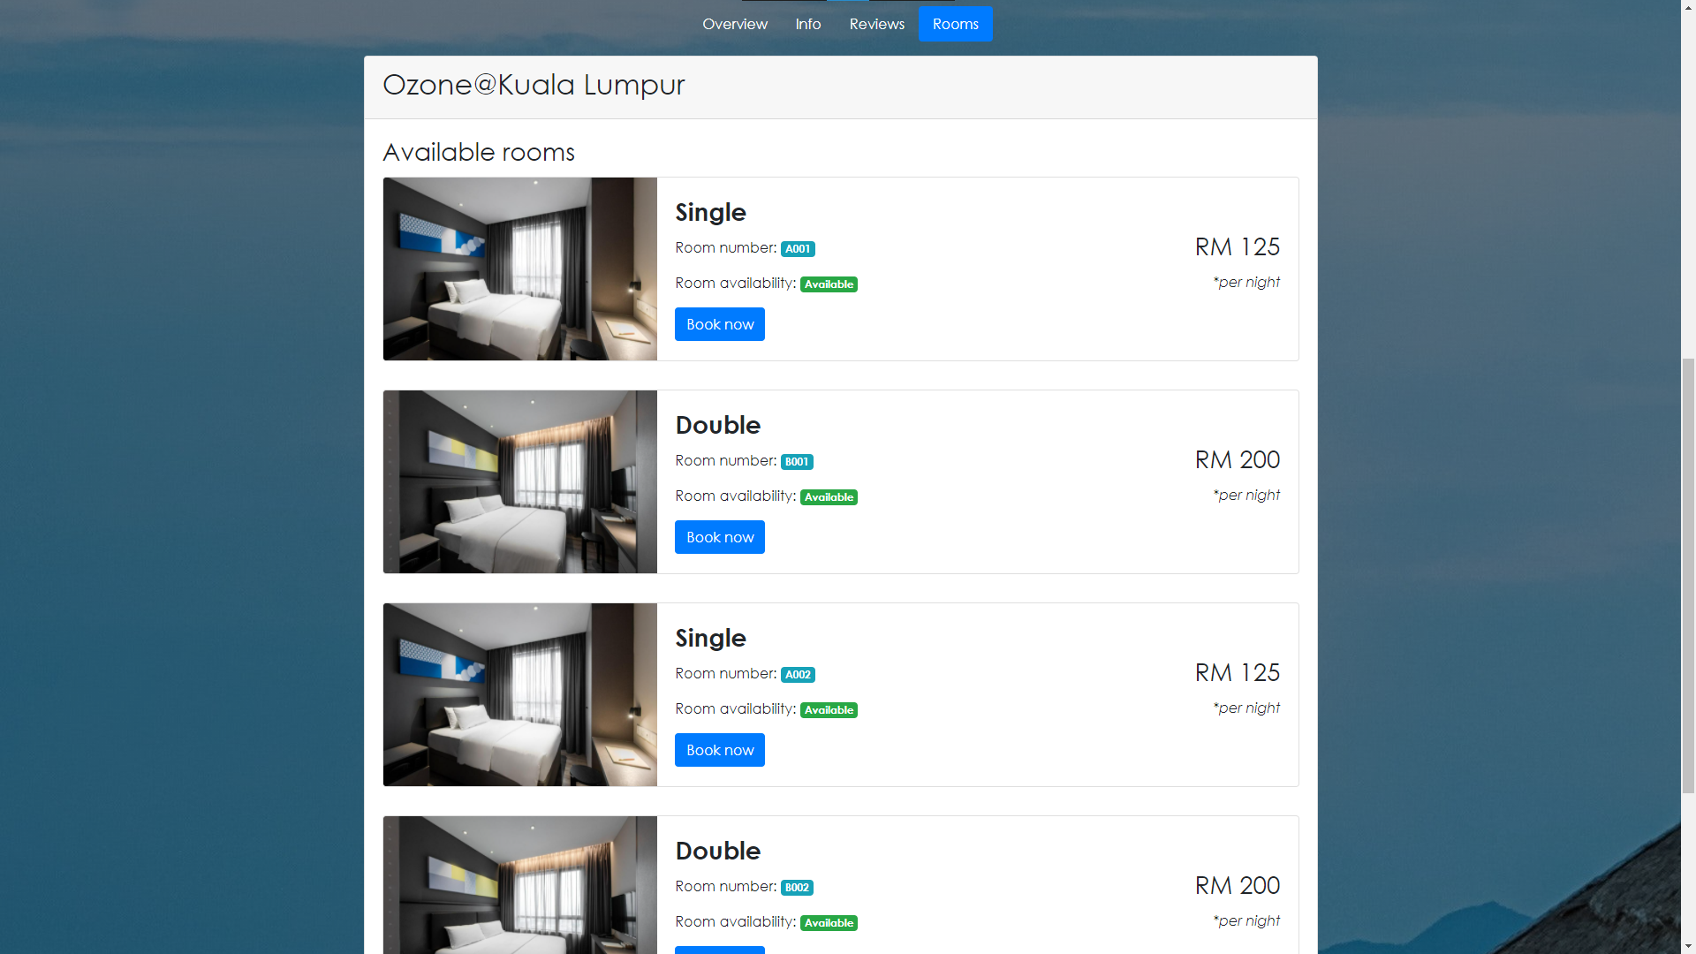

Figure 4-31. Hotel Reservation Website hotel detail page (5)

Figure 4-27, figure 4-28, figure 4-29, figure 4-30, figure 4-31 shows the Hotel Reservation Website hotel detail page. The user will be able to view the hotel information such as hotel name, hotel details, hotel’s amenities, hotel rating, hotel reviews and available rooms at this page.

### 4.3.8 Hotel Reservation Website book/reserve page

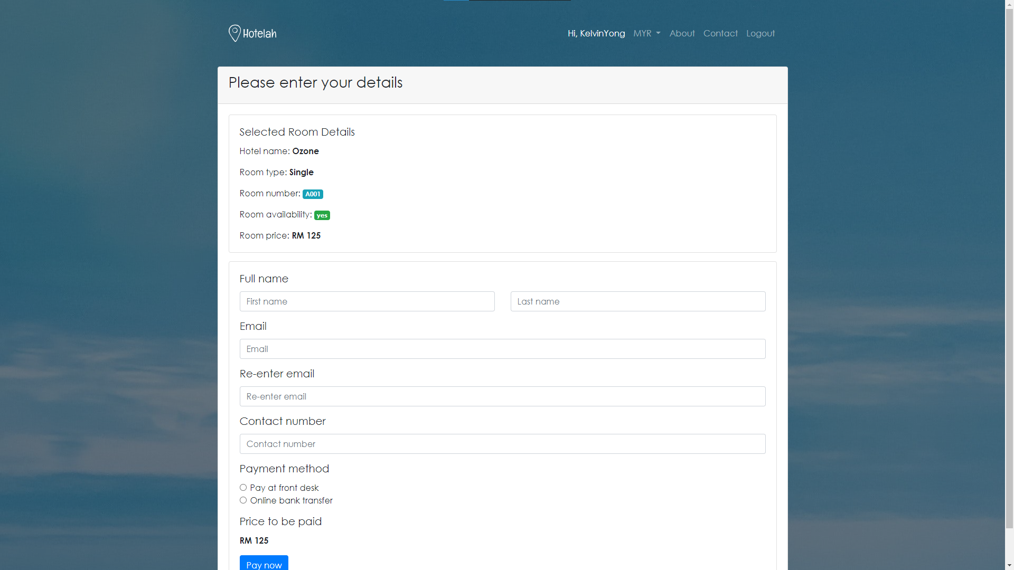

Figure 4-32. Hotel Reservation Website book/reserve page

Figure 4-29 shows the Hotel Reservation Website book/reserve page. In this page, the user will be prompted to enter their information in order to proceed to the payment page.

### 4.3.9 Hotel Reservation Website payment page

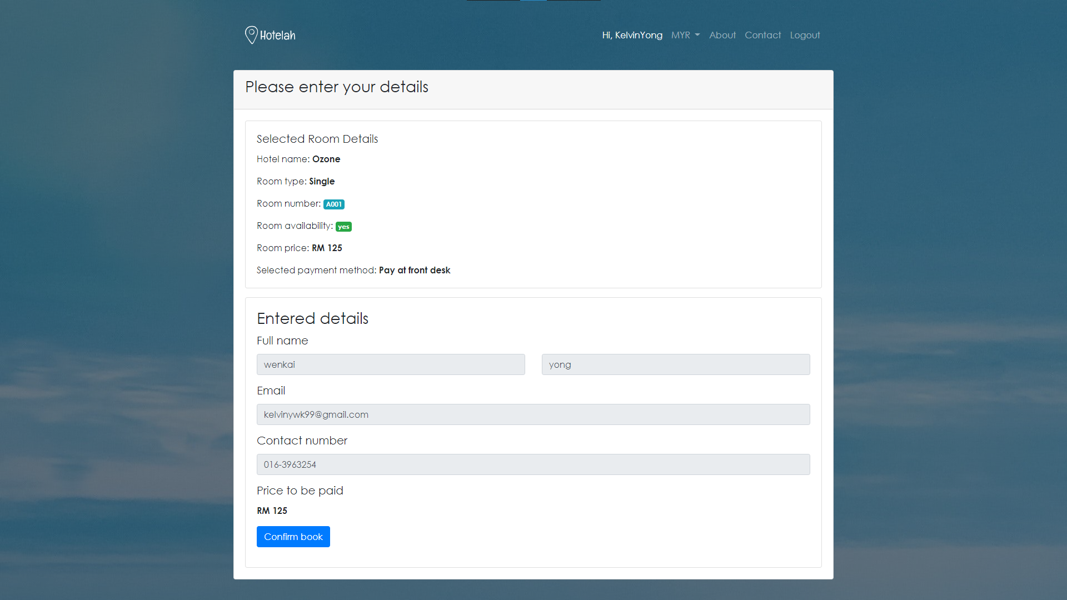

Figure 4-33. Hotel Reservation Website payment page

Figure 4-30 shows the Hotel Reservation Website payment page. The user will click on the confirm book button in order to initiate the booking. Once the button is clicked, an email will be sent to the user for confirmation purpose.

### 4.3.10 Hotel Reservation Website user profile page

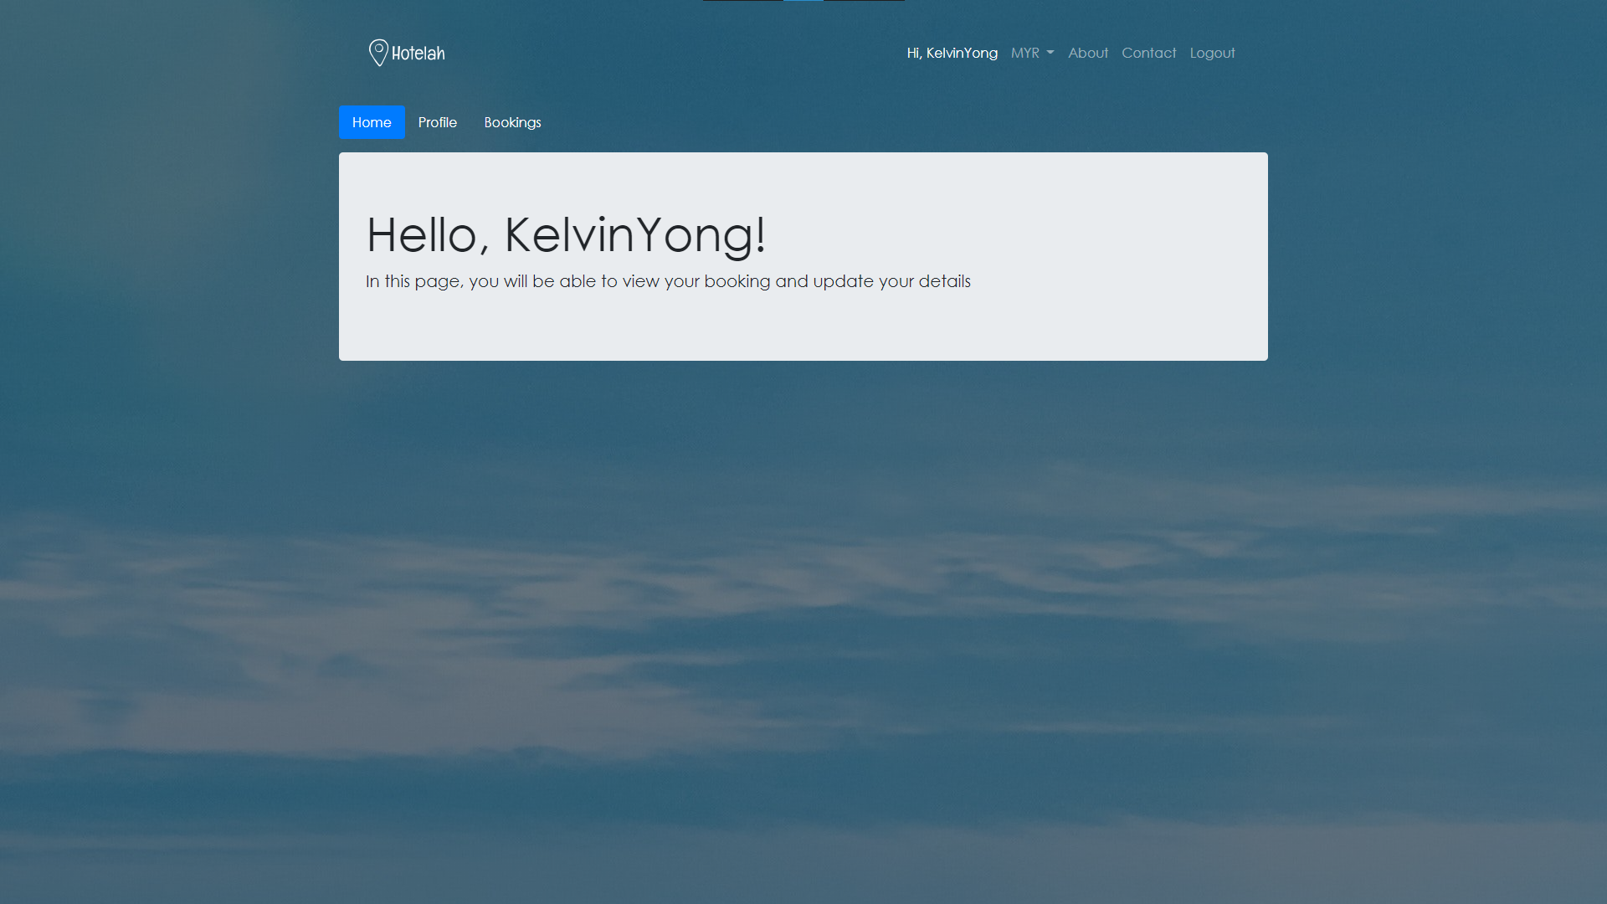

Figure 4-34. Hotel Reservation Website user profile page (1)

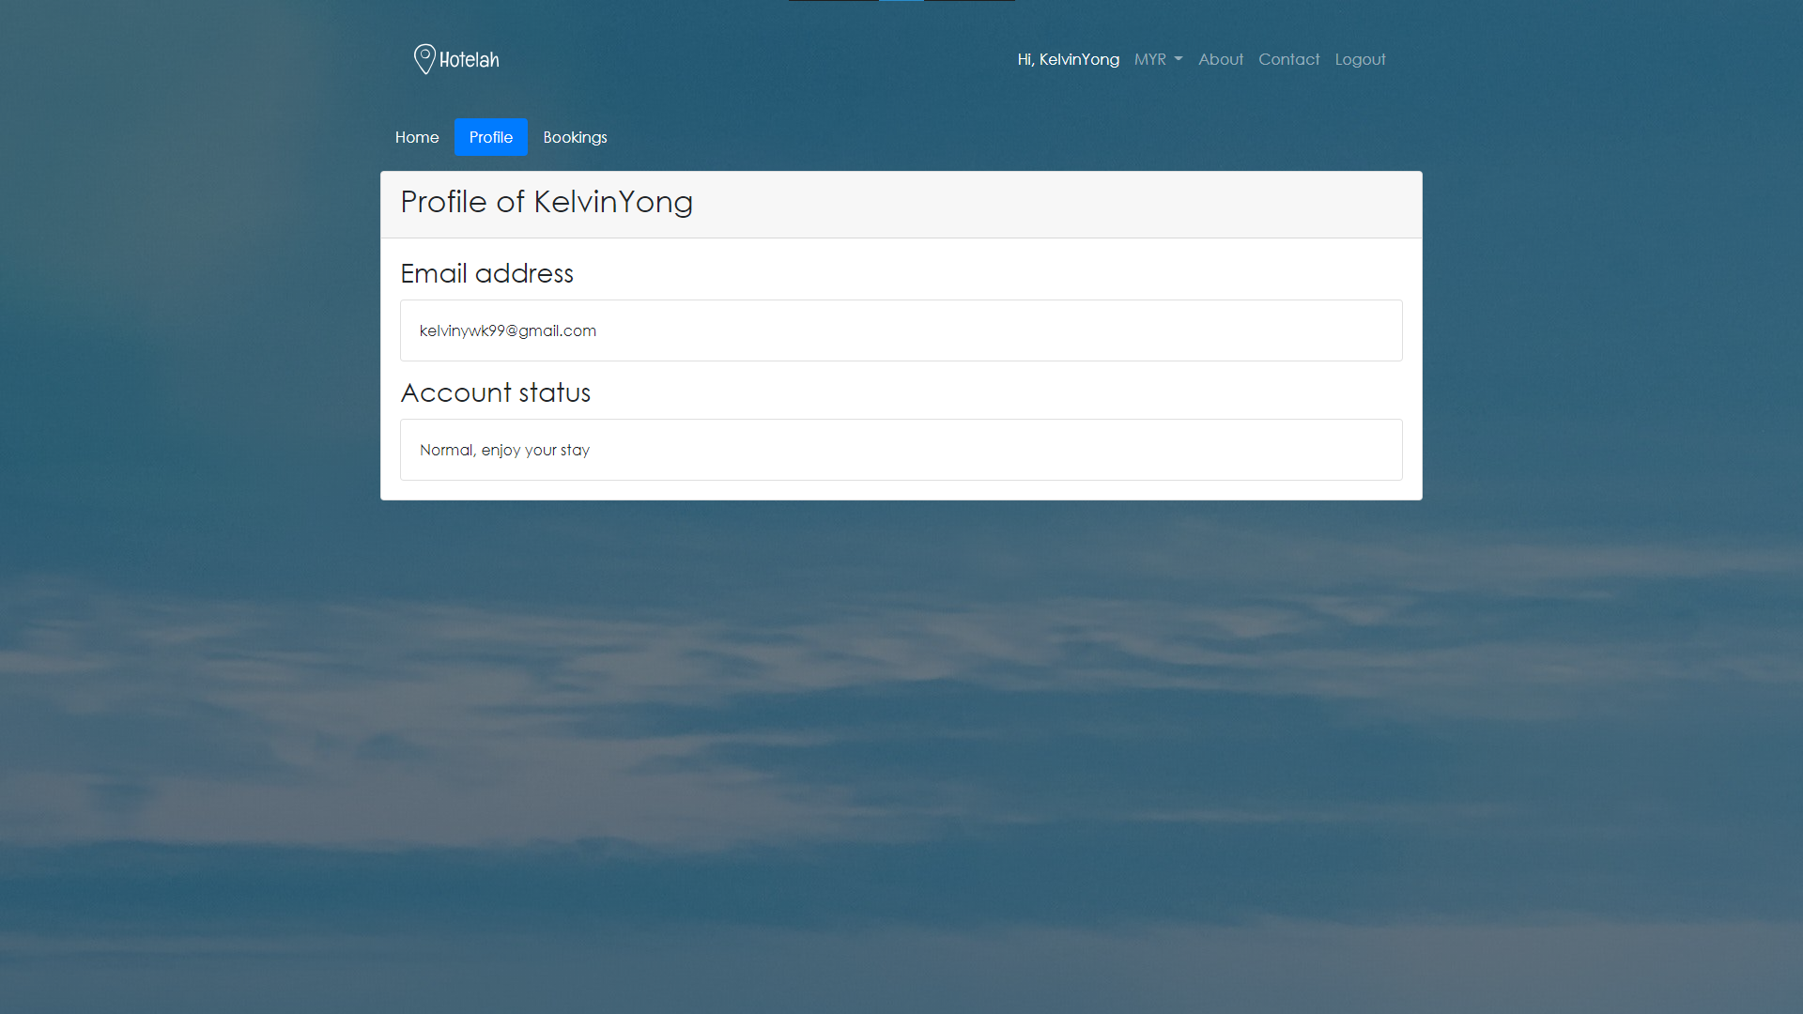

Figure 4-35. Hotel Reservation Website user profile page (2)

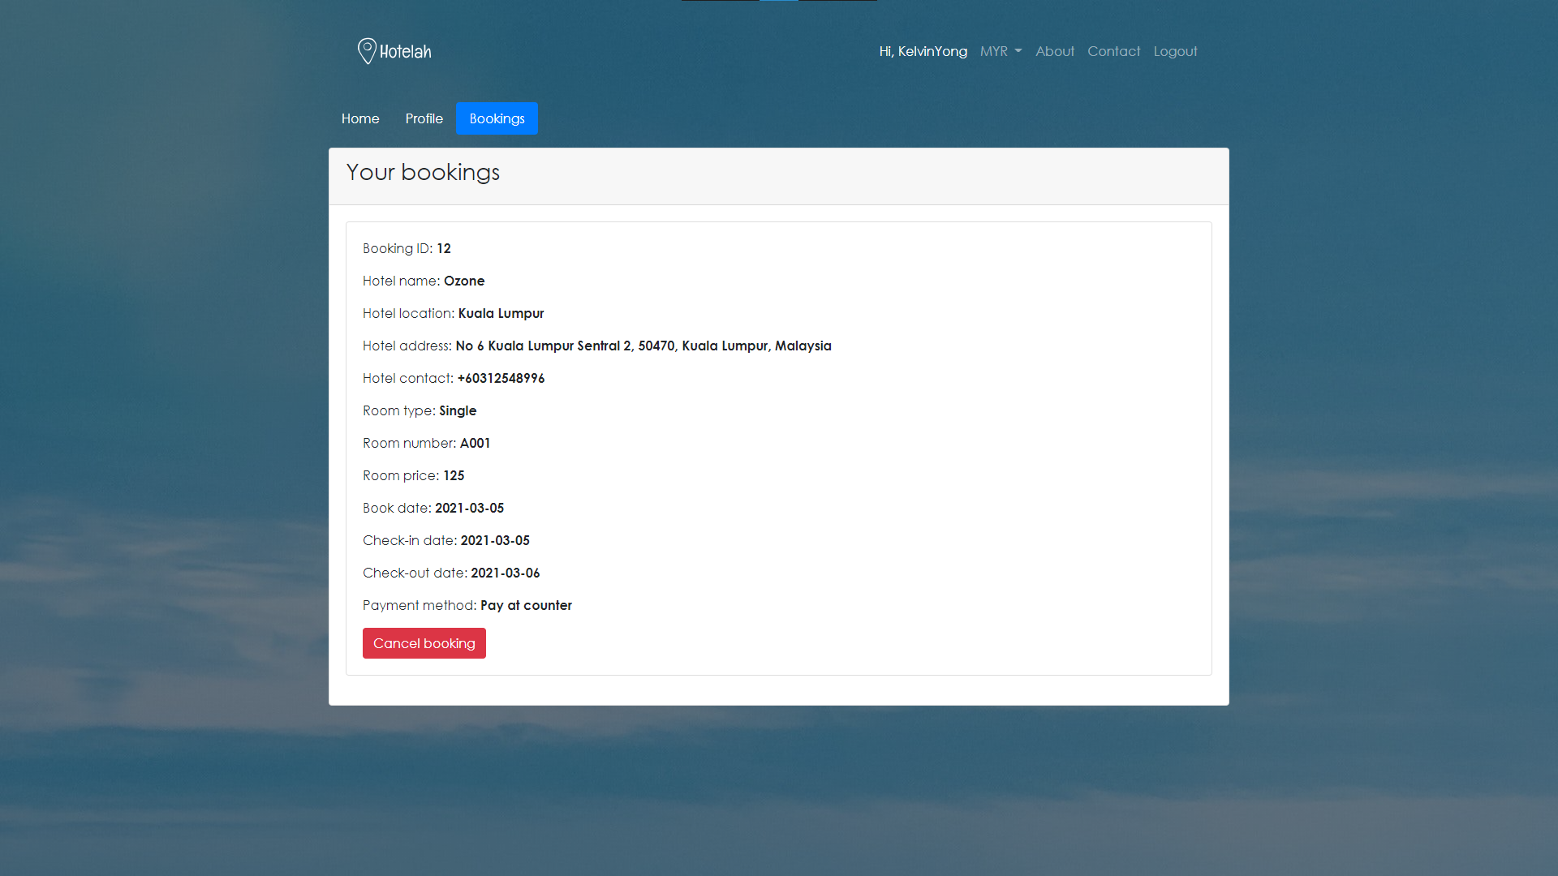

Figure 4-36. Hotel Reservation Website user profile page (3)

Figure 4-34, figure 4-35, figure 4-36 shows the Hotel Reservation Website user profile page. The user will be able to view their information and also cancel their booking in this page.

### 4.3.11 Hotel Reservation Website hotelier profile page

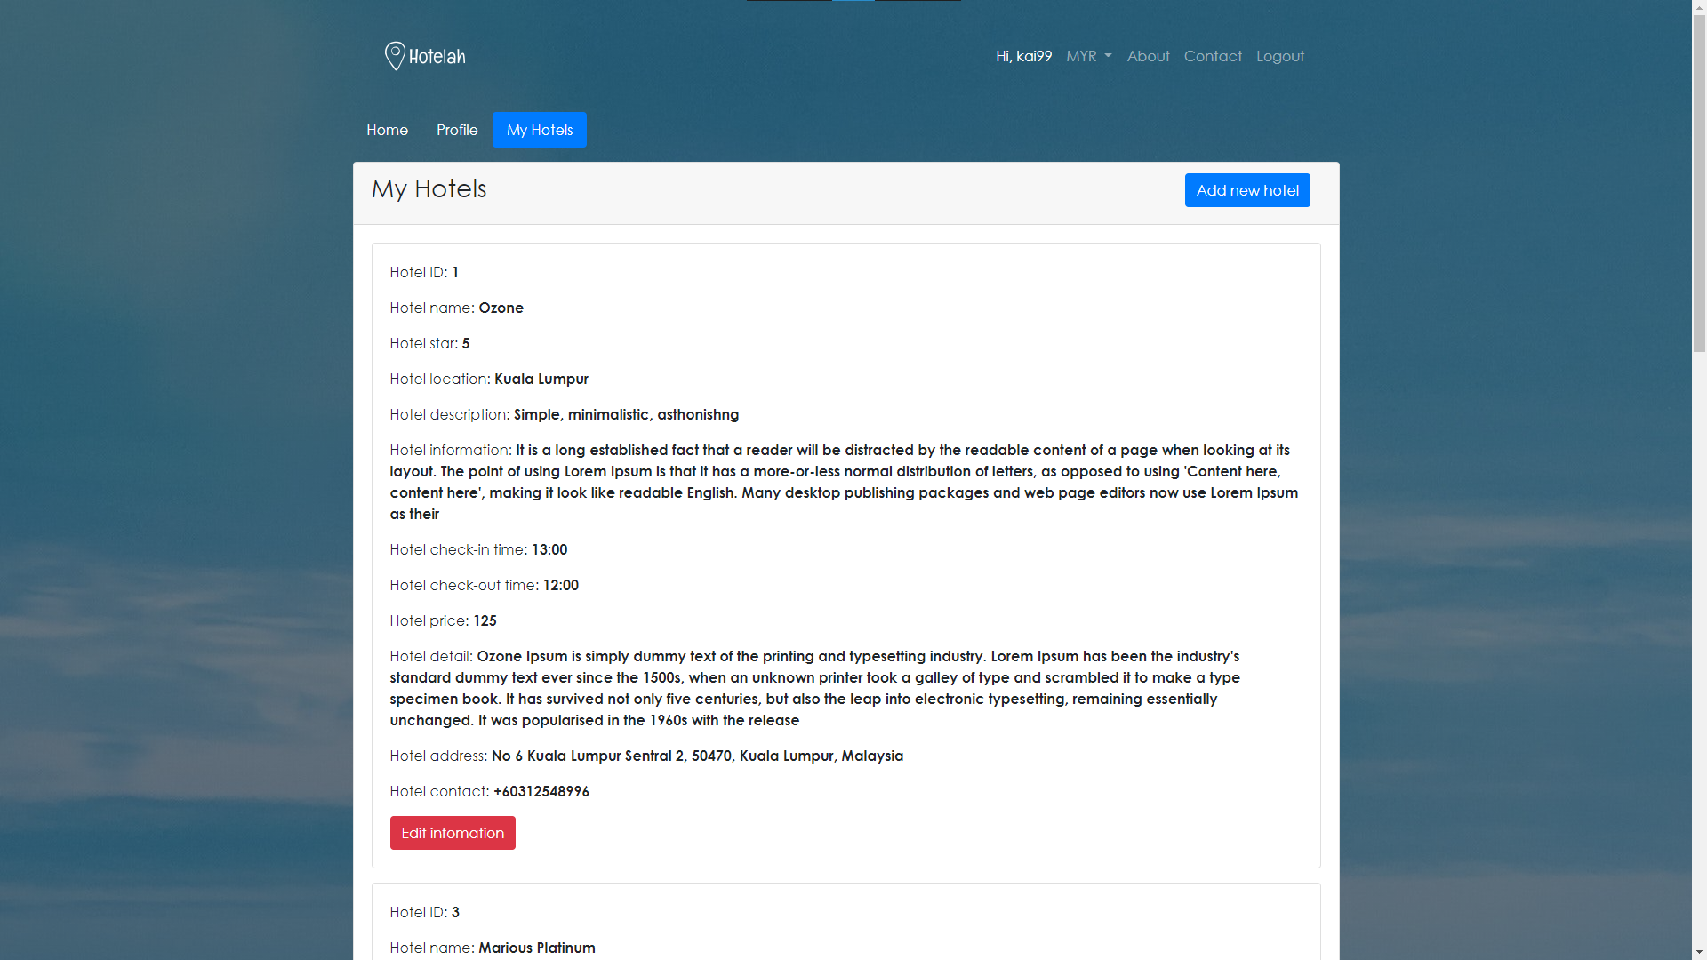

Figure 4-37. Hotel Reservation Website hotelier profile page

Figure 4-37 shows the Hotel Reservation Website hotelier page. In this page, the hotelier will be able to view their own information and as well as their registered hotel. They will also be able to add and manage their hotel.

### 4.3.12 Hotel Reservation Website add hotel page

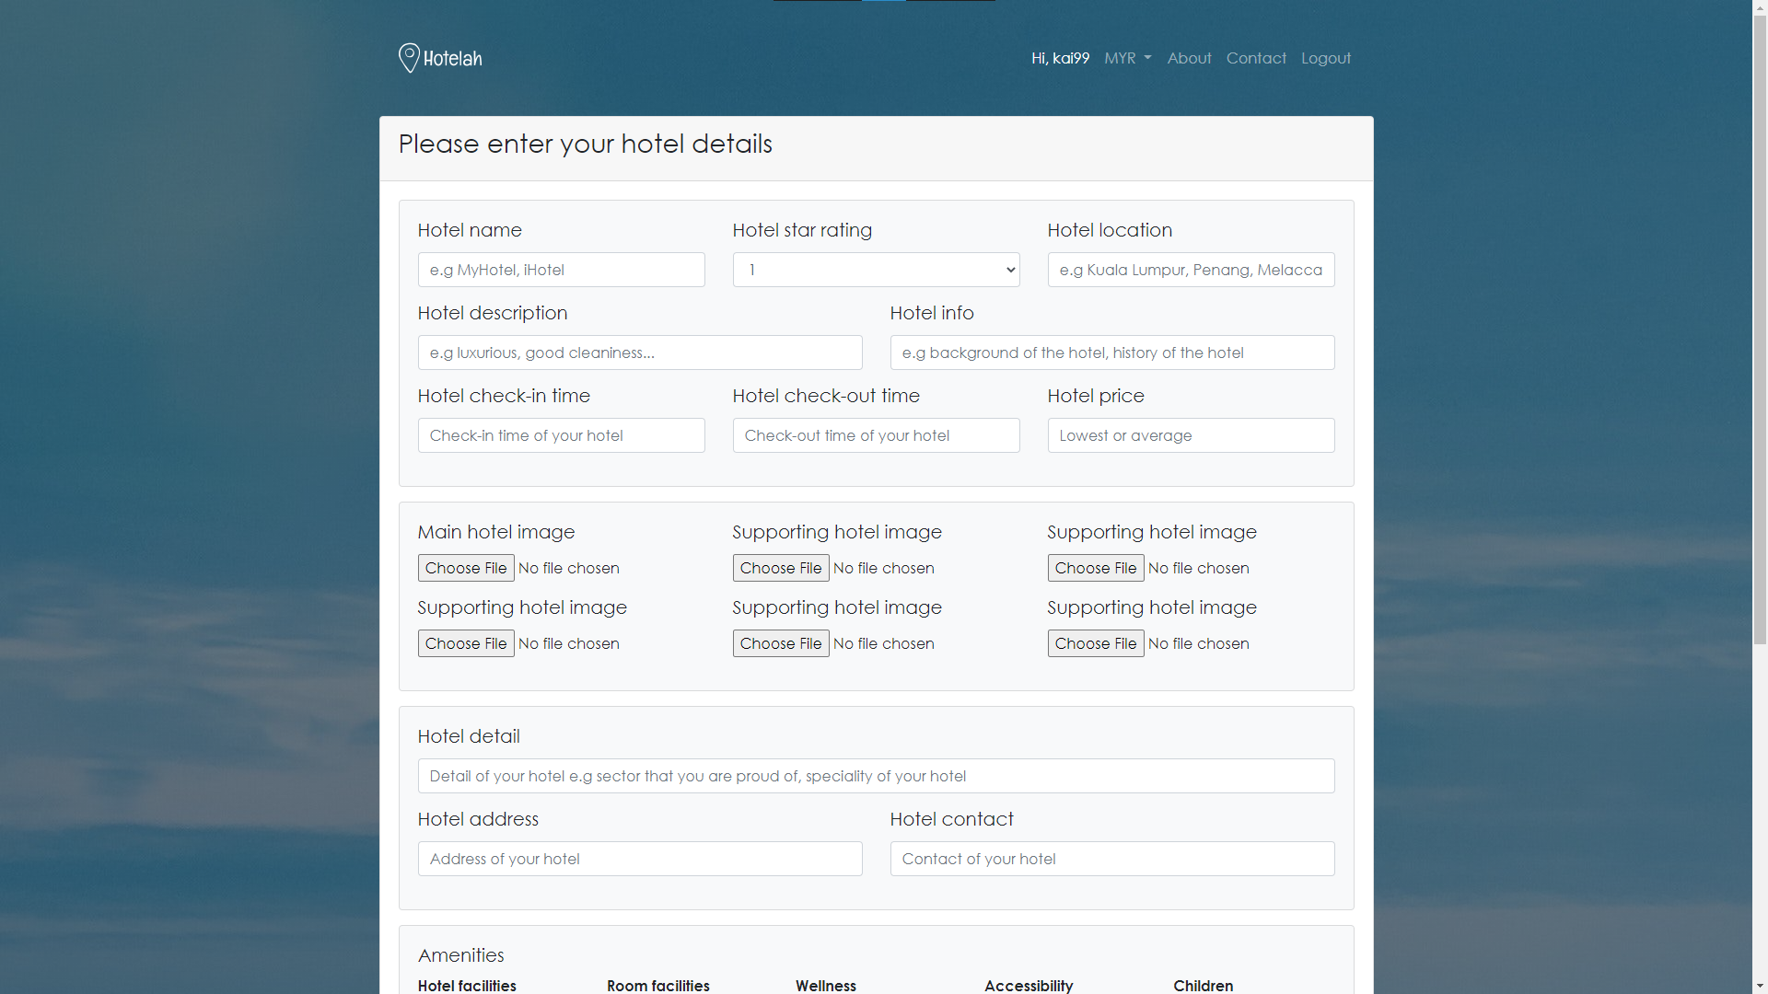

Figure 4-38. Hotel Reservation Website add hotel page (1)

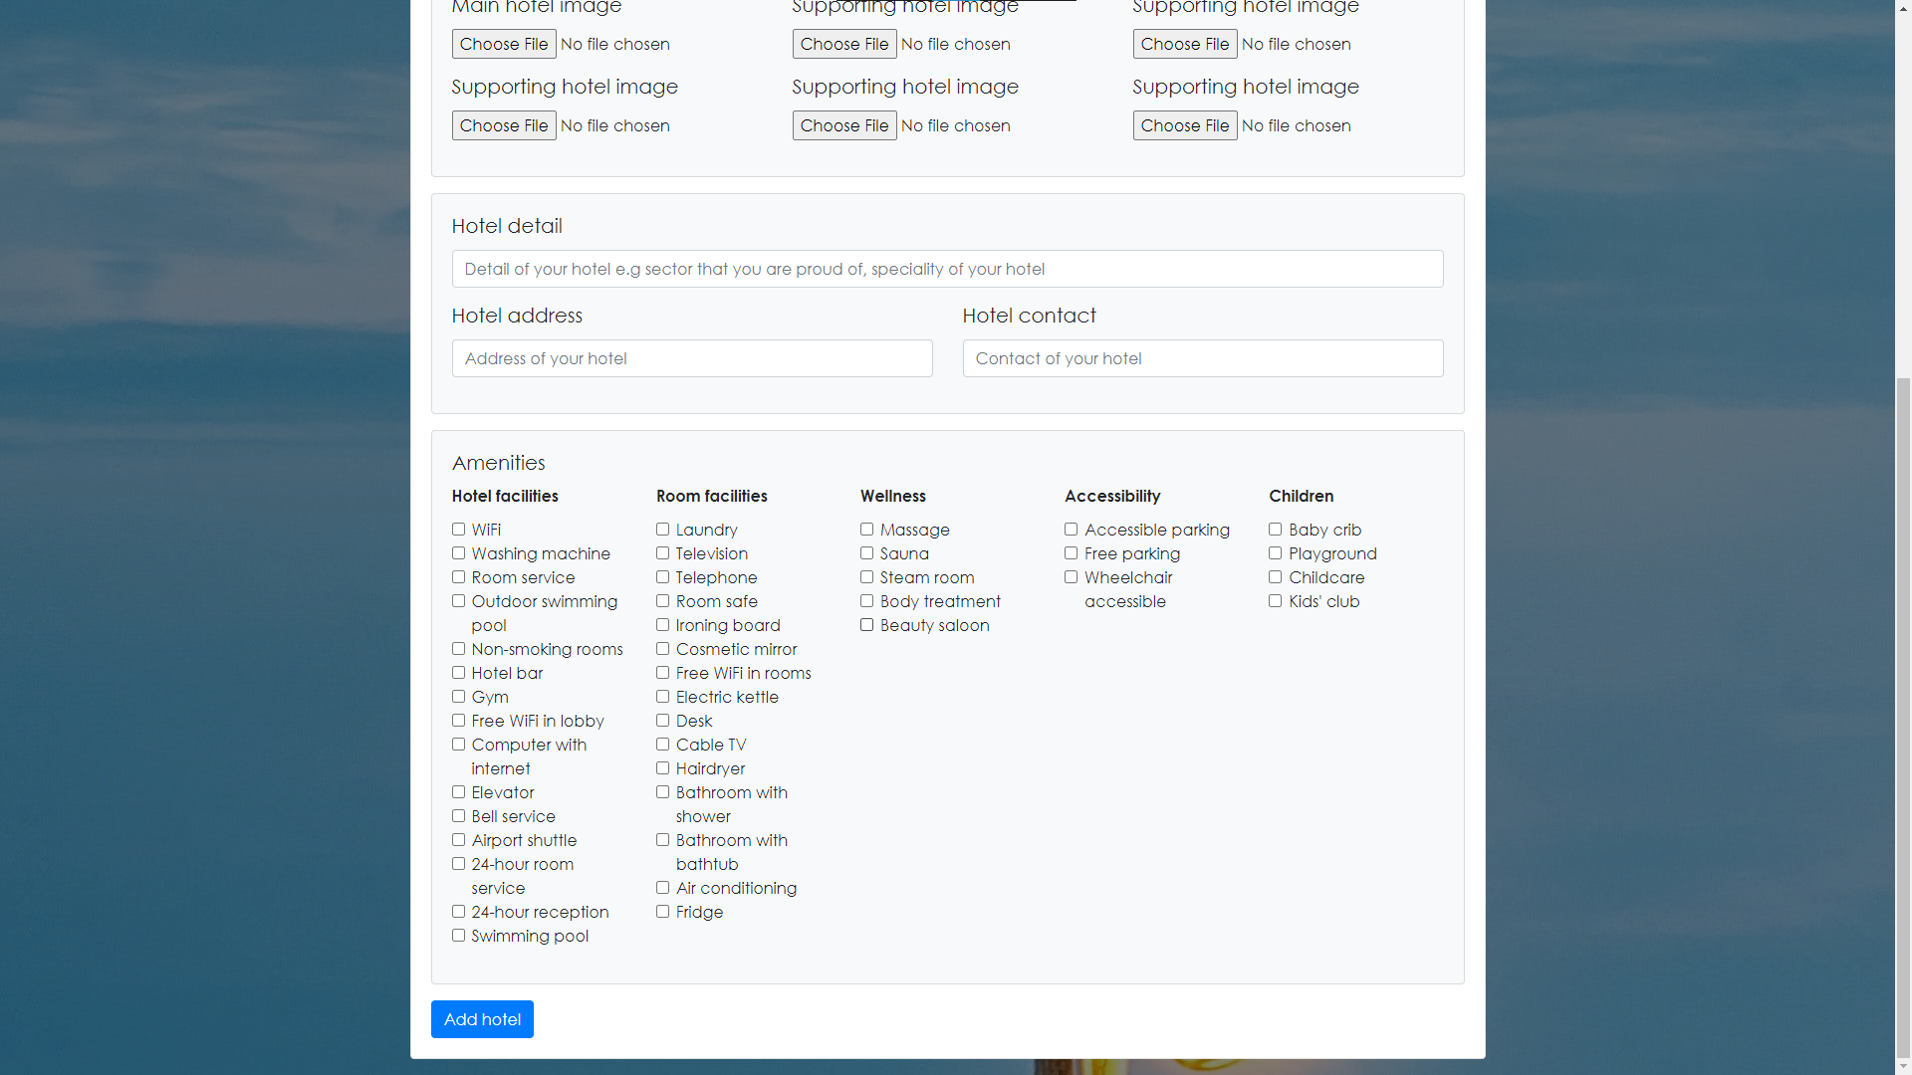

Figure 4-39. Hotel Reservation Website add hotel page (2)

Figure 4-38, figure 4-39 shows the Hotel Reservation Website add hotel page. In this page, the hotelier will enter their information such as hotel name, hotel price, hotel amenities and so on about their hotel.

### 4.3.13 Hotel Reservation Website edit hotel page

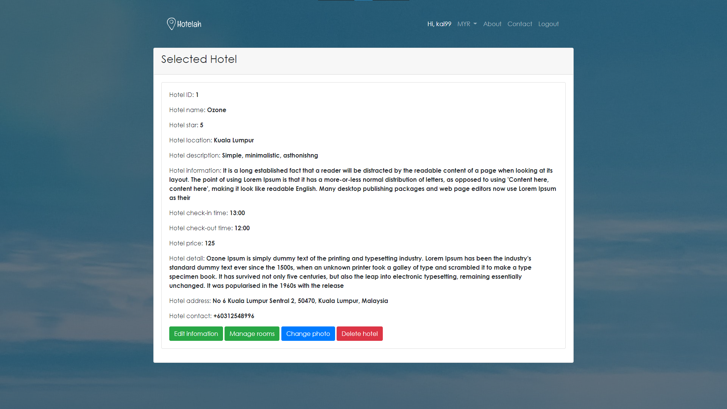

Figure 4-40. Hotel Reservation Website edit hotel page (1)

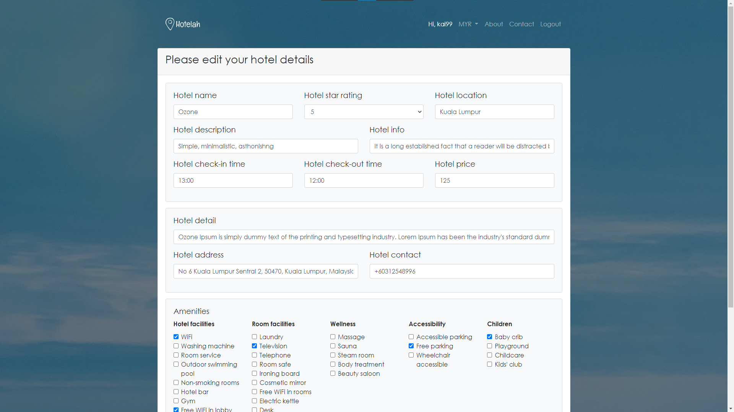

Figure 4-41. Hotel Reservation Website edit hotel page (2)

Figure 4-40 and figure 4-41 shows the edit hotel page of Hotel Reservation Website. In this page, the hotelier will be able to edit the hotel’s information, change the hotel’s photo manage hotel’s room and delete the hotel.

### 4.3.14 Hotel Reservation Website manage room page

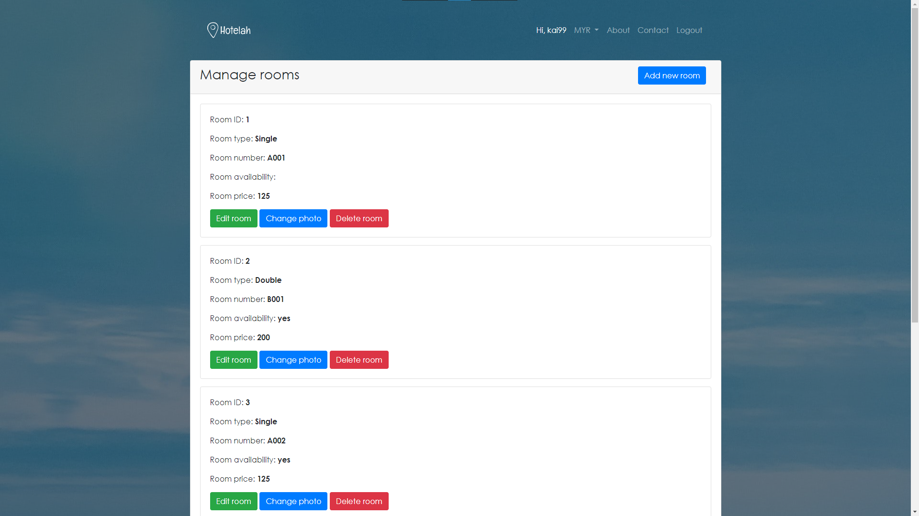

Figure 4-42. Hotel Reservation Website manage room page (1)

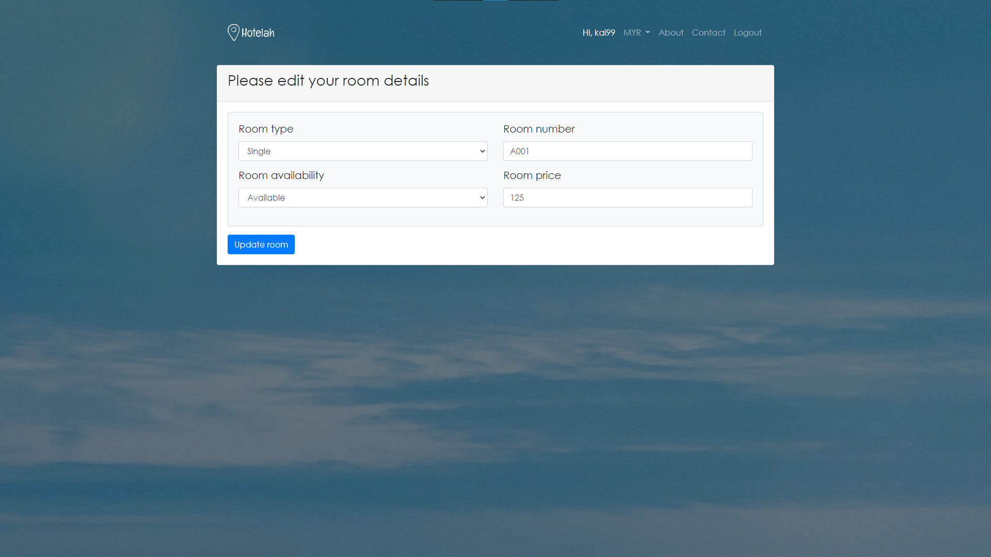

Figure 4-43. Hotel Reservation Website manage room page (2)

Figure 4-42 and figure 4-43 shows the Hotel Reservation Website manage room page. In this page, the hotelier will be able to edit the room’s information, change the room’s photo and delete the selected room.

### 4.3.15 Hotel Reservation Website admin page

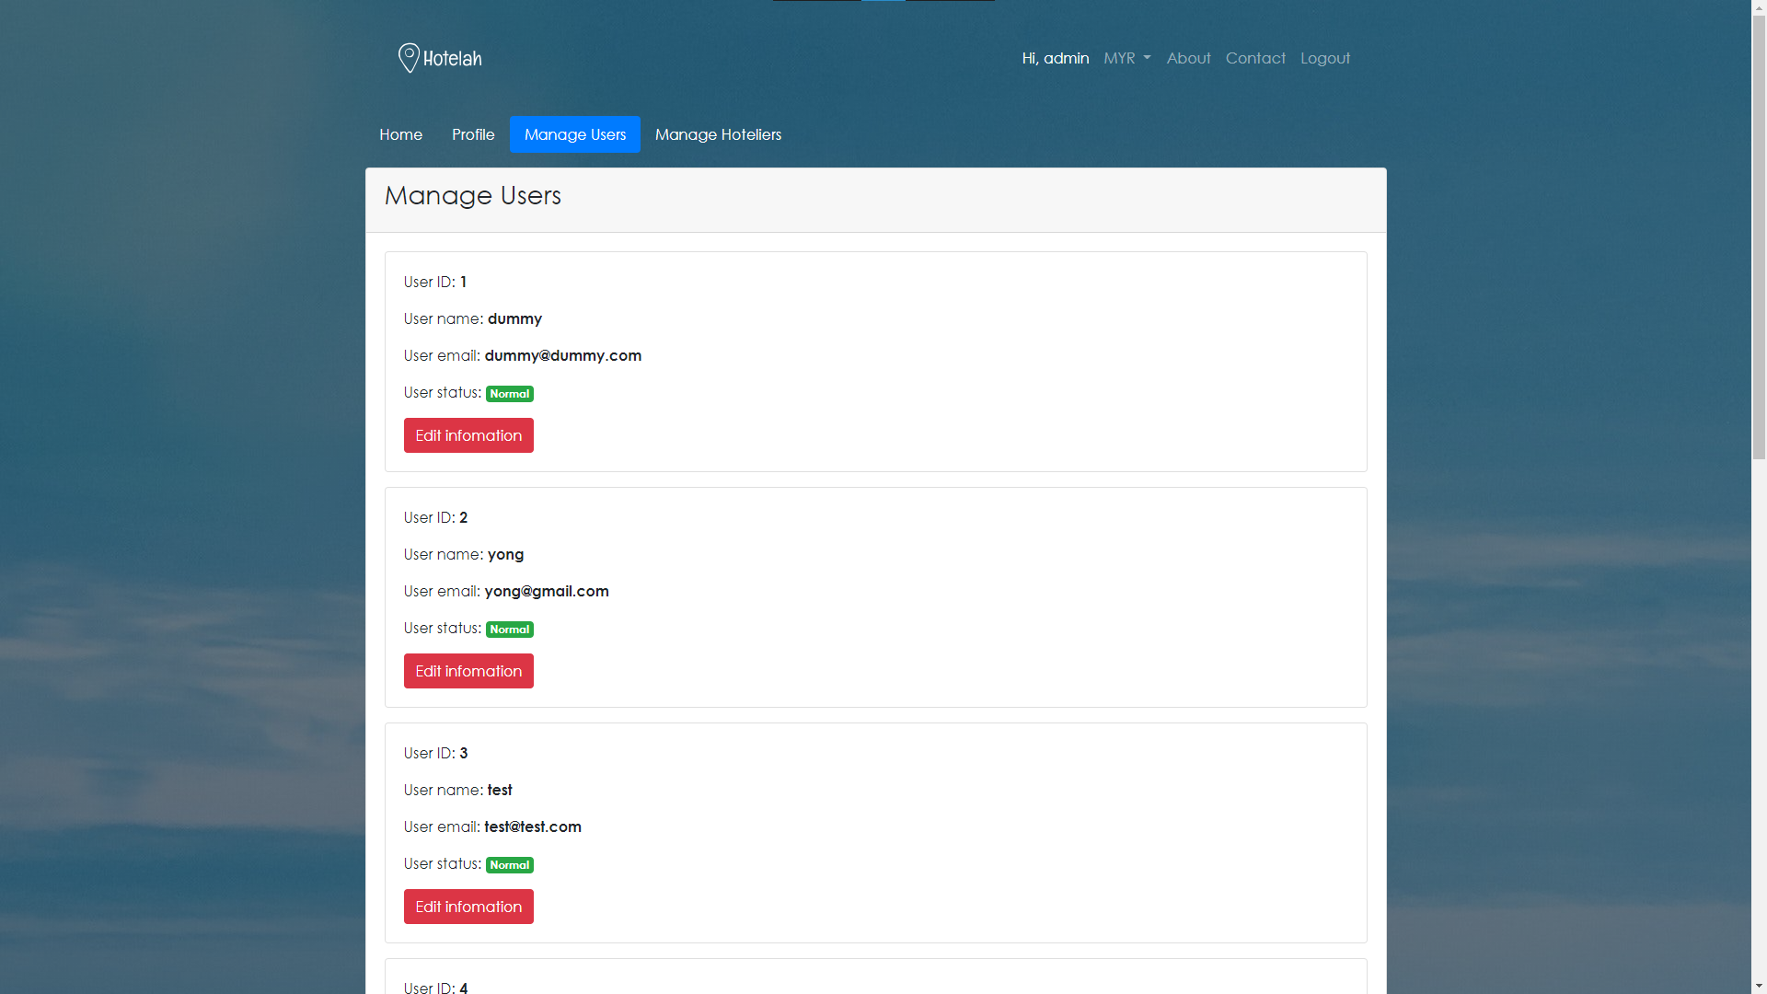

Figure 4-44. Hotel Reservation Website admin page (1)

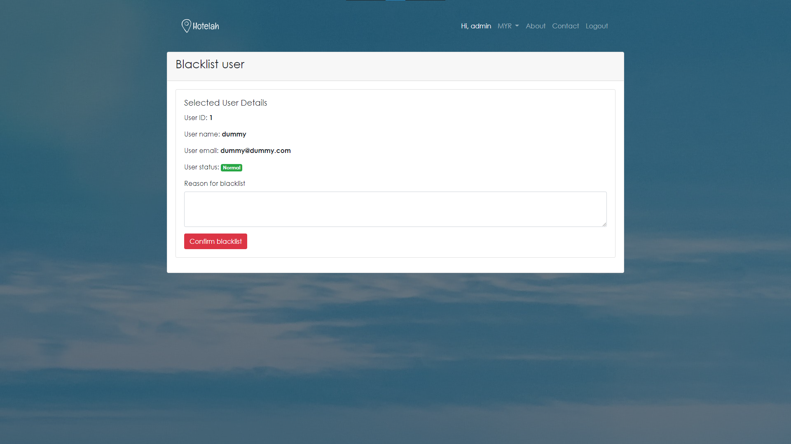

Figure 4-45. Hotel Reservation Website admin page (2)

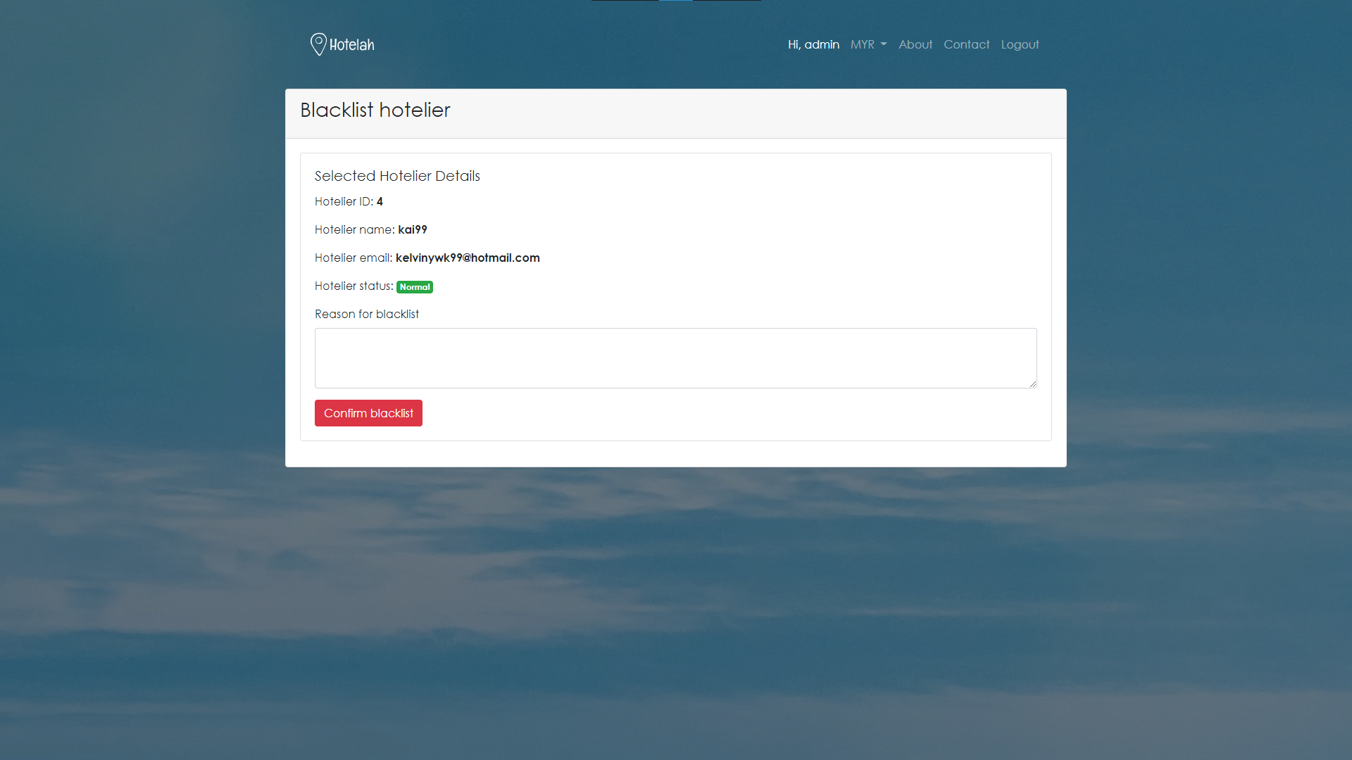

Figure 4-46. Hotel Reservation Website admin page (3)

Figure 4-44, figure 4-45 and figure 4-46 shows the admin page of Hotel Reservation Website. In this page, the admin will be able to edit the user’s and hotelier’s information by blacklisting them. Blacklisted user and hotelier will not be able to perform action such as booking, manage hotel.

### 4.3.16 Hotel Reservation website rate and comment page

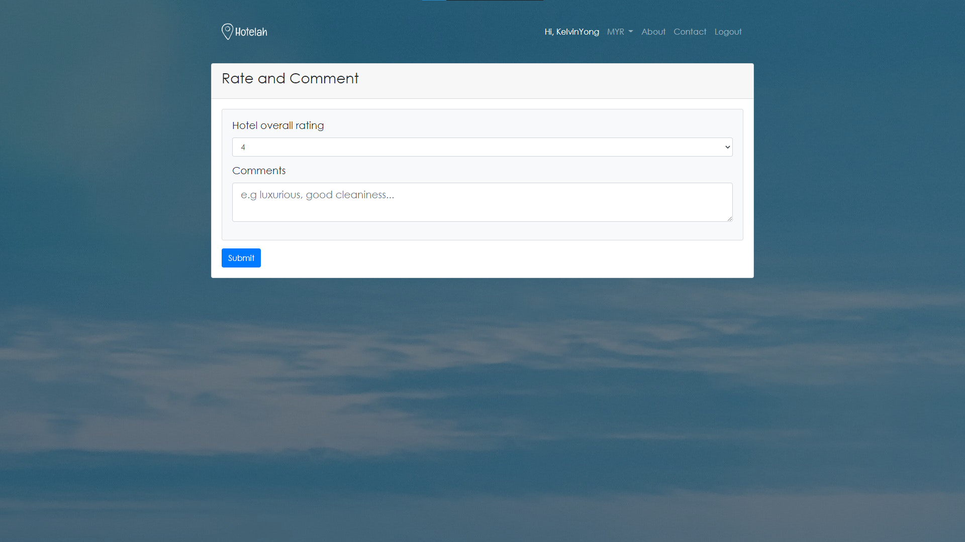

Figure 4-47. Hotel Reservation Website rate and comment page

Figure 4-47 shows the rate and comment page for Hotel Reservation Website. The user will be able to rate and comment the hotel that they booked once they had checked out from their hotel.

# Chapter 5: TESTING

## 5.1 Functional Testing

Black-box testing technique will be used to test out the Hotel Reservation Website in conformance with the requirement specification as stated above. Test cases are created in order to perform the testing and provide evidence of the test record. Test cases can be found at appendix B.

## 5.2 User Acceptance Testing

User acceptance testing is a type of testing that is done by the users to ensure that the system is functioning well and meet the requirements. The goal of this testing is to let the user test the final released version of the system from their own user’s perspective. The testing is done by using Google Form and have an approximate of 25 persons. The result was analysed in order to improve the system in the future.

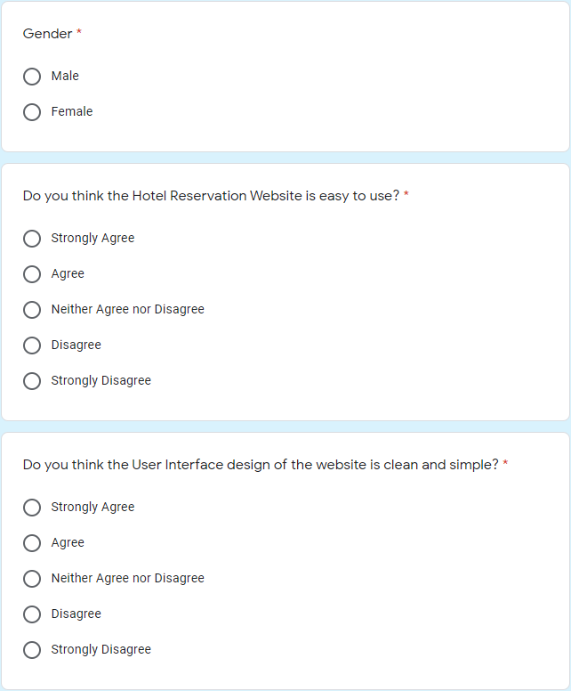

Figure 5-1. Feedback form (1)

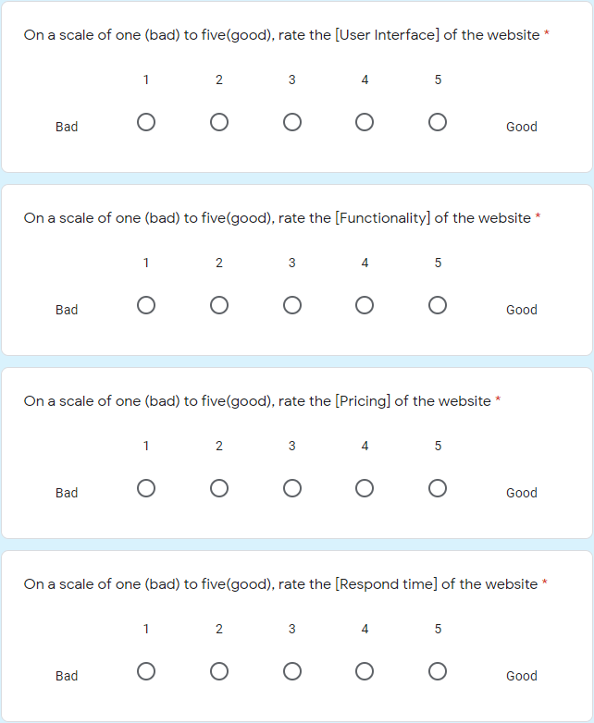

Figure 5-2. Feedback form (2)

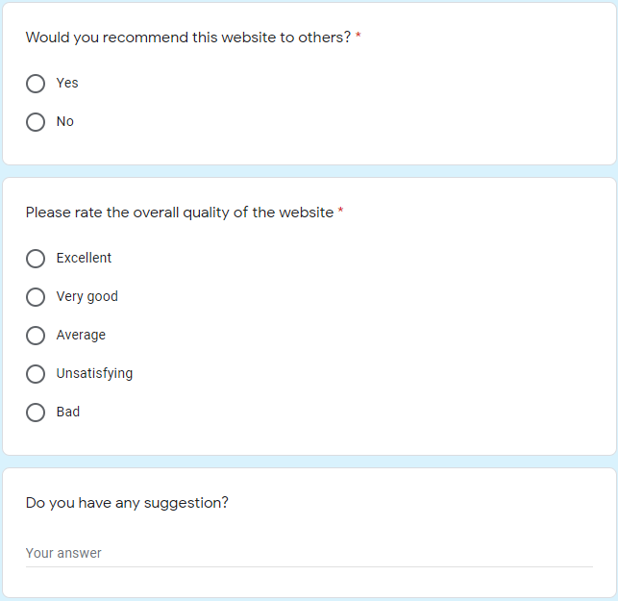

Figure 5-3. Feedback form (3)

### 5.2.1 Feedback Analysis

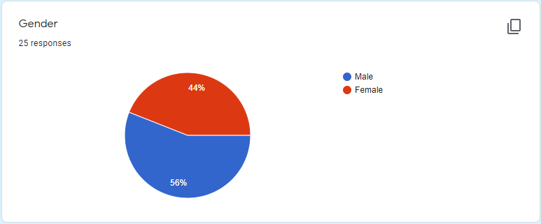

Figure 5-4. Gender of the respondent

Figure 5-4 shows that 44% of female and 56% of male are involved in the user acceptance testing.

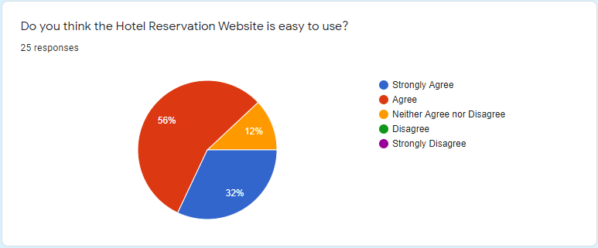

Figure 5-5. Do you think the Hotel Reservation is easy to use?

Figure 5-5 shows that majority of the respondent agree that the Hotel Reservation Website is easy to use while 32% of them strongly agree and only 12% of them felling neutral about the website.

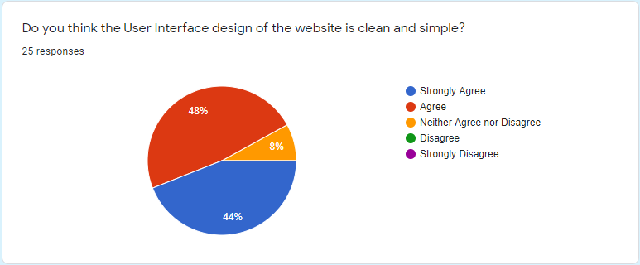

Figure 5-6. Do you think the user interface design of the website is clean and simple?

Figure 5-6 shows that majority of the respondent agree and strongly agree that the website’s user interface is clean and simple.

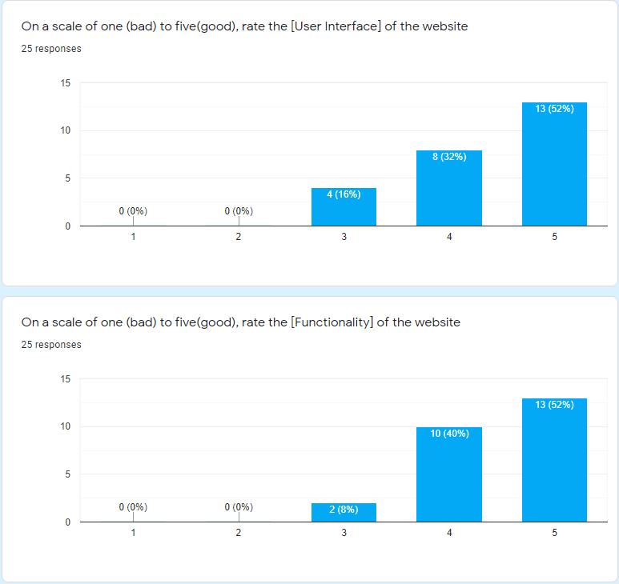

Figure 5-7. Rating of user interface and functionality of the website

Figure 5-7 shows that the user interface and functionality of the website have received a majority of four and five rating from the respondents.

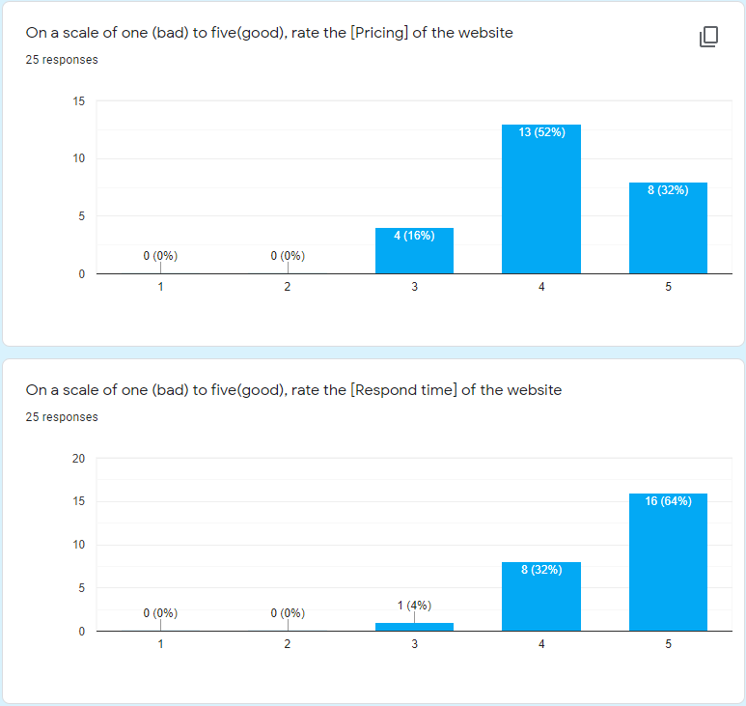

Figure 5-8. Rating of pricing and respond time of the website

Figure 5-8 shows that the rating of pricing and respond time of the website. In term of pricing of the hotels and rooms in the website, majority of the respondent gives a score of 4. While in the other hand, majority of the respondent have rated five on the respond time of the website.

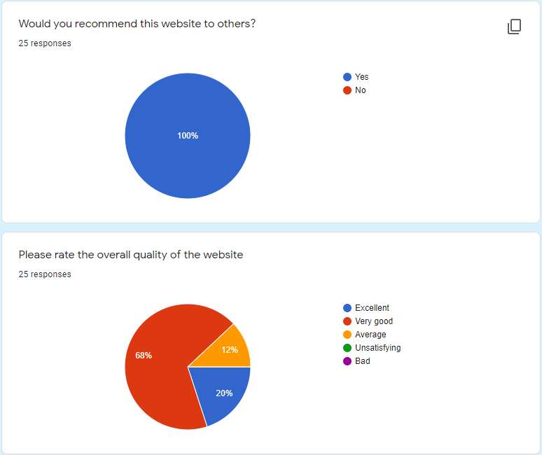

Figure 5-9. Recommendation and overall quality of the website

Figure 5-9 shows that 100% of the respondent would recommend this website to the others. Furthermore, majority of the respondent have rate very good on the overall quality of the website.

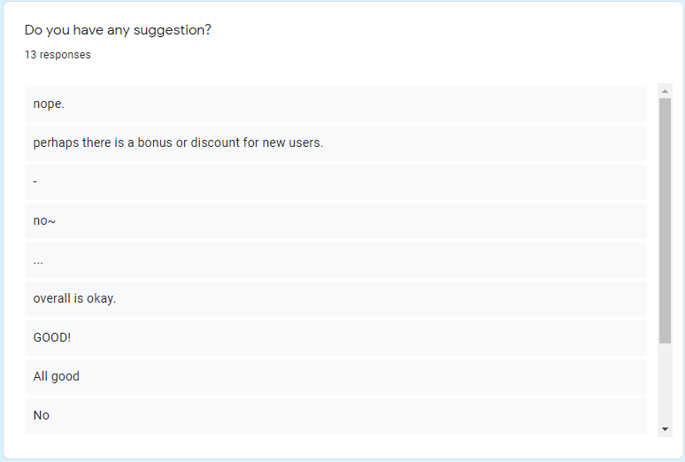

Figure 5-10. Suggestion for the website

Figure 5-10 shows the suggestion from the respondent. One of the respondents have suggested that to have a welcoming bonus or discount for new users.

# Chapter 6: CONCLUSION

## 6.1 Evaluation

The ultimate aim of this project is to develop a Hotel Reservation Website in order to allow travellers to search and book various of hotels, hoteliers to promote their hotels on the website. Main objective of this project and achievement are shown below.

Table 4-1. Objective accomplishment table

|  |  |  |  |
| --- | --- | --- | --- |
| No | Objectives | Complete | Method |
| 1 | Develop a Hotel Reservation Website to allows user to view and book hotels, hoteliers to manage and promote their hotels | Yes | A Hotel Reservation Website is built by using XAMPP as a testing server and also MySQL database server |
| 2 | Implement a personality matching feature in order | Yes | The feature is developed by using various of database query to display the user’s requested result |
| 3 | To create various booking method in order to comply with user’s preference | Yes | Booking method such as book first pay later and direct booking is implemented. |
| 4 | To create various payment method in order to comply with user’s preference | Yes | Payment method such as pay at front desk and card payment is implemented |

## 6.2 Limitation

The limitation of this project is it lack of compatibility when it comes to various of screen size and various of viewing device such as mobiles and tablets.

## 6.3 Lesson Learnt and Skill

The thing that I learned and considered the most important and vital during this project is time management and consistency. A good time management and consistency is the most important thing when it comes to everything and not just in software engineering. Other than that, scripting language, programming language and frameworks such as HTML, CSS, Bootstrap, JavaScript and PHP are considered new to me. During the development of this project, it does help me in enhancing my knowledge in these scripting and programming language.

## 6.4 Future Plan

In order to provide various of device compatibility, different parameters and versions of the system will need to be implemented. Moreover, the system will be implementing more payment method to simplify the user on payment.

# REFERENCES

1. Agoda. (3 August , 2020). *Agoda*. Retrieved from agoda.com: https://www.agoda.com/
2. Airbnb. (3 August, 2020). *Airbnb*. Retrieved from airbnb.com: https://www.airbnb.com/
3. Andrews, E. (28 October, 2019). *Who Invented the Internet?* Retrieved from history.com: https://www.history.com/news/who-invented-the-internet#:~:text=ARPANET%20adopted%20TCP%2FIP%20on,invented%20the%20World%20Wide%20Web.
4. CERN. (16 October, 2020). *The birth of the Web*. Retrieved from home.cern: https://home.cern/science/computing/birth-web#:~:text=Tim%20Berners%2DLee%2C%20a%20British,and%20institutes%20around%20the%20world.
5. Elon University School of Communications. (16 October, 2020). *1870s-1940s-Telephone*. Retrieved from elon.edu: https://www.elon.edu/e-web/predictions/150/1870.xhtml#:~:text=While%20Italian%20innovator%20Antonio%20Meucci,for%20the%20device%20in%201876.
6. INTERNETING IS HARD. (16 October, 2020). *Introduction No.1 of HTML & CSS IS HARD*. Retrieved from internetingishard.com: https://www.internetingishard.com/html-and-css/introduction/#:~:text=HTML%2C%20CSS%2C%20%26%20JavaScript,languages%20that%20run%20the%20web.&text=HTML%20is%20for%20adding%20meaning,that%20content%20and%20formatting%20interactive.
7. Miniwatts Marketing Group. (7 June, 2020). *internetworldstats.com*. Retrieved from Internet Growth Statistic: https://www.internetworldstats.com/emarketing.htm
8. Pal, S. K. (18 March, 2018). *Software Engineering | Iterative Waterfall Model*. Retrieved from geeksforgeeks.org: https://www.geeksforgeeks.org/software-engineering-iterative-waterfall-model/?ref=lbp
9. Pascarella, S. (9 July, 2009). *What Do Hotel Star Ratings Really Mean?* Retrieved from smartertravel.com: https://www.smartertravel.com/hotel-star-ratings-what-do-they-mean/
10. Trivago. (3 August, 2020). *Trivago*. Retrieved from trivago.com: https://www.trivago.com/
11. w3schools. (16 October, 2020). *PHP Introduction*. Retrieved from w3schools.com: https://www.w3schools.com/php/php_intro.asp
12. Wikipedia. (13 October, 2020). *XAMPP*. Retrieved from en.wikipedia.org: https://en.wikipedia.org/wiki/XAMPP

# APPENDIX A: COMMERCIALIZATION PROPOSAL

## 1. Executive Summary

The web-based Hotel Reservation System aims to provide users, hoteliers a platform to perform booking process and hoteliers to promote and manage their own hotels. Based on the analysis on existing system, problems such as website that is full of advertisements, messy and packed user interface design are seems to be a discomfort for the users and hoteliers. To come up with a solution, the web-based Hotel Reservation System is able to provide a totally advertisement free website with clean and simple user interface for users. Furthermore, the website is also able to provide users with function such as the personality matching feature to allows users to search for desired hotel more easier.

## 2. Market Analysis

Based on previous analysis on survey form, age group of 18-24 had the most percentage compared to other age group such as 25-44, 45-64, 65 and above. Other than that, students also had the most percentage compared to other occupation such as unemployed, working and retired. With that, targeted customers are able to finalised with age group of 18-24 and 25-44 with occupation of student and working. This is because two of these group had occupied the most in the survey. Other than that, popular competitors in the hotel sectors such as Agoda, Trivago, Expedia, Trip advisor, Booking.com, Airbnb are considered as strong competitors to this project.

## 3. Problem Statement

Advertisement such as pop ups, inappropriate content of advertisement, advertisement that blocked the content of the website, messy user interface are reported to be the problem that faced by target customers. Based on the market analysis, target customers are most like to driven by the pricing and functionality of the website. With that, pricing functionality are considered as the needs of the targeted customers.

## 4. Unique Value Proposition

With the problem stated in the previous section, solution such as simple and clean user interface design, advertisement free website is proposed as the unique value compared to the current market. Other than that, personality matching featured is also proposed to be the uniqueness of this project. With the personality matching feature, the user will be easier to find hotels that matches their personality. For example, people who prefer quiet places are automatically suggested with hotels that are far away from the city center to avoid noise pollutions.

## 5. Objective

* To develop a hotel reservation system with implementing a search engine for user without discomfort and messy searching experience and allowing view the hotel and the hotel rooms via pictures with price range and rating.
* Implementing a personality matching feature for users that allow users to comment, rate or gives feedback to the particular hotel.
* To develop various booking methods such as book now, book now pay later and cancellation of booking with or without cancellation fees based on the duration of booking.
* To create multiple payment methods such as pay using bank transfers, PayPal or pay when reach the hotel.

## 6. Methods and Scope of Work

The scope of this project consist of three module which is user, hotelier and admin module. This project will be developed by using the iterative waterfall model. By using iterative waterfall model, the project can go back in previous stages and make changes if something went wrong in the current stage. This project is developed by using various of web development programming languages, scripting languages, database and frameworks such as HTML, bootstrap, PHP, JavaScript and MySQL. XAMPP will be used as a local testing server for apache and as well as MySQL server.

## 7. Business Model

For this project, no amount of revenue is generated and as well as money on development. For marketing of this project, it is done by creating a Facebook page and through socializing between colleague, friends and families.

## 8. Milestones and Key metrics

This project has involved a total of 6 months from planning to development to final release. On planning stage, approximately 3 months had been taken and another 3 months on development stage. The results will be evaluated based on the system specification and project objective that had been stated.

## 9. Project Outcome

This project will successfully develop a web-based Hotel Reservation Website with various of functionalities such as personality matching, various booking methods and various payment methods.

## 10. Strength, Weakness, Opportunity, and Treat (SWOT) analysis

### 10.1 Strength

The strength of this project is that it will have completely advertisement free website, a personality matching feature and a simple, clean user interface design.

### 10.2 Weaknesses

Weaknesses of this project includes unable to support multiple platform compatibility, online hosting server is not presence and unable to accept more payment methods. Since the project files and database are kept in local machine, there are risk of file corruption and hardware failure. These risk can be mitigated by keeping the project in a cloud services such as GitHub and google drive so that the project will always have a back up in case of file corruption and hardware failures.

### 10.3 Opportunities

The current market is lacking websites that have a advertisement free and simple and clean user interface. Most of the existing system are having a packed and messy user interface and packed with advertisements and pop ups as well. With that being discovered, this project can use its clean and simple user interface and completely advertisement free as its advantage to stand out in the market.

### 10.4 Threats

Website creating and hosting services such as WordPress and wix.com that will handle all the website creation, hosting and payment gateway as well will be the primary threat to this project. This is because that, people who are using that can easily create another hotel reservation website without any hassle and with more advantage such as multiple platform compatibility and various of payment methods.

# APPENDIX B: SUPPORTING DOCUMENTS

## A. Functional Testing Test Cases Table

Table 0-1. Homepage test cases

|  |  |  |  |  |  |  |
| --- | --- | --- | --- | --- | --- | --- |
| Test Title: Verify Home Page | | | Main Module Name: | | Submodule Name: | |
| Test Case ID | Description | Test Steps | Test Data | Expected Result | Actual Result | Status (Pass/Fail) |
| TH01 | Test opening homepage | 1. Navigate to <http://localhost/WebBasedHotelReserve/hotel/index.php> |  | Site should open | As expected | Pass |
| TH02 | Test page navigation on home page | 1. Navigate to <http://localhost/WebBasedHotelReserve/hotel/index.php>  2. Click on “Login”  3. Click on “Register”  4. Click on “MYR”  5. Click on “About”  6. Click on “Contact”  7. Click on “Search” | Location: Kuala lumpur  Check-in: 2021-03-08  Check-out: 2021-03-10  Adults: 2  Children: 2  Room: 1 | Site should open | As expected | Pass |

Table 0-2. Sign in test cases

|  |  |  |  |  |  |  |
| --- | --- | --- | --- | --- | --- | --- |
| Test Title: Verify sign in | | | Main Module Name: | | Submodule Name: | |
| Test Case ID | Description | Test Steps | Test Data | Expected Result | Actual Result | Status (Pass/Fail) |
| TS01 | Test user sign in with valid data | 1. Navigate to <http://localhost/WebBasedHotelReserve/hotel/index.php>  2. Click on “Login”  3. Enter username  4. Enter password | Username: KelvinYong  Password: 91372871 | User should be sign in to the system | As expected | Pass |
| TS02 | Test hotelier sign in with valid data | 1. Navigate to <http://localhost/WebBasedHotelReserve/hotel/index.php>  2. Click on “Login”  3. Enter username  4. Enter password | Username: Kai99  Password: 91372871 | User should be sign in to the system | As expected | Pass |
| TS03 | Test admin sign in with valid data | 1. Navigate to <http://localhost/WebBasedHotelReserve/hotel/index.php>  2. Click on “Login”  3. Enter username  4. Enter password | Username: Admin  Password: Admin | User should be sign in to the system | As expected | Pass |
| TS04 | Test sign in with invalid data | 1. Navigate to <http://localhost/WebBasedHotelReserve/hotel/index.php>  2. Click on “Login”  3. Enter username  4. Enter password | Username: hahaha  Password: hahaha | User should not be able sign in to the system and show error message | As expected | Pass |

Table 0-3. Register test case

|  |  |  |  |  |  |  |
| --- | --- | --- | --- | --- | --- | --- |
| Test Title: Verify register | | | Main Module Name: | | Submodule Name: | |
| Test Case ID | Description | Test Steps | Test Data | Expected Result | Actual Result | Status (Pass/Fail) |
| TR01 | Test user register with new data | 1. Navigate to <http://localhost/WebBasedHotelReserve/hotel/index.php>  2. Click on “Register”  3. Enter email  4. Enter username  5. Enter password  6. Enter re-enter password | Username: newUser  Password: 1234 | User should be able to register successfully | As expected | Pass |
| TR02 | Test hotelier register with new data | 1. Navigate to <http://localhost/WebBasedHotelReserve/hotel/index.php>  2. Click on “Register”  3. Enter email  4. Enter username  5. Enter password  6. Enter re-enter password | Username: newHotelier  Password: 1234 | Hotelier should be able to register successfully | As expected | Pass |
| TS03 | Test admin register with valid data | 1. Navigate to <http://localhost/WebBasedHotelReserve/hotel/registerAdmin.php>  2. Click on “Register”  3. Enter email  4. Enter username  5. Enter password  6. Enter re-enter password | Username: Admin2  Password: Admin2 | Admin should be able to register successfully | As expected | Pass |
| TS04 | Test register with existing data | 1. Navigate to <http://localhost/WebBasedHotelReserve/hotel/index.php>  2. Click on “Register”  3. Enter email  4. Enter username  5. Enter password  6. Enter re-enter password | Username: newUser  Password: 1234 | User should be able to register successfully and displaying error message | As expected | Pass |

Table 0-4. Logout test case

|  |  |  |  |  |  |  |
| --- | --- | --- | --- | --- | --- | --- |
| Test Title: Verify logout | | | Main Module Name: | | Submodule Name: | |
| Test Case ID | Description | Test Steps | Test Data | Expected Result | Actual Result | Status (Pass/Fail) |
| TL01 | Test logout | 1. Navigate to <http://localhost/WebBasedHotelReserve/hotel/index.php>  2. Click on “Login”  3. Enter email  4. Enter username  5. Enter password  6. Enter re-enter password  7. Press “Logout” | Username: newUser  Password: 1234 | User should be able to logout successfully | As expected | Pass |

Table 0-5. Change password test case

|  |  |  |  |  |  |  |
| --- | --- | --- | --- | --- | --- | --- |
| Test Title: Verify change password | | | Main Module Name: | | Submodule Name: | |
| Test Case ID | Description | Test Steps | Test Data | Expected Result | Actual Result | Status (Pass/Fail) |
| TP01 | Test reset password with valid data | 1. Navigate to <http://localhost/WebBasedHotelReserve/hotel/resetPassPage.php>  3. Enter username  4. Enter email  5. Click on “Reset” | Username: KelvinYong  email: kelvinywk99@gmail.com | User should be able to receive reset password email successfully | As expected | Pass |
| TP02 | Test reset password with invalid data | 1. Navigate to <http://localhost/WebBasedHotelReserve/hotel/resetPassPage.php>  3. Enter username  4. Enter email  5. Click on “Reset” | Username: hahaha  email: haha@haha.com | User should be not able to receive reset password email and display error message | As expected | Pass |

Table 0-6. Booking test case

|  |  |  |  |  |  |  |
| --- | --- | --- | --- | --- | --- | --- |
| Test Title: Verify booking | | | Main Module Name: | | Submodule Name: | |
| Test Case ID | Description | Test Steps | Test Data | Expected Result | Actual Result | Status (Pass/Fail) |
| TB01 | Test booking with valid criteria | 1. Navigate to <http://localhost/WebBasedHotelReserve/hotel/index.php>  2. Login in to valid account  3. Select any hotel  5. Click on “More detail”  6. Click on room tab and click “Book now” | Username: KelvinYong  email: [kelvinywk99@gmail.com](mailto:kelvinywk99@gmail.com)  Location: Kuala lumpur  Check-in: 2021-03-08  Check-out: 2021-03-10  Adults: 2  Children: 2  Room: 1 | User should be able to view selected room | As expected | Pass |
| TB02 | Test booking with valid criteria | 1. Navigate to <http://localhost/WebBasedHotelReserve/hotel/index.php>  2. Do not login in to any account  3. Select any hotel  5. Click on “More detail”  6. Click on room tab and click “Book now” | Location: Kuala lumpur  Check-in: 2021-03-08  Check-out: 2021-03-10  Adults: 2  Children: 2  Room: 1 | User should be able to view selected room and redirect to login page | As expected | Pass |
| TB03 | Test complete booking with valid criteria | 1. Navigate to <http://localhost/WebBasedHotelReserve/hotel/index.php>  2. Do not login in to any account  3. Select any hotel  5. Click on “More detail”  6. Click on room tab and click “Book now”  7. Enter first name  8. Enter last name  9. Enter email  10.Enter re-enter email  11. Enter contact number  12. select “pay at front desk”  13. select “comfirm book” | Location: Kuala lumpur  Check-in: 2021-03-08  Check-out: 2021-03-10  Adults: 2  Children: 2  Room: 1  First name: wenkai  Last name: Yong  Email: [kelvinywk99@gmail.com](mailto:kelvinywk99@gmail.com)  Re-enter email: [kelvinywk99@gmail.com](mailto:kelvinywk99@gmail.com)  Contact: 0163963254 | User should be able to receive an email with link to complete booking | As expected | Pass |

Table 0-7. Rate and comment test case

|  |  |  |  |  |  |  |
| --- | --- | --- | --- | --- | --- | --- |
| Test Title: Verify rating and comment | | | Main Module Name: | | Submodule Name: | |
| Test Case ID | Description | Test Steps | Test Data | Expected Result | Actual Result | Status (Pass/Fail) |
| TRA01 | Test rating with valid criteria | 1. Navigate to <http://localhost/WebBasedHotelReserve/hotel/profilePage.php>  2. Select bookings tab  3. Search for “CHECKED_OUT” booking  5. Click on “Rate & Comment”  6. enter hotel overall rating  7. enter comments | Username: KelvinYong  password: 91372871  rating: 5  comment: best | User should be able to rate successfully | As expected | Pass |
| TRA01 | Test only rate | 1. Navigate to <http://localhost/WebBasedHotelReserve/hotel/profilePage.php>  2. Select bookings tab  3. Search for “CHECKED_OUT” booking  5. Click on “Rate & Comment”  6. enter hotel overall rating | Username: KelvinYong  password: 91372871  rating: 5  comment: | User should be able to rate successfully | As expected | Pass |

Table 0-8. Cancel booking test case

|  |  |  |  |  |  |  |
| --- | --- | --- | --- | --- | --- | --- |
| Test Title: Verify cancel booking | | | Main Module Name: | | Submodule Name: | |
| Test Case ID | Description | Test Steps | Test Data | Expected Result | Actual Result | Status (Pass/Fail) |
| TCB01 | Test cancel booking with valid criteria | 1. Navigate to <http://localhost/WebBasedHotelReserve/hotel/profilePage.php>  2. Select bookings tab  3. Search for “PENDING” booking  5. Click on “Cancel booking” | Username: KelvinYong  password: 91372871 | User should be able to receive an email with link to cancel the booking | As expected | Pass |

Table 0-9. View booking test case

|  |  |  |  |  |  |  |
| --- | --- | --- | --- | --- | --- | --- |
| Test Title: Verify view booking | | | Main Module Name: | | Submodule Name: | |
| Test Case ID | Description | Test Steps | Test Data | Expected Result | Actual Result | Status (Pass/Fail) |
| TVB01 | Test booking with valid criteria | 1. Navigate to <http://localhost/WebBasedHotelReserve/hotel/profilePage.php>  2. Select bookings tab | Username: KelvinYong  password: 91372871 | User should be able to view bookings successfully | As expected | Pass |

Table 0-10. View hotel test case

|  |  |  |  |  |  |  |
| --- | --- | --- | --- | --- | --- | --- |
| Test Title: Verify view hotel | | | Main Module Name: | | Submodule Name: | |
| Test Case ID | Description | Test Steps | Test Data | Expected Result | Actual Result | Status (Pass/Fail) |
| TVH01 | Test view hotel with full data | 1. Navigate to <http://localhost/WebBasedHotelReserve/hotel/index.php>  2. Enter location  3. Enter check-in date  4. Enter check-out date  5. Enter adults  6. Enter children  7. Enter room  8. Click on “Search”  9. Click on “view detail” on any hotel in result.php | Location: Kuala lumpur  Check-in: 2021-03-08  Check-out: 2021-03-10  Adults: 2  Children: 2  Room: 1 | User should be able to view hotel successfully | As expected | Pass |
| TVH02 | Test view hotel with partial data | 1. Navigate to <http://localhost/WebBasedHotelReserve/hotel/index.php>  2. Enter location  3. Enter check-in date  4. Enter check-out date  5. Enter adults  6. Enter children  7. Enter room  8. Click on “Search”  9. Click on “view detail” on any hotel in result.php | Location: Kuala lumpur  Check-in:  Check-out:  Adults: 2  Children: 2  Room: 1 | User should be not be able to view hotel and display field is required message to the user | As expected | Pass |

Table 0-11. Payment test case

|  |  |  |  |  |  |  |
| --- | --- | --- | --- | --- | --- | --- |
| Test Title: Verify payment | | | Main Module Name: | | Submodule Name: | |
| Test Case ID | Description | Test Steps | Test Data | Expected Result | Actual Result | Status (Pass/Fail) |
| TP01 | Test complete booking with payment valid criteria | 1. Navigate to <http://localhost/WebBasedHotelReserve/hotel/index.php>  2. Do not login in to any account  3. Select any hotel  5. Click on “More detail”  6. Click on room tab and click “Book now”  7. Enter first name  8. Enter last name  9. Enter email  10.Enter re-enter email  11. Enter contact number  12. select “pay by card”  13. select “comfirm payment”  14. Click “Pay with Card” | Location: Kuala lumpur  Check-in: 2021-03-08  Check-out: 2021-03-10  Adults: 2  Children: 2  Room: 1  First name: wenkai  Last name: Yong  Email: [kelvinywk99@gmail.com](mailto:kelvinywk99@gmail.com)  Re-enter email: [kelvinywk99@gmail.com](mailto:kelvinywk99@gmail.com)  Contact: 0163963254  Card number:4242 4242 4242 4242  Expiry date: 02/22  Cvc: 123 | User should be able to receive an complete booking message | As expected | Pass |
| TP02 | Test complete booking with payment invalid criteria | 1. Navigate to <http://localhost/WebBasedHotelReserve/hotel/index.php>  2. Do not login in to any account  3. Select any hotel  5. Click on “More detail”  6. Click on room tab and click “Book now”  7. Enter first name  8. Enter last name  9. Enter email  10.Enter re-enter email  11. Enter contact number  12. select “pay by card”  13. select “comfirm payment”  14. Click “Pay with Card” | Location: Kuala lumpur  Check-in: 2021-03-08  Check-out: 2021-03-10  Adults: 2  Children: 2  Room: 1  First name: wenkai  Last name: Yong  Email: [kelvinywk99@gmail.com](mailto:kelvinywk99@gmail.com)  Re-enter email: [kelvinywk99@gmail.com](mailto:kelvinywk99@gmail.com)  Contact: 0163963254  Card number:4242 4242 4242 4444  Expiry date: 02/22  Cvc: 123 | User should be able to proceed to complete payment | As expected | Pass |

Table 0-12. Promo test case

|  |  |  |  |  |  |  |
| --- | --- | --- | --- | --- | --- | --- |
| Test Title: Verify promo | | | Main Module Name: | | Submodule Name: | |
| Test Case ID | Description | Test Steps | Test Data | Expected Result | Actual Result | Status (Pass/Fail) |
| TPRO01 | Test complete booking with payment valid criteria of promo | 1. Navigate to <http://localhost/WebBasedHotelReserve/hotel/index.php>  2. Do not login in to any account  3. Select any hotel  5. Click on “More detail”  6. Click on room tab and click “Book now”  7. Enter first name  8. Enter last name  9. Enter email  10.Enter re-enter email  11. Enter contact number  12. select “pay by card”  13. select “comfirm payment”  14. Key in promo code  15. Click “Pay with Card” | Location: Kuala lumpur  Check-in: 2021-03-08  Check-out: 2021-03-10  Adults: 2  Children: 2  Room: 1  First name: wenkai  Last name: Yong  Email: [kelvinywk99@gmail.com](mailto:kelvinywk99@gmail.com)  Re-enter email: [kelvinywk99@gmail.com](mailto:kelvinywk99@gmail.com)  Contact: 0163963254  Promo code: DISC001  Card number:4242 4242 4242 4242  Expiry date: 02/22  Cvc: 123 | User should be able to receive an price reduction on payment amount | As expected | Pass |

Table 0-13 Blacklist test case

|  |  |  |  |  |  |  |
| --- | --- | --- | --- | --- | --- | --- |
| Test Title: Verify blacklist | | | Main Module Name: | | Submodule Name: | |
| Test Case ID | Description | Test Steps | Test Data | Expected Result | Actual Result | Status (Pass/Fail) |
| TBL01 | Test blacklist user | 1. Navigate to <http://localhost/WebBasedHotelReserve/hotel/profilePageAdmin.php>  2. Click on manage user tab  3. Click on “edit information”  4. Click on “Blacklist selected user”  5. Fill in “Blacklist reason”  6. Click “confirm blacklist” | Username: admin  Password: admin  Reason: for fun | Admin should be able to blacklist user successfully | As expected | Pass |
| TBL02 | Test blacklist user | 1. Navigate to <http://localhost/WebBasedHotelReserve/hotel/profilePageAdmin.php>  2. Click on manage hotelier tab  3. Click on “edit information”  4. Click on “Blacklist selected hotelier”  5. Fill in “Blacklist reason”  6. Click “confirm blacklist” | Username: admin  Password: admin  Reason: for fun | Admin should be able to blacklist hotelier successfully | As expected | Pass |

Table 0-14. Add hotel test case

|  |  |  |  |  |  |  |
| --- | --- | --- | --- | --- | --- | --- |
| Test Title: Verify add hotel | | | Main Module Name: | | Submodule Name: | |
| Test Case ID | Description | Test Steps | Test Data | Expected Result | Actual Result | Status (Pass/Fail) |
| TAH01 | Test add hotel | 1. Navigate to <http://localhost/WebBasedHotelReserve/hotel/addHotel.php>  2. Enter hotel name  3. Enter hotel star rating  4. Enter hotel location  5. enter hotel description  6. Enter hotel info  7. Enter hotel check-in time  8. Enter hotel check-out time  9. Enter hotel price  10. Select and upload hotel images  11. Enter hotel detail  12. Enter hotel address  13. Enter hotel contact  14. Select amenities | Username: kai99  Password: 91372871  Hotel name: test  Star rating: 5  Location: localtest  Description: test  Info: test  Check-in: 13.00  Check-out: 12.00  Price: 50  Images: hotel1.jpg, hotel2.jpg, hotel3.jpg, hotel4.jpg, hotel5.jpg, hotel6.jpg  Detail: test  Address: jalan test 123  Contact: 0124562115  Amenities: WiFi, laundry, massage, free parking, baby crib | Hotelier should be able to add hotel successfully | As expected | Pass |
| TAH02 | Test edit hotel info | 1. Navigate to <http://localhost/WebBasedHotelReserve/hotel/editHotel.php>  2. Enter hotel name  3. Enter hotel star rating  4. Enter hotel location  5. enter hotel description  6. Enter hotel info  7. Enter hotel check-in time  8. Enter hotel check-out time  9. Enter hotel price  10. Select and upload hotel images  11. Enter hotel detail  12. Enter hotel address  13. Enter hotel contact  14. Select amenities | Username: kai99  Password: 91372871  Hotel name: test  Star rating: 5  Location: localtest  Description: test  Info: test  Check-in: 13.00  Check-out: 12.00  Price: 50  Images: hotel1.jpg, hotel2.jpg, hotel3.jpg, hotel4.jpg, hotel5.jpg, hotel6.jpg  Detail: test  Address: jalan test 123  Contact: 0124562115  Amenities: WiFi, laundry, massage, free parking, baby crib | Hotelier should be able to edit hotel successfully | As expected | Pass |

Table 0-15. Add room test case

|  |  |  |  |  |  |  |
| --- | --- | --- | --- | --- | --- | --- |
| Test Title: Verify blacklist | | | Main Module Name: | | Submodule Name: | |
| Test Case ID | Description | Test Steps | Test Data | Expected Result | Actual Result | Status (Pass/Fail) |
| TAR01 | Test add room | 1. Navigate to <http://localhost/WebBasedHotelReserve/hotel/profilePageHotelier.php>  2. Click on My Hotels tab  3. Click on “edit information”  4. Click on “Manage rooms”  5. Click on “add new room”  6. select room type  7. enter room number  8. enter room availability  9.Enter room price  10. select room image | Username: kai99  Password: 91372871  Room type: single  Room number: B578  Room availability: available  Room price: 85  Room image: room.jpg | Hotelier should be able to add room successfully | As expected | Pass |
| TAR02 | Test edit room | 1. Navigate to <http://localhost/WebBasedHotelReserve/hotel/profilePageHotelier.php>  2. Click on My Hotels tab  3. Click on “edit information”  4. Click on “Manage rooms”  5. Click on “edit room”  6. select room type  7. enter room number  8. enter room availability  9.Enter room price  10. select room image | Username: kai99  Password: 91372871  Room type: single  Room number: B512  Room availability: available  Room price: 66  Room image: room_1.jpg | Hotelier should be able to edit room successfully | As expected | Pass |

Table 0-16. Check in & check out test case

|  |  |  |  |  |  |  |
| --- | --- | --- | --- | --- | --- | --- |
| Test Title: Verify check-in and check-out | | | Main Module Name: | | Submodule Name: | |
| Test Case ID | Description | Test Steps | Test Data | Expected Result | Actual Result | Status (Pass/Fail) |
| TCC01 | Test check-in | 1. Navigate to <http://localhost/WebBasedHotelReserve/hotel/profilePageHotelier.php>  2. Click on Manage checkings tab  3. Enter booking ID  4. Click “Search”  5. Click on check-in | Username: kai99  Password: 91372871  Booking ID: 24 | Hotelier should be able check-in successfully | As expected | Pass |
| TCC02 | Test check-out | 1. Navigate to <http://localhost/WebBasedHotelReserve/hotel/profilePageHotelier.php>  2. Click on Manage checkings tab  3. Enter booking ID  4. Click “Search”  5. Click on check-out | Username: kai99  Password: 91372871  Booking ID: 24 | Hotelier should be able check-out successfully | As expected | Pass |

## B. Meeting Logs

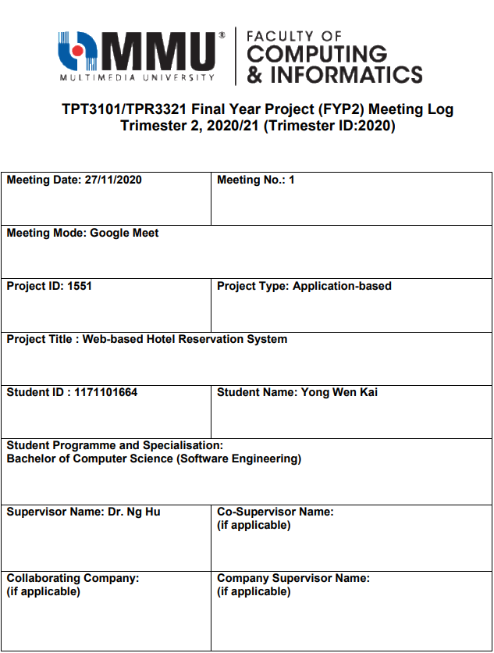

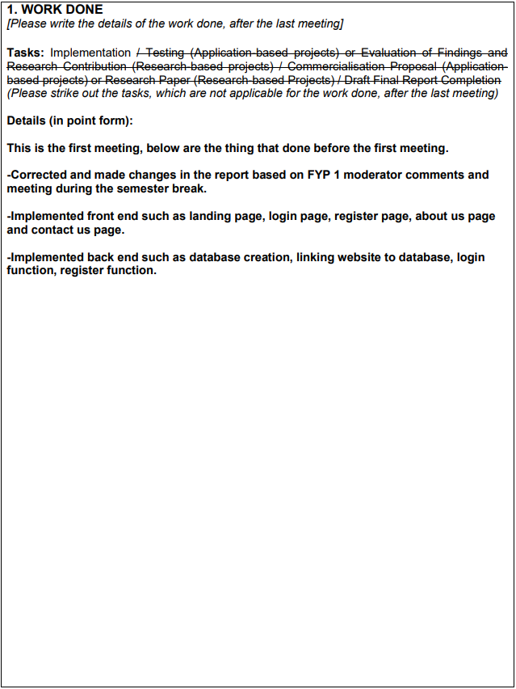

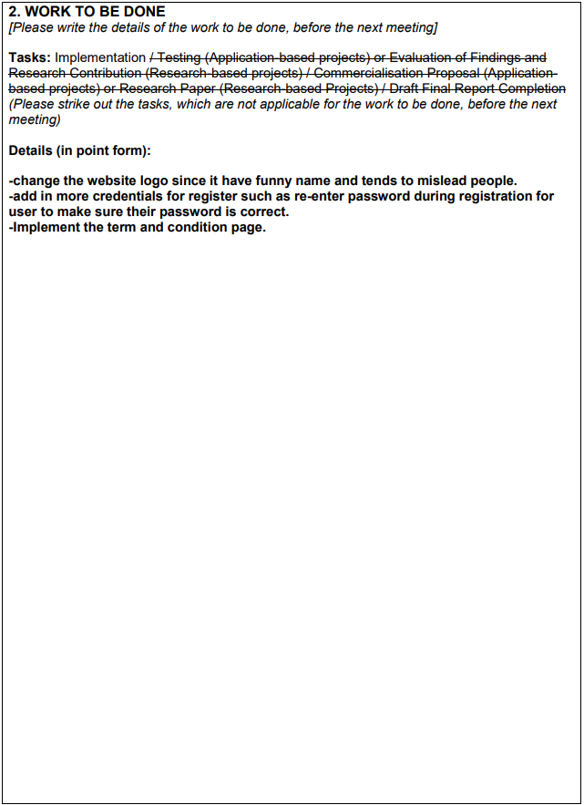

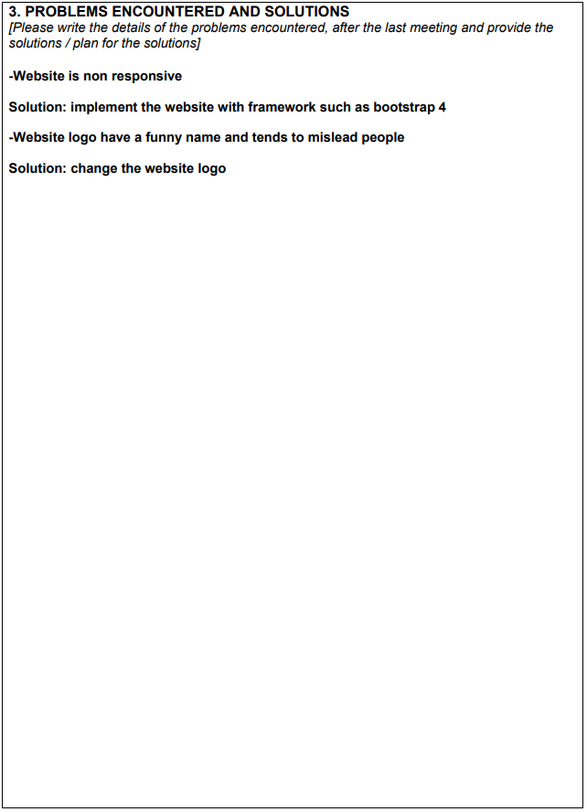

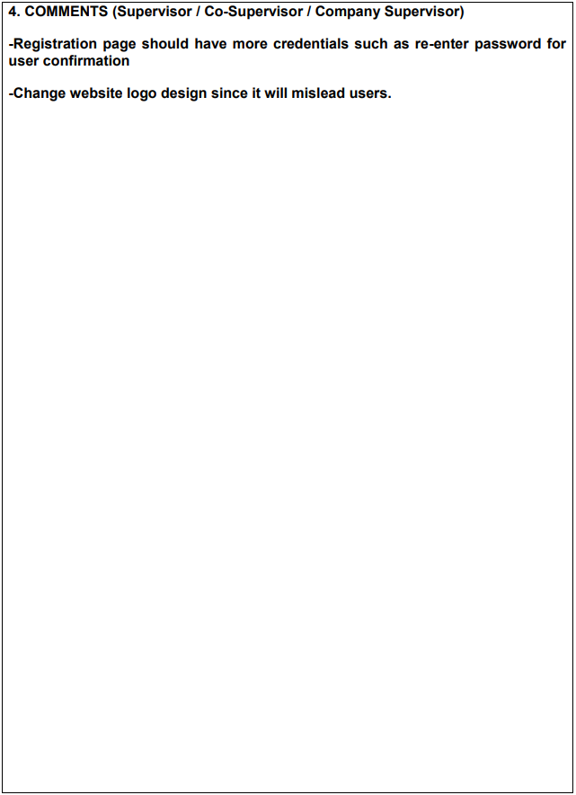

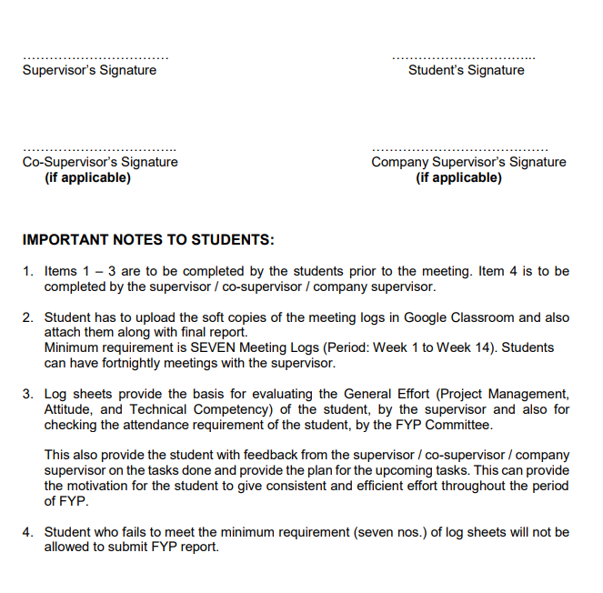

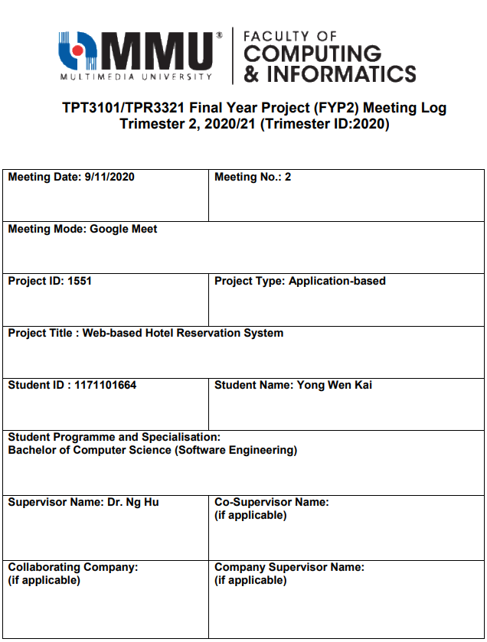

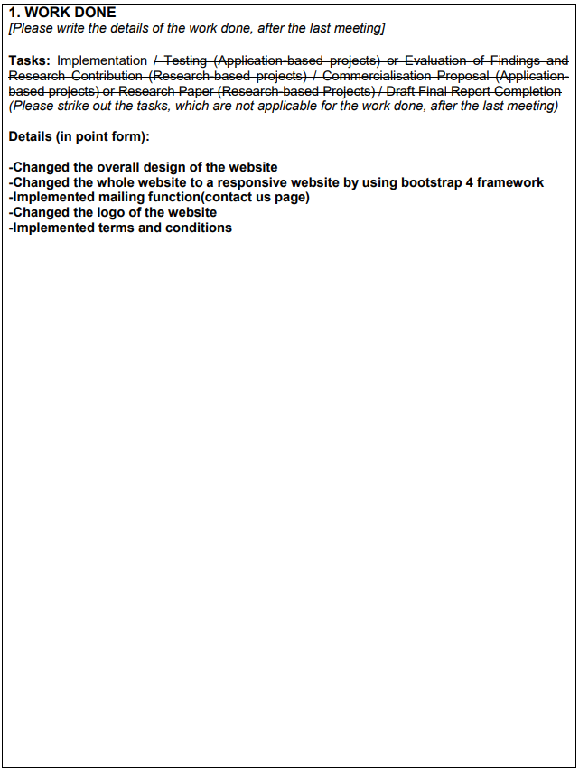

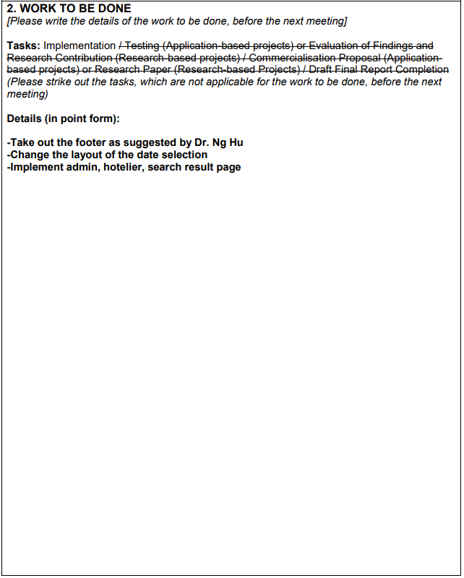

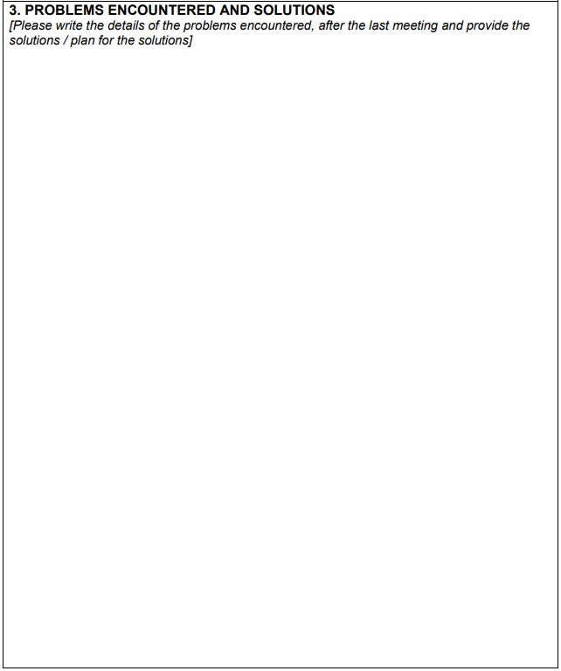

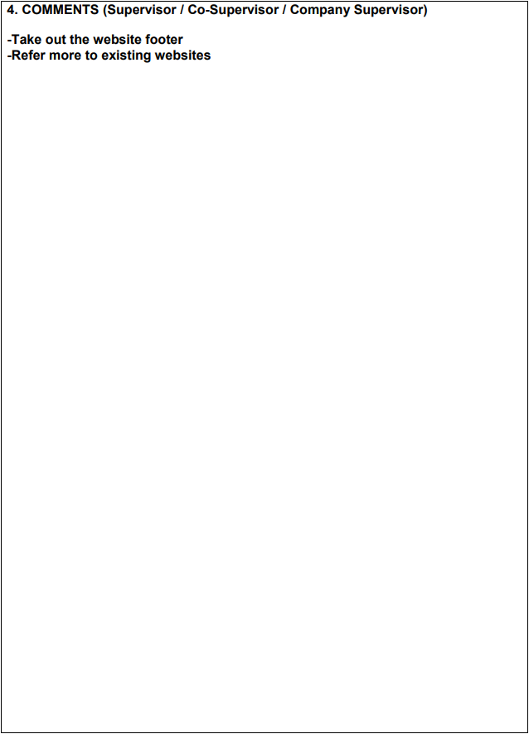

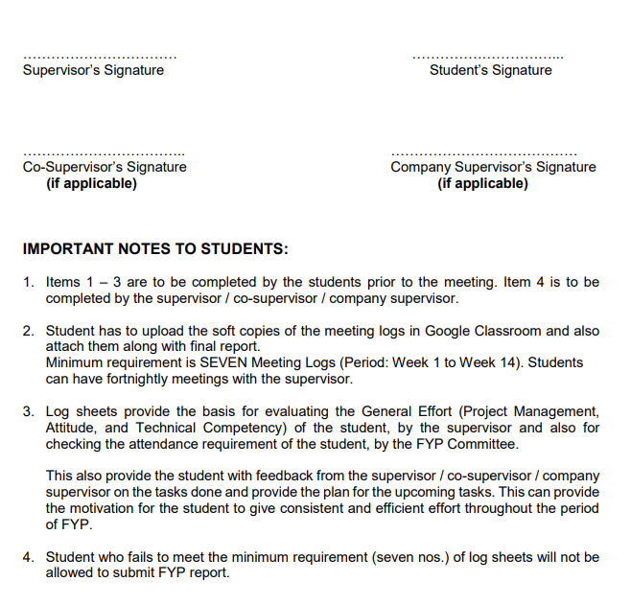

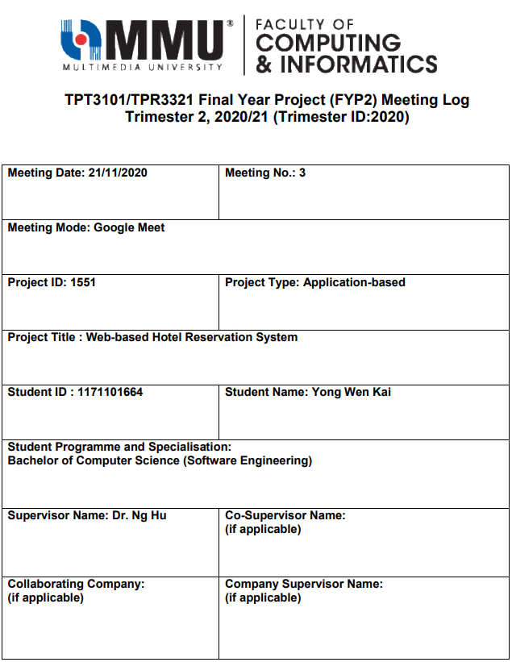

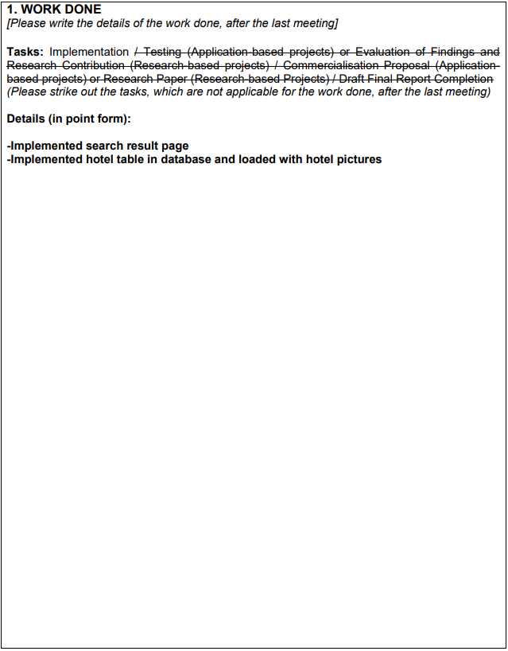

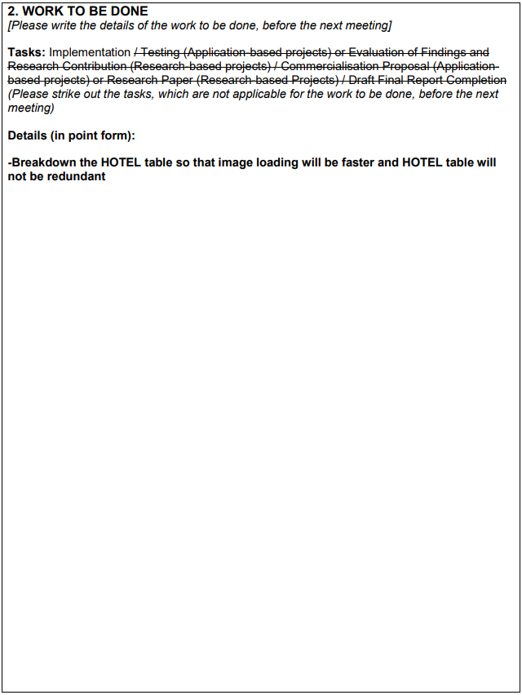

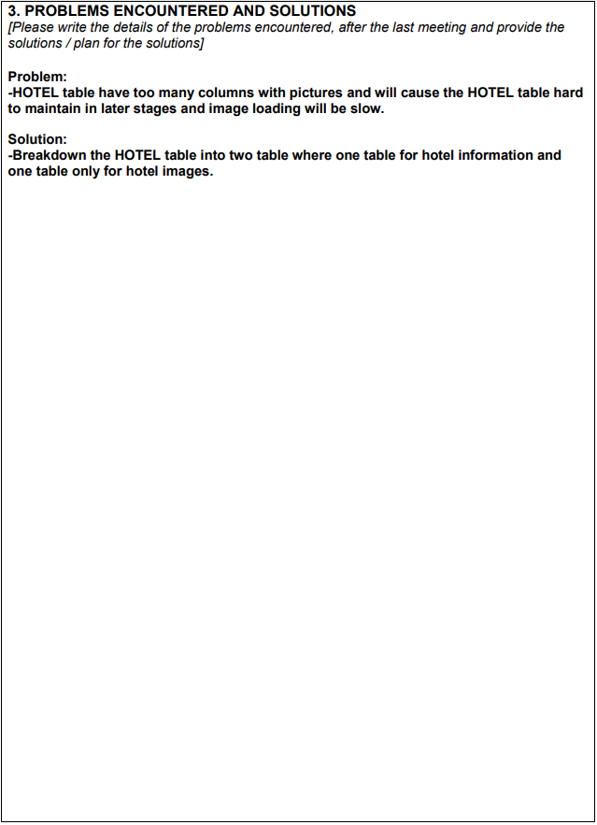

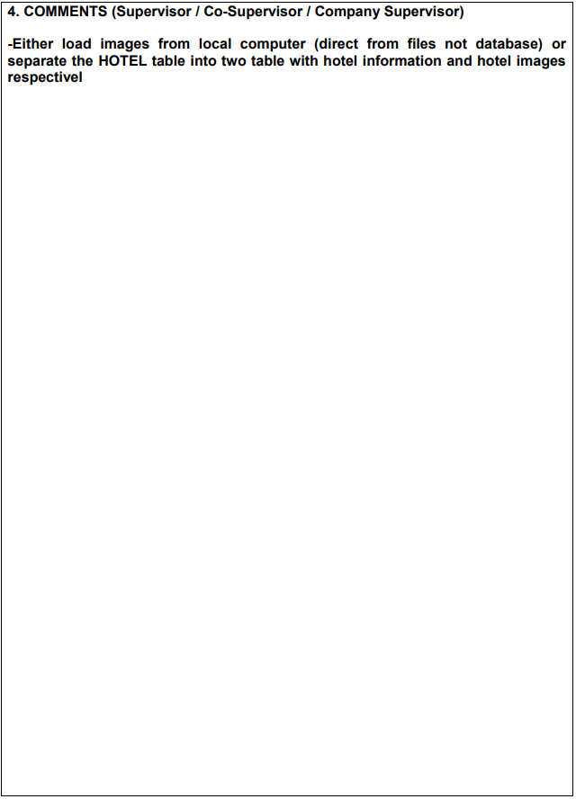

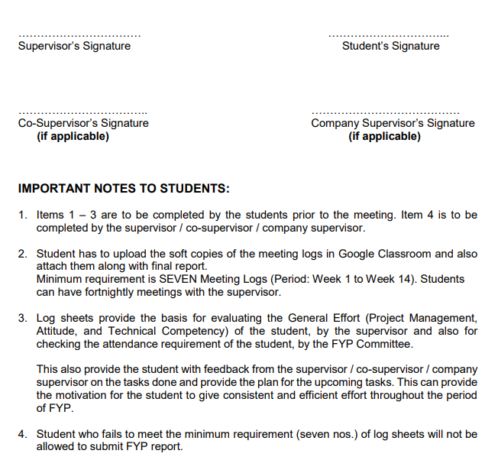

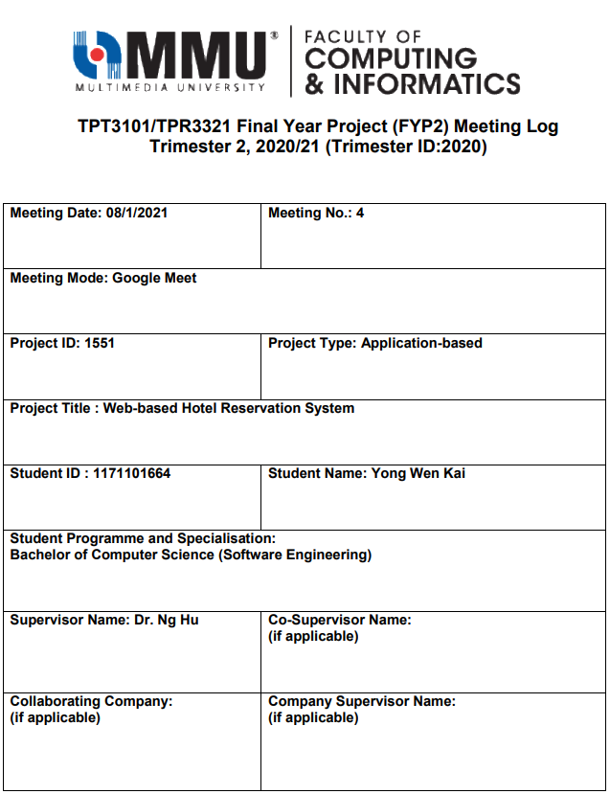

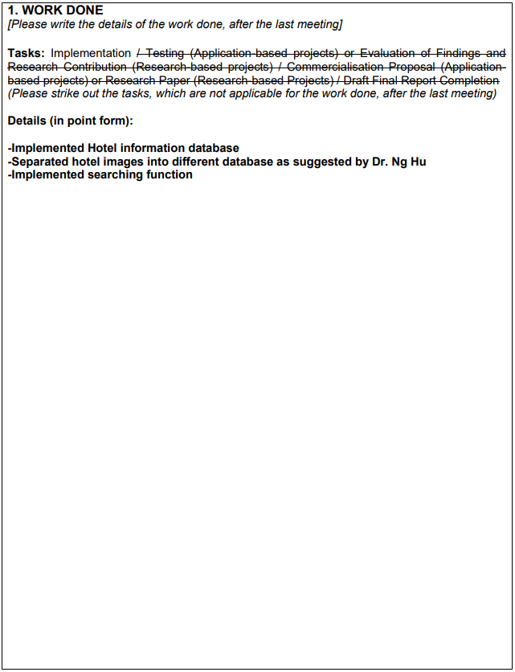

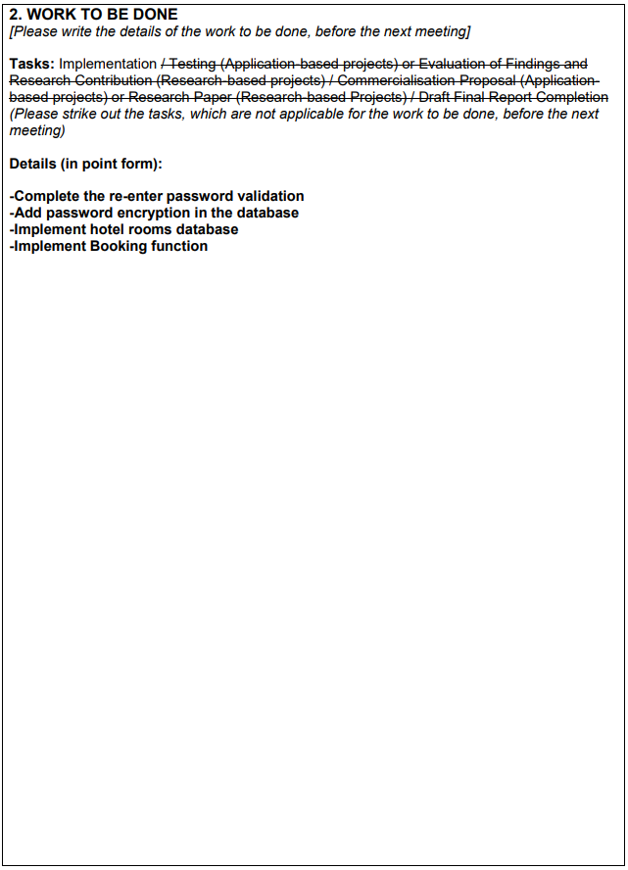

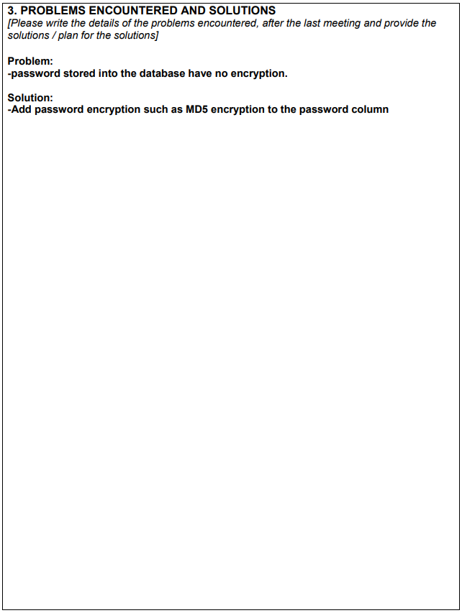

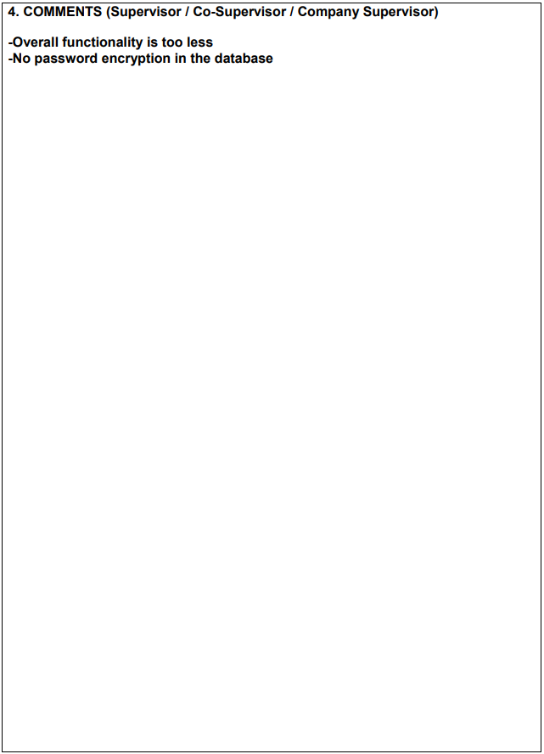

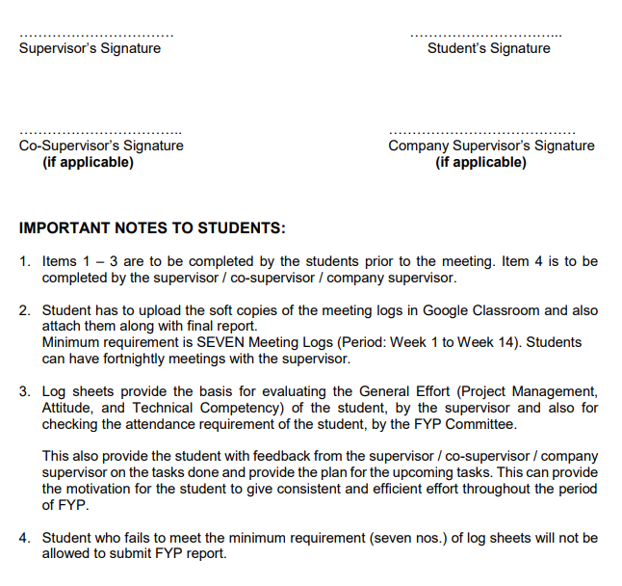

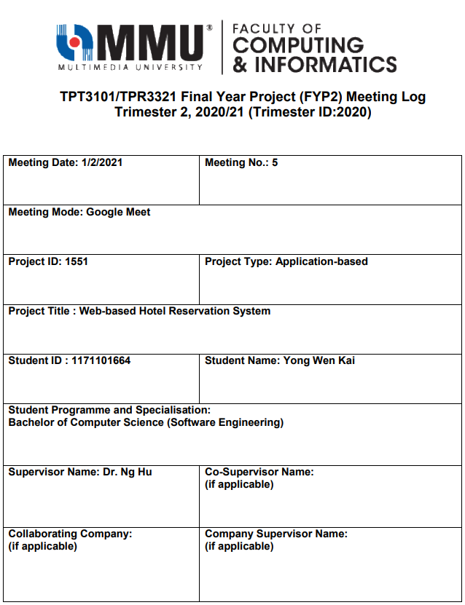

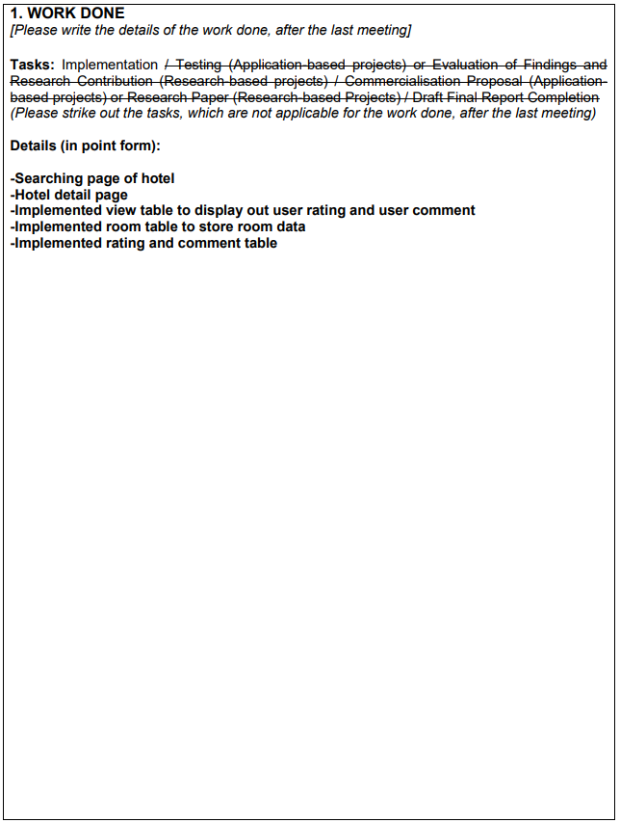

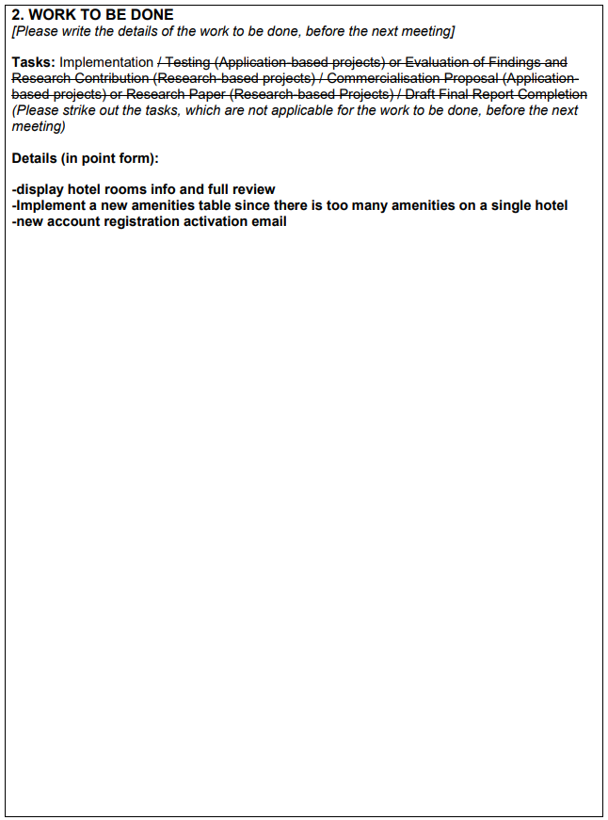

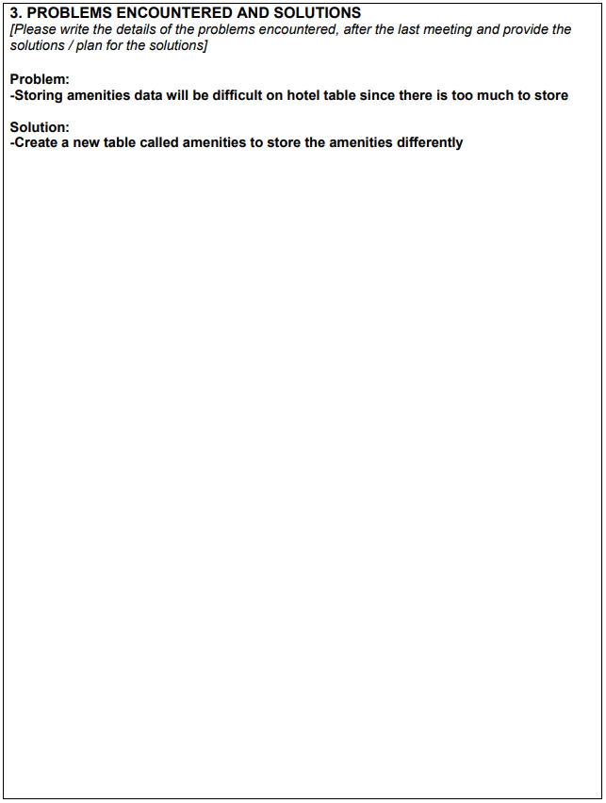

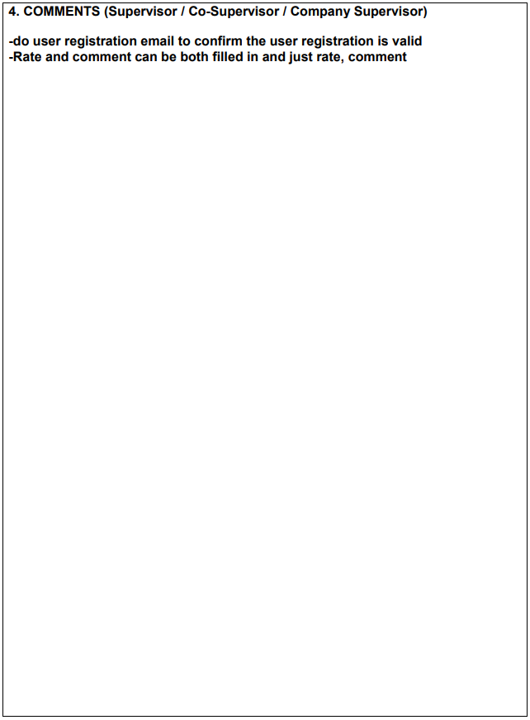

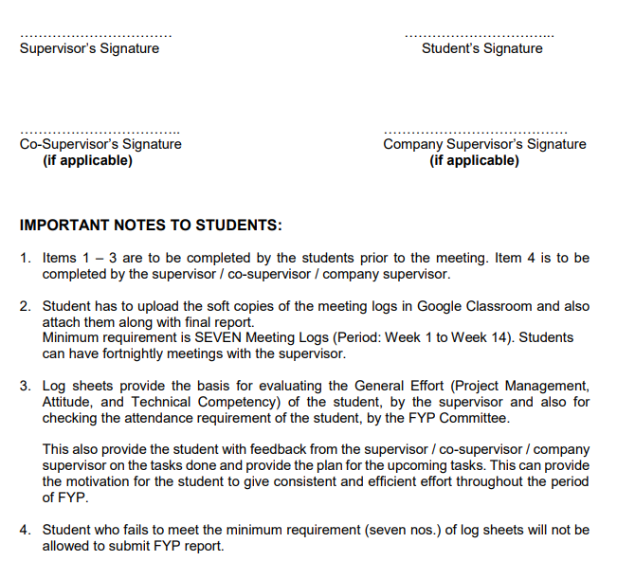

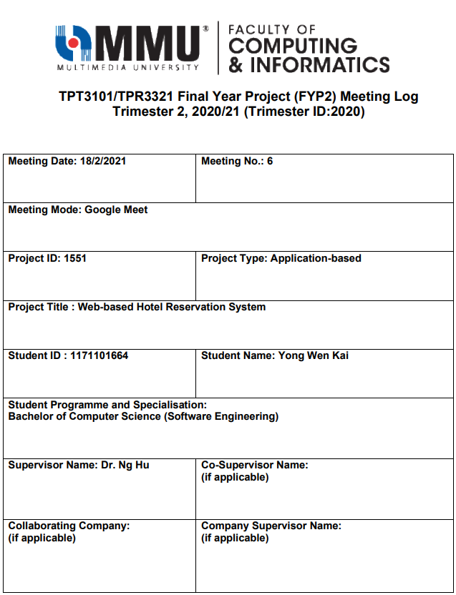

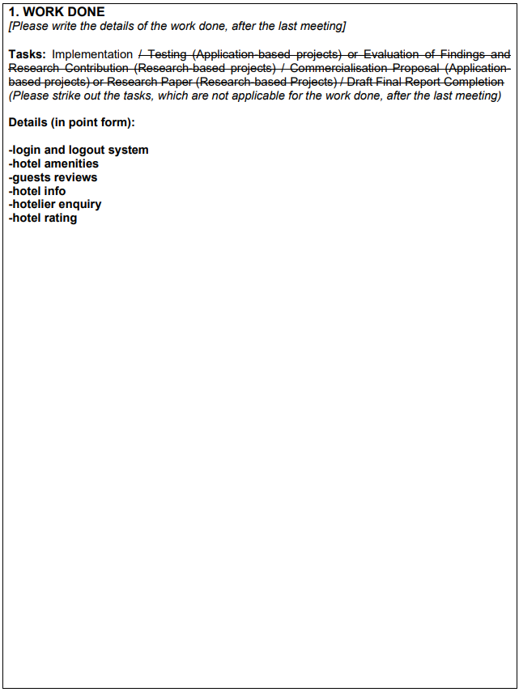

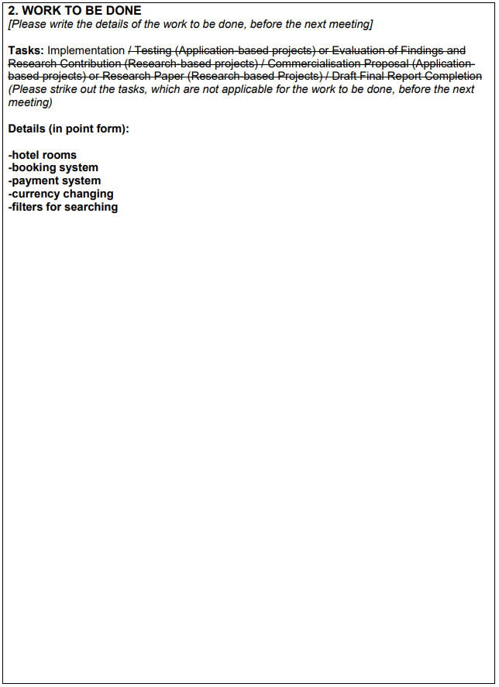

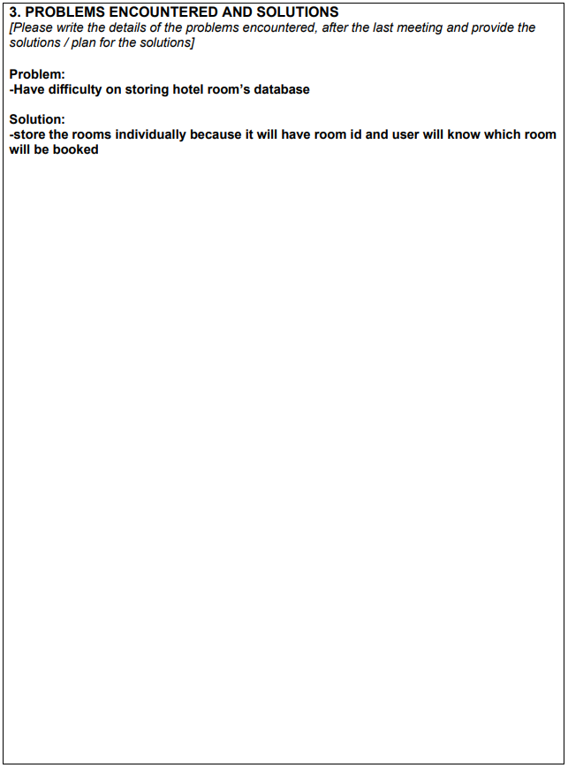

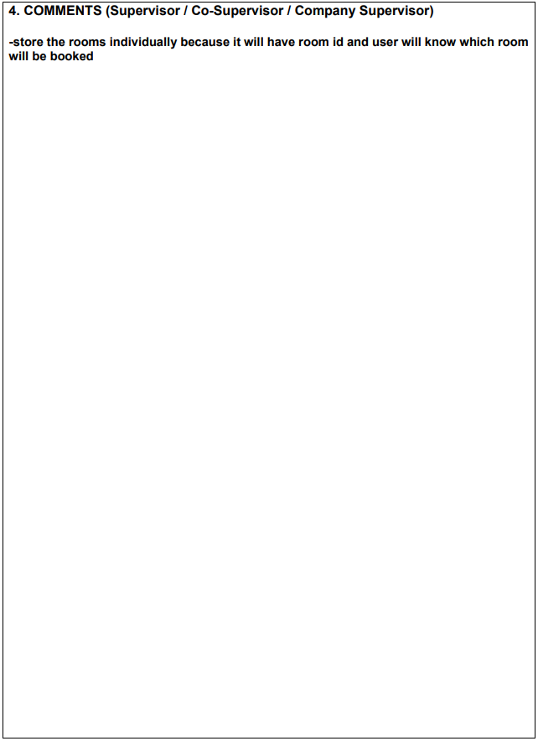

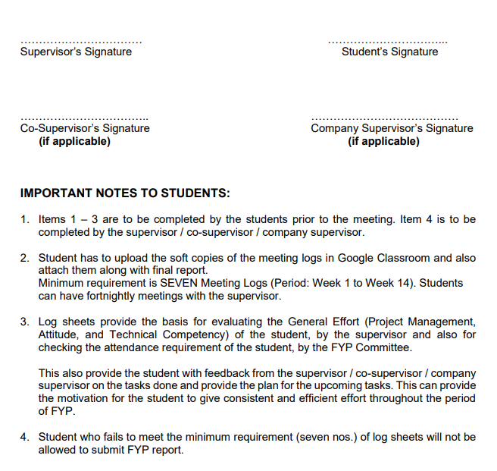

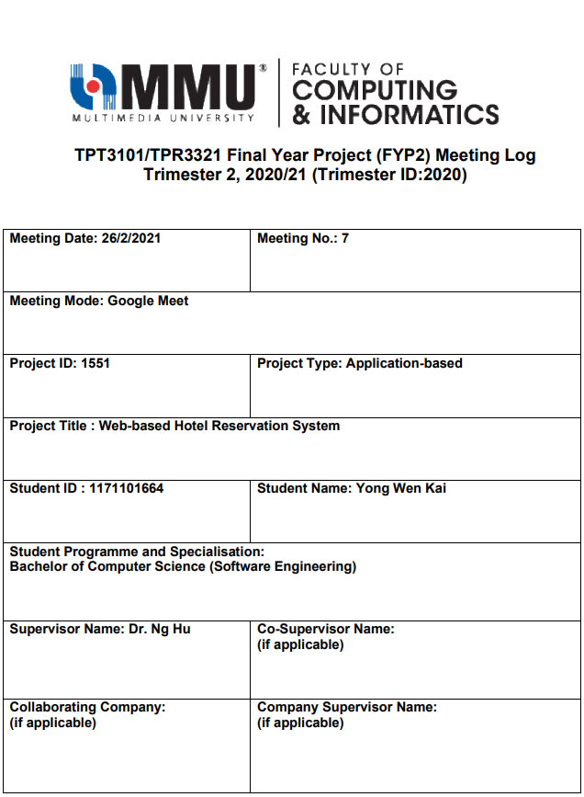

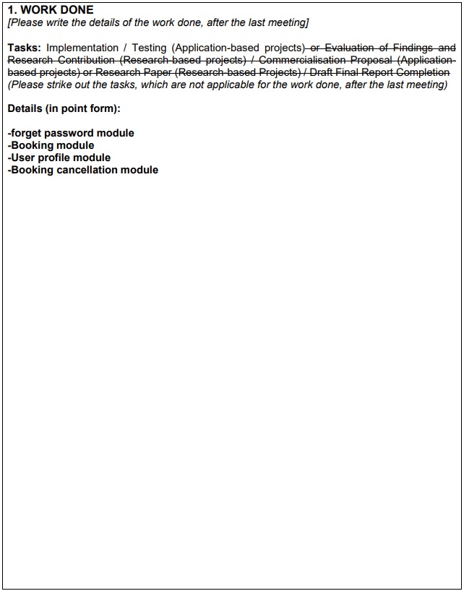

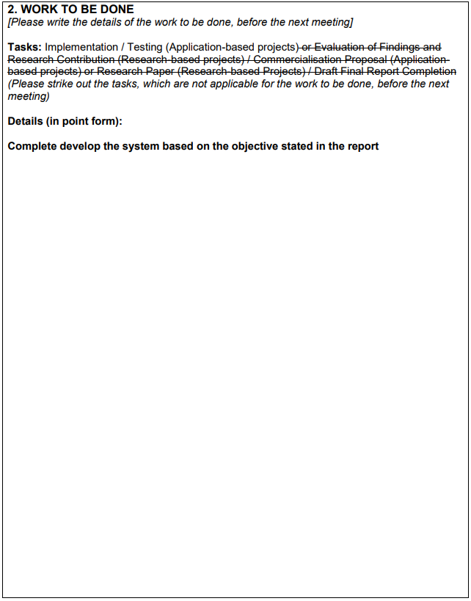

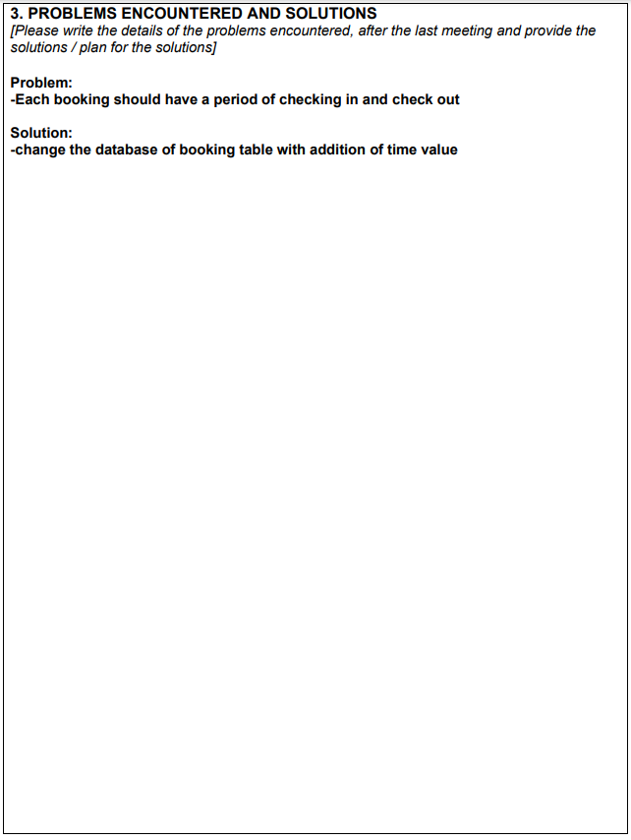

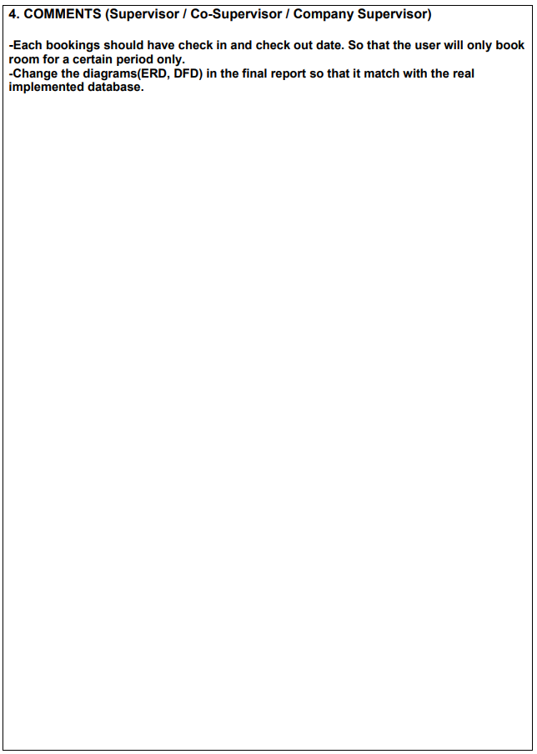

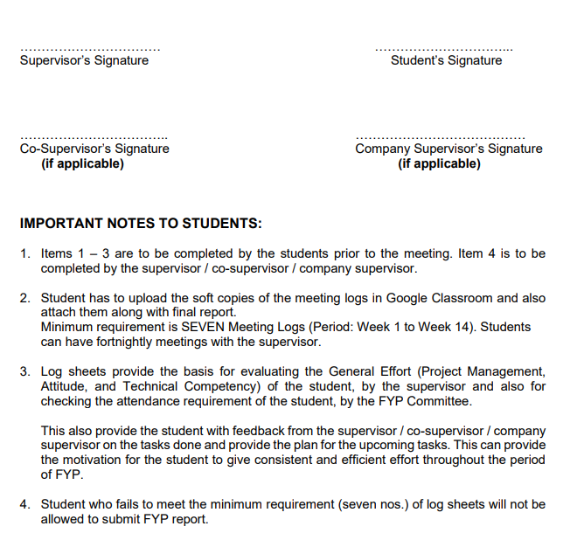

# APPENDIX C: SIMILARITY INDEX FROM TURNITIN

